Abstract
Third place is name which constitutes the wellness in terms of social prosperity, economic growth, physical health of the people and is the most important symbol of the urban realm. Street were seen in light of history, geography, land use and, perceive as a channel of movement; beyond all these, a street could be seen as the pivot of functional, social, and leisure needs of people also.
This book is an empirical examination of people inclination trends, behavioural responses, perceptions, and attitudes of people to preferred third place as well as the physical characteristics, use, and management of the neighbourhood commercial street in Lucknow. It used methods based in environment-behaviour sciences involving extensive observations of these streets over five-six months, and interviews with people using these streets to understand their behaviours and perceptions.
The findings of this research published in this book reveal that people were preferring the neighbourhood commercial street because they find it as a place for socialization; along with this, environmental and physical characteristics of the street also captivates them and hold them for some activities. The findings of the research would likely to help the architects, urban planners, and policy makers to adopt a more user-oriented approach in design and policy formulation in future.
Keywords: Third place, Urban open space, Street, Neighbourhood commercial street, Sociability, Street characteristics

CONTENTS
Title………………………………………………………………………….……i Declaration………………………………………………………………..…….vii Abstract………………………………………………………………………….ix Acknowledgement………………………………………………………………xi List of figures………………………………………………………......…..xx-xxi List of tables…………………………………………………...……...…xxii-xxiii List of abbreviations…………………………..……………………..….……xxiv
1 Chapter 01: Introduction 1
1.1 Background 1
1.2 Scope of study 4
1.3 Methodological approach 5
1.3.1 Empirical research 5
1.4 The study area 6
2 Chapter 02: Literature Review 7
2.1 Chapter overview 7
2.2 Built environment 7
2.3 Built environment components and its communication to user 8
2.4 Concept of ‘Third Place’ 10
2.5 Sociability- meaning and dimension 12
2.6 Sense of community 13
2.7 Neighbourhood cohesion 14
2.8 Neighbouring 14
2.9 Urban realm 15
2.10 Open public space 16
2.10.1 Role of open public space 18
2.10.2 Street as primary urban public space 20
2.10.3 Street as social space 23
2.11 Lively Street 25
2.12 Neighbourhood commercial streets 26
2.13 Behavior setting 27
2.14 Environmental affordance 27
2.15 Place theory 28
2.16 Human behavior as a basis of design 28
2.17 Sense of safety on the street 29
2.18 Environmental comfort on the street 30
2.19 Physical comfort and convenience on street 31
2.20 Territory, personalization, and control on the street 32
2.21 Sensory pleasure on the street 33
2.22 Conclusion 34
3 Chapter 03: Methodology 35
3.1 Chapter overview 35
3.2 Formative research 35
3.3 Focus group survey 36
3.3.1 Procedure 36
3.3.2 Result 37
3.4 Expert opinion survey 41
3.4.1 Procedure 41
3.4.2 Result 43
3.5 Inferences 47
3.6 Evaluative framework for perceived attributes of the built environment setting 47
3.7 Measuring Characteristics of Settings 49
3.8 Data collection and techniques 50
3.9 Behavioural mapping 51
3.9.1 Observation period 51
3.9.2 Duration of stay intervals 52
3.9.3 Determining optimal size of block-segment 52
3.10 Reliability of observations 52
3.11 Pedestrian counts 53
3.12 Walk by observations 54
3.13 Direct observations and field notes 56
3.14 Structured direct observation 57
3.15 Unstructured direct observation 58
3.16 Survey and interview 58
3.17 Sampling 59
3.18 Measuring Liveliness 59
3.19 Characteristics of respondents 60
3.20 Selection of study area- Neighbourhood commercial street 61
3.21 Data Analysis Technique 62
3.22 Reliability and validity of the model 62
3.23 Conclusion 63
4 Chapter 04: Characteristics of the Study Area 64
4.1 Chapter overview 64
4.2 The Study areas 64
4.3 Bhootnath Market 64
4.4 Gole Market 70
4.5 Kapoorthala Market 77
5 Chapter 05 Findings and Discussion 82
5.1 Chapter overview 82
5.2 Selection of dimensions and items for third place framework 82
5.2.1 Operationalisation of third place designation over neighbourhood commercial street 82
5.2.2 Results of formative research 86
5.3 Deriving dimensional scale for preferred third place 88
5.3.1 Data 88
5.3.2 Analysis 89
5.3.3 Result 90
5.3.4 Discussion 105
5.4 Calculating Liveliness and Analogous Mapping 107
5.4.1 Stationary Activities 107
5.4.2 Social Activities 110
5.4.3 Duration of Stay 118
5.4.4 Measuring liveliness index- Core characteristic for preferred third place 121
5.4.5 Discussion 124
5.5 Variety of goods and services 125
5.6 Permeability of street front 126
5.7 Personalization of street front 128
5.8 Articulation of street front 129
5.9 Foreground cover under shade and shelter 131
5.10 Community places 132
5.11 Sense of safety over street 134
5.12 Seating opportunity 135
5.13 Other street furniture and physical artefacts 137
5.14 Swachhata (Cleanness) of the area 138
5.15 Pedestrian Centred Strategies and condition 139
5.16 Discussion 141
5.17 Conclusion 151
6 Chapter 06 Conclusions 152
6.1 Discussion of main findings 152
6.1.1 Concept of third place 152
6.1.2 Attributes of the built environment and use of spaces associated with preferred third place 153
6.1.3 Three Aspects of Neighbourhood Public Space 156
Bibliography 159

LIST OF FIGURES
Figure 2.1 Human Needs and ways they are manifested in the built environment (Bartuska, 2007) 9
Figure 3.3 Notations used in walk-by observations to record behaviour and activities 55
Figure 4.1 Location plan- three study area in trans Gomti area of Lucknow 65
Figure 4.2 Satellite map of Bhootnath market area 66
Figure 4.3 Map showing the ten blocks studied on Bhootnath market area 67
Figure 4.4 Views of the blocks on Bhootnath market area 68
Figure 4.5 Drawing of the blocks studied on Bhootnath market area 70
Figure 4.6 Satellite map of Gole market area 71
Figure 4.7 Map showing the ten blocks studied on Gole market area 72
Figure 4.8 Views of the blocks on Gole market area 74
Figure 4.9 Drawing of the blocks studied on Gole market area 76
Figure 4.10 Map showing the ten blocks studied on Kapoorthala market area 78
Figure 4.11 Views of the blocks on Kapoorthala market area 80
Figure 4.12 Drawing of the blocks studied on Kapoorthala market area 81
Figure 4.13 Perspective views of the blocks on Kapoorthala market area 81
Figure 5.1 Number of persons engaged in some type of stationary activity on weekdays and weekends on 01-27 block segments 108
Figure 5.2 Number of persons engaged in some type of stationary activity on weekdays and weekends on 27-57 block segments 108
Figure 5.3 Number of persons engaged in some type of stationary activity on weekdays and weekends on 58-88 block segments 109
Figure 5.4 Number of persons engaged in some type of stationary activity on weekdays and weekends on all 01-26 blocks 109
Figure 5.5 Number of persons engaged in some type of social activity on weekdays and weekends on 01-27 block segments 111
Figure 5.6 Number of persons engaged in some type of social activity on weekdays and weekends on 27-57 block segments 111
Figure 5.7 Number of persons engaged in some type of social activity on weekdays and weekends on 58-88 block segments 112
Figure 5.8 Number of persons engaged in some type of social activity on weekdays and weekends on all 01-26 blocks 112
Figure 5.9 Behavioural map of people engaged in stationary and social activities 118
Figure 5.10 Duration of stay of people in stationary and social activities on weekdays and weekends on all 01-26 blocks 119
Figure 5.11 Duration of stay of people in stationary and social activities on weekdays and weekends on 01-27 block segments 119
Figure 5.12 Duration of stay of people in stationary and social activities on weekdays and weekends on 28-57 block segments 120
Figure 5.13 Duration of stay of people in stationary and social activities on weekdays and weekends on 58-88 block segments 120
Figure 5.14 Relationship between variety of goods and services, and liveliness 126
Figure 5.15 Relationship between permeability of street wall façade, and liveliness 127
Figure 5.16 Relationship between personalization of the façade, and liveliness 129
Figure 5.17 Relationship between street wall façade articulation, and liveliness 130
Figure 5.18 Relationship between foreground cover under shade or shadow, and liveliness 132
Figure 5.19 Relationship between number of community places, and liveliness 133
Figure 5.20 Relationship between sense of safety after dark, and liveliness 135
Figure 5.21 Relationship between availability of seating or sitting spaces, and liveliness 136
Figure 5.22 Relationship between other street furniture and physical artefacts, and liveliness 138
Figure 5.23 Relationship between cleanness status of the area, and liveliness 139
Figure 5.24 Relationship between Pedestrian Centred Strategies and Condition, and liveliness 140
Figure 5.25 Scree plot showing the Eigenvalues of the components 147

LIST OF TABLES
Table 3.1 Deriving statements to framing context for preferred third place over neighbourhood commercial street from responses of focus group survey 38
Table 3.2 Comparing two rounds of experts’ opinion -Wilcoxon signed rank test 43
Table 3.3 Comparing item-wise consensus between first and second round based on Wilcoxon signed rank test 44
Table 3.4 Analysing and selecting the statements in Delphi 45
Table 3.5 Selected characteristics of the street environment 50
Table 3.6 Codes for pedestrian counts in walk-by observations, and direct observations 53
Table 3.7 Symbols used in recording pedestrian counts 53
Table 3.8 Schedule of pedestrian counts for behavioural mapping for the three study areas 54
Table 3.9 Schedule of walk-by observations for behavioural mapping for the three study areas 55
Table 3.10 Symbols used in recording walk-by observations and direct observations 56
Table 3.11 Notations for recording Duration of Stay of people on the street 57
Table 3.12 Assigned Score for Duration of Stay of the user 57
Table 3.13 Characteristics of respondents 61
Table 5.1 Selected list of statements for third place framework 86
Table 5.2 Components variance explained of Model 1 90
Table 5.3 Scree plot of Model 1 91
Table 5.4 Component Matrix of Model 1 92
Table 5.5 Random Data Eigenvalues based on Brian O'Connor syntax engine 95
Table 5.6 Pattern Matrix of Model 2 96
Table 5.7 Component Correlation Matrix of Model 2 98
Table 5.8 Sampling Adequacy and Data sphericity test 98
Table 5.9 Component communalities of Model 3 99
Table 5.10 Components variance explained of Model 3 100
Table 5.11 Rotated Component Matrix in 6 factors of Model 3 102
Table 5.12 Component Transformation Matrix of Model 3 104
Table 5.13 Reliability check of extracted factors 105
Table 5.14 Liveliness index at Block segment and Block level 122
Table 5.15 Correlation matrix: variety of goods and services, and liveliness 125
Table 5.16 Correlation matrix: permeability of street wall façade, and liveliness 127
Table 5.17 Correlation matrix: personalization of the façade, and liveliness 128
Table 5.18 Correlation matrix: street wall façade articulation, and liveliness 130
Table 5.19 Correlation matrix: foreground cover under shade or shadow, and liveliness 131
Table 5.20 Correlation matrix: number of community places, and liveliness 133
Table 5.21 Correlation matrix: sense of safety after dark, and liveliness 134
Table 5.22 Correlation matrix: availability of seating or sitting spaces, and liveliness 136
Table 5.23 Correlation matrix: other street furniture and physical artefacts, and liveliness 137
Table 5.24 Correlation matrix: cleanness status of the area, and liveliness 138
Table 5.25 Correlation matrix: Pedestrian Centred Strategies and Condition, and liveliness 140
Table 5.26 Relationship between characteristics of street and liveliness 142
Table 5.27 Model fit statics of the 11 street characteristics 143
Table 5.28 ANOVA of Model fit statics of the 11 street characteristics 143
Table 5.29 Relationship between the 11 street characteristics with liveliness 144
Table 5.30 Correlation matrix between the 11 street characteristics 145
Table 5.31 Percentage variance of five factors 148
Table 5.32 Factor analysis showing the weightings of each characteristics 148
Table 5.33 Model fit statics of the five factors 149

LIST OF ABBREVATIONS
ANOVA | Analysis of variance
AVE | Average variance extracted
CFI | Comparative Fit Index
C.I. | Confidence interval
df | Degree of Freedom
EFA | Exploratory factor analysis
ICC | Intraclass correlation coefficient
IN | Informal neighbouring
N | Neighbourliness
NA | Neighbour annoyance
PA | Place attachment
PCA | Principal Component Analysis
RMSEA | Root Mean Square Error of Approximation
Sig. | Significance level
SOB | Sense of belonging
SOC | Sense of community
SOT | Strength of tie
VIF | Variance inflation factor

Chapter 01: Introduction

Background
More than three centuries earlier, when a powerful monarch established his capital city partly guided by the ‘karmuka’ of ancient Hindu texts of vastu shastra, he has sited his palace-fortress at the juncture of the two main streets of the city which was supposed to be the most auspicious spot. This monumental structure, in itself a miniature city, provided the paradigm for the socio-physical structure of the entire city. In the layout of its streets and in its social structure, the city was guided by the imperial pattern established within the citadel. If the palace-fortress symbolised the city, the city in turn symbolised the mansion of the emperor. The emperor was Shahjahan and his city Shahjahanabad. Over two centuries later, a national commission has formed, who has highlighted the necessity of majority interest rather development based on astrological predictions or the glorification of a king, during writing policies on urbanization. Reacting to existing situation in urban India, commission proposed a new approach to planning and management. Assigning the erosion of urbanity in our cities to lack of the human scale and human values in contemporary town planning, the commission said, the search for a better city must, begin with the smallest and most human unit-the neighbourhood (National Commission on Urbanisation, 1988).
In any neighbourhood, does the provision of shelter and necessary services are the only requirement? No, neighbourhood is much more than this, which includes home (not just dwelling unit), neighbour, and the space around them. This ‘space around them’ is the place where people live and it is the ‘liveability’ of the neighbourhood in terms of the socio-physical quality of the built environment that chiefly concerns the deliberation of this book with a study scope narrows down to neighbourhood commercial street. The built environment in its qualitative aspect as the ultimate expression of policy planning needs to be considered urgently if we mean to improve to quality of life in our cities. Equally important is the fact that over half the built-up area of any large Indian city under residential land use, the quality of built environment of these areas determines that of the city.
Rapid demographic growth and uncontrolled physical expansion has occurred at the cost of quality of life in urban India. Modern architecture and consequent deterioration in urban form is everywhere evident. In India, where there is still a shortage of 18.78 million urban housing as reported in 2012 (Planning Commission, Government of India, 2013) and an expected 600 million urban population by 2031 (Planning Commission, Government of India, 2013); a rapid development is taking place to overcome this demand. With the increasing demand for the housing and urban settlement, it is necessary to pay heed towards rich built environment in its qualitative aspect.
The image of any city and their city dwellers are the ultimate reflection of the built environment of the city, A persuasive historian and English Prime Minister, Sir Winston Churchill, forcefully expressed this: “We shape our buildings; thereafter they shape us.” Another noted historian, Arthur Cortell, conveys this same by claiming: “Tell me the landscape you grew up in and I will tell you about yourself.” Human spatial behaviour, in the context of architectural design, is a term that describes the relationship between the built environment and its human inhabitants (Yan W., 2005). There has been a long-standing awareness that the built environment could be manipulated to achieve obvious physical or behavioural results (Drew, 1971). Ordering the architecture in an urban realm; public spaces have been considered as the backbone and are supposed to be the most expedient place for sociability and everyday interface, where their vivacity and usability depend on the socio-physical physiognomies. The richness of the socio-physical quality of any urban open space plays a major role in attracting people and turn out to be an active built environment for multiple social activities including everyday societal interactions, trade activities, political demonstrations or special events; they have become the venues for goods, knowledge, experience, culture, and entertainment (Salama, Remali, & Maclean, 2017).
Increased consumer culture has led to the privatization of public spaces, shopping malls, corporate plazas and hence this has replaced traditional public spaces including main streets (Banerjee, 2001; Rybczynski, 1993). However, the same consumer culture, together with the need for active and passive engagements, interactions, relaxation, and leisure; supports the concept of public life in coffee shops, bookstores, theatres, health clubs etc. on traditional public spaces such as ‘streets' (Banerjee, 2001). Other than the channel for movement; the street is the place where inhabitants spend most of their time after home and workplace. It means streets are the important part of public open spaces and are seen as the most important symbols of the public realm in today’s perspective of urbanization (Jacobs J. , 1961; Appleyard, Gerson, & Lintell, 1981; Moudon, 1991; Chekki, Lofland, & Cahill, 1994; Southworth & Ben-Joseph, 1997; Lofland & Lofland, 1998; Hass-Klau, 1999; Carmona, Heath, Oc, & Tiesdell, 2010). Furthermore, in an urban setting it is observed as the ‘primary public space’ as well as a smallest definable community space and an indicator of the socio-physical fabric of the area (Mital, 2002). It is also an acknowledged fact that the potential for the development of a successful neighbourhood lies in the possibility of the spaces around buildings, generally streets, generating social activities. With the tool of human spatial behaviour, in the context of architectural design, a street can be established from a primary public space to a ‘Place’. Jacob says about an urban settlement that “Think of a city and what comes to mind? It's streets. If a city's streets look interesting, the city looks interesting; if they look dull, the city looks dull” (Jacobs J. , 1961).
Another perspective of this book is concerning the “third place”. The term introduced by an urban sociologist Ray Oldenburg, who defines it as “a place which serves the people for their regular visits, a place of communication with friends, neighbours, co-workers, and even strangers, welcoming and providing comfort to regular visitors, as well as is a place to meet old friends and make new ones” (Oldenburg, 1998). After home and workplace, a place where people can spend their remaining quality time. In recent researches, some researchers have defined the term third place as the place mostly focussing on the friendliness and qualities that support sociability and place attachment (Mehta & Bosson, 2010).
Like other major Indian cities, Lucknow a city of Uttar Pradesh India also has the highest increase in residential areas from 1981 to 2001 accounting to nearly 99.4% than other land uses, along with this, researchers have already pointed out the problem of unfamiliar neighbours and lack of interaction amongst the dwellers settling in these residential areas. Further research has been done to identify the impact of built environment (if any) on users’ social relations, for which the city was earlier known for.
In this context, understanding the dynamics of this particular built environment of the primary urban spaces over the sociability of the users, and its evaluation in the context of third place parameters as given by the recent researchers, become an important aspect and has been chosen as the focus of the present research. The findings of this research are expected to help the architects and urban planners in adopting effective physical design parameters, ensuring that built environment of the primary urban space becomes a place satisfying in all possible ways and could be designated as third place.

Scope of study
Urban sociologist Ray Oldenburg defined a third place as a place of refuge other than the home or workplace where people can regularly visit and commune with friends, neighbours, co-workers, and even strangers. Oldenburg’s (2001) treatise on third places mostly focuses on the social aspects, that a third place is welcoming and comfortable, is visited by regulars, and is a place to meet old friends and make new one. Even while Oldenburg was lamenting the decline of third places, but he has ignored the differences that may occur in developing countries like India where population and other infrastructure are in challenging situation and in consequence cities, streets are either overcrowded or underperforming. Furthermore, the consequence of places in linking the environment to social behaviour has already been elaborated by Canter (1991). Through this research thus the aims to derive the dimensions and role of other built environment attributes for third place designation specifically in context of study area at Lucknow (India). The study in this book has been organized with the following objectives in mind
Objective 1: To understand the concept of ‘third place’ and establish the appropriate dimensions to assess sense of third place based on user’s perception over a neighbourhood commercial street.
Objective 2: To identify the built environment attributes as well as usage of the neighbourhood commercial street that contributes towards the establishment of preferred third place.
Objective 3: To identify a relationship (if any) between the built environment attributes and the activity over the spaces in the context of preferred third place designation.
Objective 4: To identify the association amongst the built environment attributes identified for the neighbourhood commercial street as preferred third place.
This book tries to comprehend what constitutes any primary urban public space as the preferred third place for the people who use this space in their daily life while being the part of its urban neighbourhood; and, also the association, if any, between the attributes of the primary urban public space and preferred third place. Since, in the urban realm, author has designated street as a primary urban public space, he attempt has been made to understand the urban setting of neighbourhood Commercial Street at the micro level.
Limiting the scope of book, perspectives of the seasonal/ climatic variation of activities as well as the different types of festivals that may influence the characteristics of the space, have not been taken into consideration in this study. The street selected in this empirical research are the neighbourhood commercial streets; which are not considered in the central business district of Lucknow but are the major commercial streets in their respective dense urban neighbourhoods having a mixed-income group. Streets are having the mix of usage as variety in retails at street level to serve the daily need of their respective neighbourhood, some offices, some residential units; and well connected to main transit stops.
Since all the streets taken into consideration for study lie in trans Gomti area, there are likely to be some cultural differences in preferences for location and day to day shopping and other commercial activities, especially related to the local residential environment. Different religion/ culture has a different threshold for tolerance and acceptance of perceptual stimuli and level of social interaction, especially amongst people of different gender, race, and class; which has not been taken into account of this book.

Methodological approach

Empirical research
In the beginning, an attempt has been made to integrate the opinion of various stakeholders viz-a-viz, user, the experts of various disciplines; and tried to reinforce the framework in this interdisciplinary, less explored, context-specific issues. Focused group survey along with expert opinion survey (Delphi technique) with nine experts has been carried out for the same. As we progress further, based on the understanding derived from the literature review and formative research, a research framework for fulfilling the objectives have been framed. Then, it reaches to an evaluative framework for perceived attributes of the built environment setting and people’s behaviours also, which may impact in designating the space as preferred third place for the people.

The study area
All three neighbourhood commercial streets of the study area are in Lucknow city, trans-Gomti area at 26.873º N 80.982ºE and, are the major commercial streets of the residential neighbourhoods. An attempt has been made to select blocks within study area where macro-scale characteristics including housing and commercial density of the area, type of people living in the area, proximity to natural magnets, cultural institutions, academic institutes, transport nodes and so on; would remain common or of same nature. Thus, the selected blocks in each of the study area were part of the same urban context as well as with similar micro-scale characteristics of the environment. The blocks selected within the study area are in about range of hundred fifty-meter diameters, so chances of variation in macro-scale factors amongst the blocks are least.
The selected streets comprise mostly the buildings of same age except few and have the age of 30-35 years of construction. The height of the buildings lies mostly from one to four storeys and have the usage of small independent local business to some outlets of a national chain. The selected study areas are considered for shopping, dining and entertainment destination by the people in and around the area.

Chapter 02: Literature Review

Chapter overview
The focus of this chapter is to examines the available literatures that deals with the aspects broadly outlined in Chapter one of this book. It explores the terminologies related to the built environment, its component, reviews the concept of third place and other related terminologies. Further, this deals with the urban open spaces, public spaces, and particularized about the street as primary urban public space; potentials in street and its capacity to serve the need for preferred third place in urban realm has been sightsaw in this chapter. Moreover, the related urban design attributes as physical characteristics of street have been explored in the dimension of open public spaces and street in particular. The overall understanding and lessons learnt leads the to the gap areas in earlier related researches which helped in to formulate the thrust area for this study.

Built environment
The term, built environment refers to the human-made surroundings that afford the setting for human activity, ranging in scale from buildings and parks or green places to neighbourhoods and cities. In practice the term is used to represent all the factors and stimuluses that have impact on a particular object of study or consideration. In result, when we talk about the suitability of the place, it means the physical setting of so many variables are in better position. The built environment provides the setting by which we live our lives, and impacts on our senses, our emotions, participation in physical activity and community life, our sense of community, and general well-being. Meanings are generated by buildings and spaces, which we ‘read’ as we pass through them. Places are created and shaped by those in control of resources and with certain interests, which affects our degree of access to, and the way we use, those spaces (Butterworth, 2000).”
The term emerged in the 1980s and came into widespread use in the 1990s. To illustrate the term, built environment is an integral part of a new definition of landscape architecture approved in 2003 by the ‘International Federation of Landscape Architects’ who are involved in work including planning, design, management, maintenance and monitoring of functional and aesthetic layouts of built environments and, identifying and developing appropriate solutions regarding the quality and use of the built environment in urban, suburban and rural areas.
It is the fact that every built is the result of human need, to meet their most basic needs, people first created tools, harnessed fire, and developed shelter to survive in the wilderness. Once human survival needs became less uncertain; people turned their attention beyond survival and continued to modify the environment at an accelerating rate to make their lives safer and more comfortable, productive, and enjoyable (Figure 2.1). Times have changed, change has accelerated, and populations have exploded, but the basic reasons for creating a built environment remain essentially the same as people design and construct tools and products, modify and manipulate space, build structures, plan and shape landscapes and cities, and manage regions and the Earth. We build the things and therefore make important contributions to the built environment; we design and build our lives from one experience to another; based on these experiences, components of the built environment emerge from human needs, thoughts and actions (Safiullah & Sharma , 2017). Sometimes the substances of human actions are grand, and we design and plan quality life experiences for ourselves and others; in other hand, these actions could be short-sighted, creating uncomfortable situation that are less fit for healthy human activities and negatively impact the surrounding environments (Safiullah & Sharma , 2017). Collectively, these products and processes of human creation are called the built environment.

Built environment components and its communication to user
Every built form has a unique nature which could be easily perceived by the user and accordingly they prefer to go and enjoy. Now, why this question of selection arises, when this is the ultimate result of their need itself. Actually, this is true that, they prefer or not prefer amongst their own creations but, this happens because the said built patch is satisfying their single parameter either physiological or psychological need (Figure 2.1), while the other parameter somehow overlooked. Every element such as line,
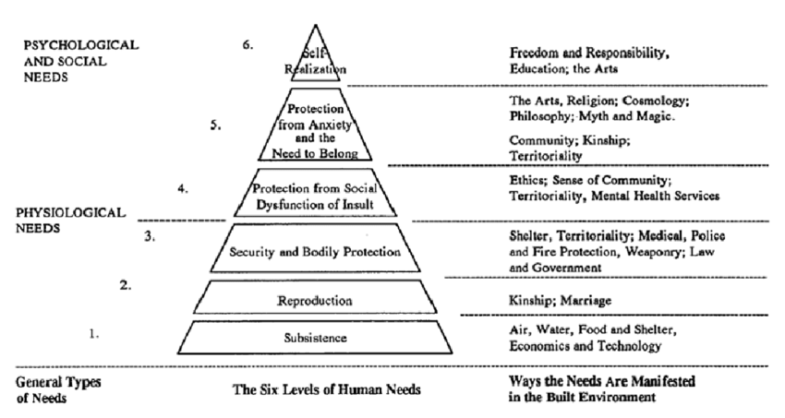
Figure 2.1 Human Needs and ways they are manifested in the built environment (Bartuska, 2007)
plane, surface, mass, volume, material and structure has the contribution of their unique identity in formation of physical or visual character in the architecture of any area means, beside the individual building or surrounded space, the arrangement of buildings or surrounded space (architecture) also matters which is being overlooked somehow and affects the usability of area and not being choose by the user; in result, most of our urban spaces / built forms of the Indian cities or either underperforming or over crowded. The term ‘psychological need’ which have the number of synonyms as ‘user need in context to their psychology’; or the ‘environmental-behaviour studies’; or in terms of research it is called ‘environmental psychology’; which is the matter of concern in this research. Environmental psychology is the field of study that examines the interrelationship between environments and human affect, cognition, and behaviour (Bechtel & Churchman, 2002; Gifford, 2007; Stokols & Altman, 1987). It means interrelationship (architecture) of the various components and elements of the built environment is to be taken care of for making the environmental psychology more appealing.
Since the time of Vitruvius thoughts; first century B.C., when he had given the basics for architecture to suits the human behaviour and make more appealing architecture of the environment; so many influencing factors have generated. Amongst that, three basic factors have been recognized which influence the architecture of any region viz a viz Utilitas, Firmitas, and Venustas, or in our language, it is ‘Human Behaviour (function)’, ‘Technology’, and ‘Aesthetics’ (Moore G. T., 1979). As the word has become more complex and the complete griping over all three domains is very difficult, it is obvious to get succeeded with more command over the greater number of domains. It means for better psychological environment; we would have to work on their basic influencing factors which directly interact to the users. Likewise, we can identify the real relationship of the various variables; and their associated functions viz-a-viz circulation flow, proximities between activities, symbolic values of the enclosure, form, its embodied technology, and aesthetics etc., all these turn into the commuters’ behaviour, and physical environment.
Broadly speaking, the built environment can be understood as a system of spatial and physical conditions for human activities and the satisfaction of human needs and desires. Whether in the house, at the workplace, or in recreation, people are surrounded by elements of the built environment. Having regarded the reciprocal relationship, the impact of the built environment on its users has evolved into a distinct field of research. Almost 2500 years ago, Hippocrates spoke in his treatise on ‘On Airs, Waters and Places’ about the importance of the impact of environment on human health (Hippocrates, 2007). While the shaping of the built environment in accordance with the ‘sense of place’ represented a common practice in the past, technical-technological and socio-economic development altered the possibilities of transforming the natural into the man-made environment, and simultaneously changed mutual influences between built space and its users.

Concept of ‘Third Place’
In search of a place which is neither home nor work, Oldenburg (1998) coined this term ‘Third Place’. A place to visit in a regular way, without any sense of host or guest, without any fear of hierarchy, with a clear absence of stress, and looking for some type of escape from both the previous places. Escape theme suggest a world of difference between morning coffee in the bungalow and that with the gang at the local bakery. Oldenburg sees the third place which is having another kind of potential to endure the people, motivate them for any kind of stationary, sustained, and lingering over the space. According to definition, the term defines as, public place that hosts the regular, voluntary, informal, and happily anticipated gatherings of individuals beyond the realms of home and work (Oldenburg, 1998). In support of third places, and in connection to America’s policy of creating safe and sanitized areas, Oldenburg has mentioned ...people then become overly dependent on the first two places – home and work. He argues that these places do not have the capacity to meet the expectations of people and therefore “Multitudes shuffle back and forth between the ‘womb’ and the ‘rat race’ in a constricted pattern of daily life that easily generates the familiar desire to ‘get away from it all’ (Oldenburg, 1998).
The third place serves as a place where they can get away from it all and has explicit physiognomies that extricate it from other places that people visit. It is on neutral ground with no host or hostess, a level place where people are equal, there is lively conversation, the mood is playful, there are regulars who bring it to life, it is easy to get to and the hours are convenient, it has a low profile and can even be called plain, and it is a home away from home for regulars. Oldenburg’s (2001) accords on third places mostly focuses on the social aspect, that a third place is welcoming and comfortable, is visited by regulars, and is a place to meet old friends and make new ones.
International acclaimed dramatist, guru, psychologist and trend scout Christina Mikunda draws on his extensive experience of working with marketers, designers and architects to show how to create pleasurable and memorable sensory experiences, slightly differ with the third-place perception; he sees the third place as being staged as a sight-seeing attraction, whereas Oldenburg described plainness as a critical aspect of third places. While plainness was a virtue for Oldenburg because it reduced self-consciousness and pretension, Mikunda argues that some third places can be places that allow people to ‘reload themselves with their lifestyle’ (Mikunda, 2004). Another perspective to the research on third places by introducing the views of Generation Y students in a developing nation, with a similar lines of Oldenburg neutral ground and no hierarchy, the virtual third place is another generational shift; describe it as a place where individuals may come into contact with new and old friends (Klang & Olson, 1999).
Thus, it could be concluded as the third places are the designation to a space which has an embodied characteristic fostering social activities with a main moto of communication either with themselves or with the other people present over the area. On a neutral ground, with clear absence of host or hostess, having a low-profile aura, and cheerful character supported by physical and environmental structures; third place should demonstrate a lively behaviour in whole.

Sociability- meaning and dimension
Sociability is a term that is widely used in sociology, political science and psychology. Many times, it has been considered as an indicator of the social health of a community (Luhr, 2016). However, there is very little consensus on its actual definition. The concept generally looks at social relations, derived from attitudinal and behavioural aspects in three broad domains of human activities (Bernard, 1999): economic, political and socio-cultural. Researchers define it as interdependence, trust and mutual support among members of society (Jenson, 1998). Although sociability is a characteristic of a group or a society and does not claim for an ideal or maximum limit (Chan, To, & Chan, Reconsidering Social Cohesion: Developing a Definition and Analytical Framework for Empirical Research, 2006). As per Berger-Schmitt (Berger-Schmitt, 2000), social cohesion consists of mainly two dimensions:
- Reduction of inequality, disparity and social exclusion; and
- Strengthening of social relationship, interaction and ties.
Sociability is a key protagonist of public places in cities and neighbourhoods. Through the good public places, a better communication and socializing behaviour can be established amongst the residents of the city. Social life has been acknowledged as everything that occurs in public spaces between buildings: sitting, chatting, walking, cycling, running, standing and playing, which form “the life between buildings” (Gehl, 1987). In this sense, public life is translated into the presence of people and residents in their practice of everyday life in the public spaces of cities and neighbourhoods. In his book Life Between Buildings, Jan Gehl has focused about the qualities of urban life, and how the sociability achieved through the built environment can become a major landing stage.
Qualities that are believed to offer prospects for social interactions in public places comprise the factors that reassure residents to walk or the ones that encourage people to engage in stationary activities. The factors that encourage walking behaviour are density (Amick & Kviz,, 1975; Franck & Stevens, 2007; Gehl, 1987; Jacobs J. , 1961; Pendola & Gen, 2008; Talen, 1999), human scale development (Amick & Kviz,, 1975; Gehl, 1987; Langdon, 1997), mixed land use (Alexander, 1977; Audirac & Shermyen, 1994; Jacobs J. , 1961; Mehta, 2007; Montgomery, 1998), easy pedestrian access (Marcus & Francis, 1997; Gehl, 1987; Gehl, 2010; Gehl & Gemzøe, 2004), improvement in condition for cycling (Gehl, 1987), and soft facades (Gehl, 1987).
The qualities that are studied to encourage stationary activities in public places are provision of seats and sitting areas (Gehl, 2010; Gehl & Gemzøe, 2004; Mehta & Bosson, 2010; Mehta, 2007; Whyte, 1980), provision of community gathering places (Lofland & Lofland, 1998; Oldenburg, 2001), improvements in sidewalks and building edges (Mehta, 2006), greenery (Al-Hagla, 2008; Sullivan, Kuo, & Depooter, 2004; Whyte, 1980), and using a fine hierarchy (Chermayeff & Alexander , 1971; Chermayeff & Alexander, 1966).

Sense of community
Sense of community is considered a necessary tool to mitigate most of the social problems and also for the development of a community in urban areas (Chavis & Wandersman, 1990; Nasar & Julian, 1995). The concept was originally developed in the 1970s. Sarason (1974) defined sense of community as "The perception of similarity to others, an acknowledged interdependence by giving to or doing for others what one expects from them, the feeling that one is part of a larger dependable and stable structure" (p. 111). However, the most acceptable definition came after a decade. McMillan and Chavis (1986) defined this concept as a psychological construct, which consists of four elements:
- Membership is an element that depends on the boundary, emotional safety, sense of belonging, personal investment and common symbolic features.
- Influence indicates towards a sense of making a difference to a group or being a member adopting something from the group. It helps to fulfil the personal needs as well as the community needs through a member’s influence on the community and the community’s influence on the member, simultaneously.
- Integration and fulfilment of needs explores one’s need, being part of the group and utilizing its resources.
- Finally, the fourth element is the shared emotional connection, which involves the commitment and belief that members have shared and will share together, like, history and time, and carry similar experiences.
Places that help shape community attitudes, that provide a continuity from past to present, that may often cater to mundane but essential everyday functions, that help in establishing their community’s identity become significant to the neighbours and achieve a social value and meaning (Lofland & Lofland, 1998; Johnston, 1992). Johnston adds that these are places that “loom large in the daily comings and goings of life” and “are accessible to the public and offer the possibility of repeated use to build up associations and value to the community of users.” Often these are small local businesses or informal community gathering places in the neighbourhood and are what Oldenburg (1998) has termed “third places.” Hester (1993), contends that in neighbourhoods these places are usually “public and ambiguously owned private spaces” and among many others, are likely to be favourite spaces, streets, sidewalks, storefronts, alleys, parks, and so on.

Neighbourhood cohesion
Whereas psychological sense of community signifies an individual’s psychological feeling in a particular setting, neighbourhood cohesion is a group-level phenomenon. Based on the sense of community concept of Sarason (1974), Buckner (1988) developed the concept of neighbourhood cohesion claiming the sense of community and neighbourhood cohesion as the similar concept. Buckner (1988) identified three components to define neighbourhood cohesion:
- Users’ sense of community felt within the context of the place;
- Users’ degree of attraction to live and remain in the place (place attachment); and
- Neighbouring or users’ degree of interaction within the place.

Neighbouring
Unger and Wandersman (1985) defined neighbouring as “the social interaction, symbolic interaction, and the attachment of individuals with the people living around them and the place in which they are breathing” (p. 139). This concept (Unger & Wandersman, (1985) of neighbouring identified three core components: social (social interaction), cognitive (knowledge and experiences), and affective components (sense of mutual aid, the sense of community and the attachment to a place). However, the concept did not consider any negative aspect. Another concept of neighbouring by Skjaeveland et al. (1996) considered both positive and negative aspects of social relations. Their neighbouring has four dimensions:
- Supportive acts of neighbouring combine the concept of the social act and sense of mutual aid (Unger & Wandersman, 1985; McMillan & Chavis, 1986).
- Neighbourhood attachment is a social psychological process and similar to place attachment that includes place dependence and place identity (Brown, Perkins, & Brown, 2003; Mihaylov & Perkins, 2014). Place attachment, as described by Brown and Perkins (1992) and Scannell and Gifford (2010), is a positively experienced bond between people and place; it develops from the affective, cognitive and behavioural process and depends on characteristics of people and place.
- Weak social ties or bridging ties refers to ties that develop among neighbours, from frequent face to face contacts and limited shared interests. The weak ties concept is derived from the theory of strength of weak ties of Granovetter (1973).
- User annoyance measures the dislikes or negative aspect of neighbouring that develops among co-users in a relatively consistent neighbourhood.

Urban realm
The term usually and very loosely used to refer a better algorithm of spaces, mainly urban public spaces. The terms urban realm, public domain, public realm, public life, are here meant to refer to the social processes among city inhabitants that occur in public places. In the literature, ‘urban realm’ and ‘public realm’ are used more-or-less interchangeably to refer to the publicly accessible spaces between the buildings in an urban environment (Sheldon, Heywood, Buchanan, Ubaka, & Horrell, 2007). Urban realm exists when, people of the city or an area can easily enjoy their benefits and rights, without encroaching any other benefits and rights as well as without any obstruction; and make the city or area live as they wish to. It is in the public places of cities, its squares and streets accessible to all of the city’s inhabitants, that all can see and hear each other. Here, persons different from one another, and present in public places for diverse purposes can come together. In the public realm, many perspectives and the common world may be found; within the public realm, young and old may learn about, and from each other (Lennard, The Public Realm and the Good City, 2018).
Since, all the city space components have the equal weightage to contribute in an urban realm; Streetscape is sometimes used in the same sense as urban realm (TfL, 2017; Nellthorp, Chintakayala, & Wardman, 2011), ‘Placemaking’ also relates very closely to urban realm, although some of the placemaking literature focuses on the cultural, social or economic processes by which transformation of the urban realm occurs (Schneekloth & Shibley, 1995; Cilliers & Timmermans, 2014; Glaeser & Gottlieb, 2008). The urban realm is a focus for urban designers, economists and transport authorities. At the heart of much urban realm research and planning is the idea that streets and squares can be transformed into “more people-friendly places” (New York City Department of Transportation, 2008) and that this is beneficial for existing local businesses, economic regeneration, and residents’ health as well as their economic prosperity.

Open public space
There is a popular notion about the public space as that is like a stage of any auditorium or theatre surrounded by audience. Public space is described as theatrical like setting, French (1978), Whyte (1988), Carr et al. (1992), Engwicht (1999) and more recently Cousseran (2006) where, variety of activity by the variety of users in a variety of ways for expressing their real-life freedom, social, and cultural expressions take place. Along with so many other components, Open public space is another important part, a physical manifestation, of the public realm (Thomas, 1991). Most of the people have a need and desire to establish a link between themselves and other part of the word, curious to know about the other people and part of their surroundings. Public spaces are significant because they are able to accomplish their need, desire and curiosity; support them to establish a communication, a platform for enjoyment and relaxation, as well as serve the purpose as channel for movement. Few researchers have even labelled public spaces as the open public library where one can learn a lot, particularly, in history, when, public spaces had played a significant role, either in setting strategies for defence from enemies and make them confused and trapped, celebrating their rituals, or setting up the bazaar (Safiullah & Sharma, 2017).
There are various other definitions of public spaces mainly illustrious by issues of ownership, control, and access. Some authors express it firmly as the “space that is not controlled by private individuals or organizations, and hence is open to the general public. This space is characterized by the possibility of allowing different groups of people, regardless of their class, ethnicity, gender and age, to intermingle” (Madanipour, 1996). Beside ownership and control, another basis of defining public spaces are access and use. In this sense, public space is defined as “publicly accessible places where people go for group or individual activities” (Carr, Francis, Rivlin, & Stone, 1992). In the physical dimension, public space is “all the parts of the urban fabric to which the public has physical and visual access. Thus, it extends from the street, park, square of a town or city into the buildings which enclose and line them” (Tibbalds, 1992). For this research, accessibility and use of the space is being used as public space rather its ownership, means if the space is accessible physically and visually, having any kind of ownership, is used to refer as open public space; while if not physically or visually accessible, and having even public ownership will not be qualify as open public space.
As a part of a summary of public space, Carr et al. (1992) have amassed a typology of contemporary urban public spaces. The authors suggest that these different urban public spaces furnish to different needs and desires, and various physical and social aspects of human functioning either in terms of comfort, relaxation, passive and active engagement, or discovery. By the nature of their type, access, and use, these spaces are likely to satisfy one or more of the aspects mentioned above.
Though, a large portion of literature on public space denotes it as open public space, and do not distinguish between enclosed public space and open public space, but in present-day most of the enclosed spaces are also working as public space. In history public spaces were the open of kind and majority of public life occurred there. For the purpose of this study, then, open public space will be connoting as part, which will include not only the spaces between the buildings but also the objects, artefacts, and the enclosure, which help in defining the territory and physical boundary of the space. For this study one type of traditional open public space – the neighbourhood commercial street has been considered as limit.

Role of open public space
The scope of this part of the research is to take the cognizance of the historical form of urban spaces in our ancient Indian cities, also, the algorithm and the ambience created through various means and methods. The intent is not to produce an extensive list of the roles of public space but its basic contribution to the cities and their people. Many of such roles, such as the collection of water and the disposal of garbage, the dissemination of news, and the display of public punishments and executions (Lofland & Lofland, 1998) no longer pertain in present times. Rather, the intent is to identify the roles of public space in highly privatized contemporary societies.
In context to the spatial arrangement of the medieval cities, we can conclude the pattern arranged in a minimalistic approach, and most of the system follows the principles of Vatu shastra. Temple, fort, palaces normally occupies the most auspicious place of the area, while the access route of the said temples, fort, palaces determines the development pattern or style of the city which normally evolve with defence strategies keeping in mind so that the said places can be defended from the enemies and make them confused and trap. If we take the example of Suchindram- a typical south Indian temple city, Capital cities like Jaisalmer, Jaipur, Shahjahanabad, Awadh; all had reflected the same characteristics; only the difference is the capital cities had their forts and palaces instead of temple. The access route which are the derivatives of development pattern had a very narrow, Steep and planned in way to maintain the air channelization. These accesses were normally having so many gateways of very articulated and unique in nature; and this shows their glory and status (Ghose, 1968).
The spatial arrangement of Vijayanagar shows that the whole city is divided in three basic zones viz-a-viz ‘the scared centre’, ‘the royal centre in the urban core’, and ‘the sub urban area’; along with three kind of road pattern as redial, ring and linear. Most of the commercial activity, military and ceremonial movements take place on these roads which links all three different zones. The junction points of the road of urban core area have the Ramchandra temple which was the focal point as well as the visual reference point for all movement system taking place through or around it. Furthermore, these open public spaces are reinforced by their function like processions, whether that is ritual procession of the temple cities or, emperor’s daily ride to the mosque in Shahjahanabad or, the ritual show of military strength at Vijayanagar. Their scale of construction at this focal point is another pier, which itself speak through its monumental scale; if we take the example of Jaisalmer where no construction is allowed higher than the central one, so that the visual dominance can be retained over the entire city (Blake, 1991).
The organization and its layout are affected by the layout system of the street and their connectivity as they link private courtyards to the public square and ultimately to the palace square. In Jaisalmer, a dramatic pace of haptic experience built up as the fort view changes, disappears and then appears again; the narrow corridor of the street, broken up at some intervals by twist and turns, opening shockingly onto a square. A very solid with few openings, no infill spaces, recessed facades at some point, cross connectivity with other building at upper levels, overlooked to the street, their height and roof establishment, and stone carvings; distinguish each building along the street.
Jaipur can be seen as a strong geometrical patterned layout city which is believed to be based on sastras. The streets were the main spin which linked the various levels of activities to each other and eventually to the palace. Residential areas within this overall geometry were not subject to the same architectural controls as have the standard house type design in introvert plan focused on the private courtyard, having the pink wash and continuity in activity spaces; which makes a theme (Ghose, 1968).
The typical south Indian temple towns thus may be described as have the number of high-level configuration either in context of architectural appearance or spatial arrangement. Any of the users like devotee, the layman, or the scholar may perceive the temple complex in either way or all but experiencing it profoundly. Within the overall order established in mediaeval settlements by the dominant structures as well as the supporting street network converged from these structures; residential lands are allotted as per the individual status at the royal court or is depending on their caste and occupation. So, each area of residential settlement has a distinct social and occupational identity (Thapar, 1982). Furthermore, these sectors space resolved itself into some other unique wards, Mohalla, Pols, Chaks etc. consisting of varying number of dwellings. Concluding the algorithm and activities of the spaces of ancient cities, their functioning and set up of the built environments clearly indicates the various traits of the activities meant for public spaces.
In contrast, modern urban societies no longer depend on mandirs, forts, palaces, and even on park and piazzas; good urban spaces are required now for their social and psychological need. Researches in urban studies indicates that public space in contemporary times is important to generate, enhance, and sustain a sense of community (Boyer, 1994; Hayden, 1995). Local residents attach meaning to everyday public spaces and places as valuable “sacred structures” in their daily life (Hester, 1993). Public spaces where people regularly meet their friends and watch daily life play a critical role in people’s lives (Low, 2000). Crowhurst-Lennard and Lennard (1995) engage the literature from sociology, psychology, psychiatry, political science, architecture, urban design, and planning to develop a list of social functions served in public spaces. This list includes learning, the development of social competence, the exchange of information, the facilitation of social dialogue, the fostering of social awareness, the enhancement of social integrative functions, and the encouragement of ethical conduct.
Crowhurst-Lennard and Lennard (1995) argue, “urban public space is the single most important element in establishing a city’s livability” (p. 25). With their research in European cities, they advocate that good urban public space provides easy and safe access for all, enables a variety of activities, nurtures self-esteem and sense of belonging, upsurges awareness and interest in the environment, and provides enjoyment and social contact.

Street as primary urban public space
Think of a city and what comes to mind? Its streets. If streets look good, the city looks interesting; if they look dull, the city looks dull (Jacobs J. , 1961). Streets are an important part of open public space in the city. For many urban thinkers, it is the streets that signify the outdoors (Jacobs A. B., 1993). With the origin as Latin word ‘sternere’, street defined as just a significant surfaced face in comparison to other surround surfaces. Most of the researchers claimed that street does not necessarily mean as traffic carrier, but a station set apart for public use. Street differs from the road in definition in that it does not suggest direction or movement. Road suggests a purely functional space for transportation, whereas street suggests a place to linger and enjoy.
Street is viewed as the primary public space in the urban setting. As the smallest definable community space of any area, the street may also be seen as an indicator of the socio-physical fabric of that area. It is also an acknowledged fact that the potential for the development of successful neighbourhood lies in the possibility of the spaces around the blocks, generally streets are meant to generate social activity.
Streets and their sidewalks, the main public place of the city, are its most vital organs (Jacobs J. , 1961). Streetscape as an important element in the city scape have been the subject of considerable study in deliberations on urban design. But these studies in the early part of the last century concentrated more on the major streets of the city, specially their points of convergence as in the square where emphasis was on physical appearance. Today, notwithstanding Grady clays’s (1991) complain about the ‘mechanical denizens of the streets’ being gazed at with more intensity than the street itself in her spirited claim about the potential of the street as a teacher, deliberations on the street in their many aspect has been subject to much scholarship.
Originating, possibly, with Jane Jacob highlighting the social function of the neighbourhood street and Lynch establishing ‘paths’ as one of the key structuring elements of any settlement, the street has been analysed in its various aspects: formal, social, cultural. Rappoport (1969) in house form and culture, illustrated the necessity of seeing the dwelling as part of the larger system to which it belongs, particularly space hierarchies from private dwellings space to the semi-public and public community spaces.
Street of the past (a small universe’ that embodied in condensed form the character of the whole town) has been lost in modern context of scattered buildings, automobile traffic and immense scale. Defining the space form of the street as longitudinal but not necessarily straight, Norberg-Shulz (1971) believes that for the street to regain its ‘figural character’, in other words the building must appear as continuous bounding surfaces rather than masses connected by the street, thus reducing the street to merely a ‘subordinate ground’. This not only presupposes a certain density but also that the houses must belong to same family. The monotony that this may suggest was counteracted by buildings appearing as variations of the same theme allowing freedom for details. These principles were commonly followed up to the nineteenth century after which the ‘parade street’ became the norm.
Echoing same sentiments, Jan Gehl (1987) writes that functionalist planning caused streets to disappear, replacing them with roads and paths of the ‘built-in’ qualities experienced in ‘nearly all’ mediaeval town he says: ‘not only are the streets and squares arranged with concern for people moving about staying outdoors, but the city builders appear to have had remarkable insight concerning the fundamentals for this planning. Gehl is concerned about the thinning out of people and events in urban spaces resulting in situations where ‘nothing happens because nothing happens’. His conviction that a high degree of social life between buildings specially in residential areas is the principal factor that will allow healthy, safe and cohesive neighbourhoods to develop.
‘The battle for high quality in cities and building projects must be won at the very small scale’. Gehl’s concerns with the building themselves is restricted to their perceived scale at the pedestrian level and the potential in design of their facades for ‘influencing the concentration of activities and the intensity of experiences for those who pass by on the sidewalk’.
After a number of years of automobile dominated streets, Gehl cites examples from Scandinavia where pedestrianization of precincts or even traffic calming has resulted in better places for people.
Oscar Newman (1972) in defensible spaces following in the tradition of Jacobs is concerned with the social qualities of residential areas in seeking places that are safe from crime by the very virtue of their planning and design. The potential of street as network of public urban spaces that can organise and unify cities and thus become powerful tools for urban planning and design is dealt with in public streets for public use edited by Anne Vernez Moudon (1991).
Cliff Moughtin (2016) in urban design street and square recognises the need to design using the main formal elements found in the city, namely the square, the street, and the buildings. He observes that: Although the street accounts for most of the urban public realm, in practice, particularly modern practise, the street is what remains after private planning of individual properties is considered satisfactory. In analysis the utility of the street as an element if city design, he warns against sentimentality but see the street as both a ‘physical element and a social fact’. The two main characteristics of the streets are directly related to form, ‘it is at one and the same time, both path and place. He argues that if the properties that made ‘fine streets and the city squares’ in the past could be analysed, we may be able to reproduce some of those qualities not by copying but employing the underlying principles of composition. The understanding of how things are put together’ in the aim of Hilliers (1998) analysed of urban spaces. He views the city as social space and demonstrates how space connectivity and integration together make intelligible spaces. From almost the other end of the spectrum, Alan Jacob defines what makes for great Street though careful presentation and analysis of the some of the best street in the word More than just documenting Jacobs’ objective is to help make future great streets. Michael Southworth and Eran Ben-Joseph focus on neighbourhood streets attempting to rethink residential layout and street towards a better tomorrow. And as it becomes apparent that great street is those that bring people together in comfort and safety, some work at the technical aspects of streets with Jim McCluskey spelling put many practical details in Road form and Townscape (McCluskey, 1992). Street as a ‘primary ingredient of urban existence, at once a product of and part of what Apiro Kostoff called the urban process. Understanding the urban process, they believe is essential for the creation of meaningful public space. And while the struggle against the death of the street’ may be argued about, scholarship linking good streets to good cities continues. Thus, giving further credence to Norman Pressman’s prediction that increasing attention will be paid to the quality of life in our urban centres and residential neighbourhoods.

Street as social space
For the purpose of this research, it is to be identify, neighborhood commercial street as social space and having a lively environment in result. Since, the basic requirement of a ‘third place’ designation is - a space must be live and vibrant with the users (Oldenburg, 1998) and social, communicative in nature. In history, streets were used as to aid basic survival, communication, and entertainment needs and to accomplish numerous political, spiritual, commercial, civic, and social functions (Lofland & Lofland, 1998), while in contemporary developed societies and, increased consumer culture has led to the replacement of traditional public spaces and main Streets (Banerjee, 2001). However, the same consumer culture, together with the need for active and passive engagement and interaction, relaxation, and leisure, also supports the concept of public life in coffee shops, bookstores, theaters, health clubs, and so on (Banerjee, 2001). Interesting fact is that all these venues are situated over a neighborhood commercial street, which itself was, and even could be the venue. Beside this people used to go to parks, plazas, malls, arcades etc.; who serve them and fulfill their desire of social and leisure activities along with the shopping needs. Studies show that most of the visits to parks, piazzas, malls, arcades are to meet and spend time with their friends, to look around and people-watch, and to walk around besides the primary activity of acquiring goods and services. Most of the researchers in sociology, and environmental psychology have identified social affiliation and interaction, sensory stimulation, and other leisurely activities among important and basic motives for shopping behavior (Tauber, 1972; Jansen-Verbeke, 1987; Bloch, Ridgway, & Sherrel, 1989; Bloch, Ridgway, & Dawson, 1994; Falk, 1997).
However, especially in many center-city and mixed-use neighborhoods, people still depend on streets for functional, social and leisure activities, for travel, shopping, play, meeting, and interaction with other people, and even relaxation (Jacobs J. , 1961; Appleyard, Gerson, & Lintell, 1981; Gehl, 1987; Moudon, 1991; Carr, Francis, Rivlin, & Stone, 1992; Jacobs A. B., 1993; Southworth & Ben-Joseph, 1997; Lofland & Lofland, 1998; Hass-Klau, 1999). The concept of the street as a space for social interaction that may transpire as an outcome of any of these activities is the focus of this research.
Street is viewed as the smallest definable community space of any area; the street may also be seen as an indicator of the socio-physical fabric of that area. It is also an acknowledged fact that the potential for the development of successful neighbourhood lies in the possibility of the spaces around the blocks, generally streets; are meant to generate social activity rather a channel for movement see, for example, (Jacobs J. , 1961; Appleyard, Gerson, & Lintell, 1981; Moudon, 1991; Gehl, 1987; Jacobs A. B., 1993; Loukaitou-Sideris & Banerjee, 1993; Hass-Klau, 1999). Though it provides opportunities for short-term, low-intensity contacts that constitute easy interactions with other people in a relaxed and relatively undemanding way (Jacobs J. , 1961; Gehl, 1987) but, according to Jacob ‘The sum of such casual, public contact at a local level – most of it fortuitous, most of it associated with errands, all of it metered by the person concerned and not thrust upon him by anyone – is a feeling for the public identity of people, a web of public respect and trust, and a resource in time of personal or neighbourhood need. ‘… Lowly, un purposeful and random as they may appear, sidewalk contacts are the small change from which a city’s wealth of public life may grow’ (Jacobs J. , 1961).
Another noted fact is as most of the scholars have labelled street as a public library which offers multiple lessons for children just by watching people and their activities. Experiences in public space are not only a source for the education of children in learning how to cope with new situations in real life (Jacobs J. , 1961; Gehl, 1987; Moore R. C., 1991), but also for the education of adults in learning, by observing the way people do things differently (Lofland & Lofland, 1998). Additionally, seeing other people engaged in activities can be an encouragement to engage in new activities. Hence, even in present-day, the street, as a social space, can play manifold and offer social contact and interaction, social awareness and learning, and social cohesion.

Lively Street
In context of this research, liveliness would be taken as the accumulated energy demonstrated by the street means the number of people engaged voluntarily in number of informal activities, happily anticipated and, without any constraint of guest or host, with one moto as get refreshed. Here, the dimension is people and activity, so, variation in liveliness could be easily seen if any of them i.e. people presence or type or number of activities variety. For any good social neighbourhood or social sound society, lively streets are like the channel of happiness rather movement only. Lively streets are a desired component of any good mixed-use neighbourhood and therefore of any good city (Jacobs J. , 1961; Lynch, Good City Form, 1984; Gehl, 1987; Whyte, 1988; Montgomery, 1998; Carmona, Heath, Oc, & Tiesdell, 2010; Coupland, 1997; Llewelyn-Davies, 2000).
Hence, a street may appear lively because of a number of people walking through it: a dynamic activity. Alternatively, the appearance of liveliness of a street may be the result of a number of people engaged in various activities while seated, lingering, or standing in it: a predominantly static or stationary activity Further, the appearance of liveliness may be a result of a combination of both static and dynamic forms of activities. For the purpose of this study, a lively street is defined as a street with the presence of a number of people engaged in a variety of predominantly stationary and sustained activities, particularly those activities that are social in nature.

Neighbourhood commercial streets
Urban design and planning literature of last few decades clearly suggested about the development which should include other land usage like commercial, cultural, work, retail, light industrial etc. beside the residential land use. This indicates that mixed-use neighbourhood are predominantly residential development but also includes above land usage to make the development more sustainable and liveable. Researchers have considered that mixed-use neighbourhood developments are more safe, secure, live and vibrant (Jacobs J. , 1961; Bentley, Alcock, Murrain, McGlynn, & Smith, 1985; Whyte, 1988; Krier, 1991; Ewing, Clemente, Handy, Brownson, & Winston, 2006; Coupland, 1997; Llewelyn-Davies, 2000) rather residential development alone. India is having the population in fast growth, dependency on one or two urban cores make the city more haphazard and congested, as well as showing un-sustainable behaviour because of unnecessary travel demand and energy consumption. In recent years, local planners also started to focus on mixed-use development in a form of sub cities, colonies etc. Previous studies have shown that one of the most important characteristics that people look for in mixed-use neighbourhoods is the liveliness and diversity of the predominantly core areas - the neighbourhood commercial streets (Brower, 1996). Hence, one of the most important components of mixed-use neighbourhoods is the planning and design of neighbourhood commercial streets to support the functions, activities, and ambience desired by the people who will live or work there.
Significant works have been done by various researchers to establish a relation between the activities over neighbourhood commercial streets and the micro scale physical factors available over there see, for example, (Cervero, 1996; Messenger & Ewing, 1996; Cervero & Kockelman, 1997; Moudon, 1991; Kitamura, Laidet, & Mokhtarian, 1997; Kasturi, Sun, & Wilmot, 1998; Greenwald & Boarnet, 2000; Crane, 2000). Thus, Street becomes live and vibrant through the activities generated because of available micro-scale physical factors; some time with equal availability of micro-scale physical factors, some streets shows more activities and in result more live than others.

Behavior setting
The term ‘behaviour setting’ was first coined by Roger Barker, and Herbert Wright, 1955, to express the complex combination of human behaviour and physical environment. The term means: Setting of a space for a specific behaviour. The choices made in any particular setting depend partly on each individual's own situation and characteristics (ego, personality, goals and values, available recourses, past experience, life stage, etc.). Space and society are clearly related. It is difficult to conceive of space without social content, or, to conceive a society without a spatial component. People are not passive. The greater the congruent relationship between the particular layout of the environment and the activity, the better the behaviour setting is able to afford human behaviours and needs. Allan Wicker further enhanced the concept of ecological psychology by placing it in the context of larger social contexts and issues. His work emphasized the importance of behaviour settings as the most immediate and “behaviourally significant, human environments” (Wicker, 1979), and the importance of the theory of “manning”: the dependency of the behaviour setting to operate with an optimal number of people. Wicker suggests that in the case of undermining or overmanning adjustments must be made in order for the behaviour setting to operate normally.
A behaviour setting consists of a milieu (a particular layout of the environment) (Barker, 1968; Bechtel R. , 1977; Lang, 1987). Using behaviour setting concept and considering the block or block segments as milieu in this research; and examined to determine how well it is able to support stationary, sustained, and lingering activities and social interaction.

Environmental affordance
Gibson, J. (1979), says…The affordances of the environment are what it offers the animal, what it provides or furnishes, either for good or ill. The verb to afford is found in the dictionary, but the noun affordance is not. I have made it up. I mean by it something that refers to both the environment and the animal in a way that no existing term does. It implies the complementarity of the animal and the environment.
When ambient energy—light, sound, and so on—intermingles with structures, it produces perceivable information about the inherent properties of those structures. The “complementary” part is key: it refers to the way organisms’ physical capacities are complementary to the particular affordances in the environment for instance hands can grasp branches, spider legs can traverse webs etc.; Unlike the concept of behaviour settings, affordances do not possess “coercive” or “invitational qualities” (Gibson, 1979; Lang, 1987). Affordances exist on their own in the environment, but they are partly defined by their relationship with a particular species’ physical capabilities. These environmental and bodily structures fit together because the contours of the latter evolved within the shaping mould of the former.
In addition, similar to the idea of a behaviour setting, the various affordances of an object or setting do not imply that it will be used. Affordances may either support or limit activities; they do not necessarily generate or “trigger” an outcome (Heft, 1997). “The affordances of the environment are what it offers … what it offers or delivers, either for good or for ill” (Gibson, 1979).

Place theory
Canter’s (1977) theory of place enhances additional dimension to the notion of behavior setting in environmental psychology. According to Canter, environments or places are distinct by, and understood as, the physical characteristics of the place, the activities in them, and the meanings that they hold for people. Unlike for Tuan (1977), Relph (1976), Norberg-Schulz (1971), or Hiss (1990), this concept of place does not infer a quality of a setting. Instead it makes “… available a unit of study that summarizes a intermingling of progressions that create our understanding of our socio-physical surroundings” (Canter, 1991). Therefore, in conclusion, Canter suggests that our understanding of a setting depends on what we do in places and how we feel about them.

Human behavior as a basis of design
Environmental psychologists or behavioral scientist have believed to test their theories which involve direct application of theories to real life humans means studying real life situations and engaging common users of the environment. It is suggested that an effective way to study human behavior and to understand human needs and preferences is by empirically observing human behavior (Studer, 1969; Craik, 1970; Michelson, 1975).
The most commonly accepted unit for design purposes is ‘human need’. Such a concept has relevance perhaps; what it lacks is empirical substance. That is, we cannot observe need, but we can only infer its existence through observation of its empirical counterpart, behavior … Human behavior to be more correct unit of analysis, it has characteristics, which are relevant, empirically verifiable and operationally definable (Studer, 1969).
With the landing on theories in ecological psychology and disparaging the results of architectural designs, Perin (1970) established the perception of behavior circuits matched to the field of environmental design. A behavior circuit suggests “… an anthropological ergonomics, tracking people’s behavior through the fulfillment of their everyday purposes at the scale of the room, the house, the block, the neighborhood, the city, in order to learn what resources - physical and human - are needed to support, facilitate or enable them” (p. 78). However, following Canter (1991) and Gibson (1979), it is suggested that the criteria for selection of place encompass more than its ability to afford behavior. The role that aesthetic responses and affective qualities play in selection of place is equally important in understanding the use of space (Hull & Harvey, 1989; Kaplan & Kaplan, 1989; Nasar & Julian, 1995). Hence, following the theories in ecological psychology and understanding of place, an effective way to better understand human needs and preferences on neighborhood commercial streets would be to empirically study the interrelationships among the characteristics of the street (including its uses, physical characteristics, and the management of the uses and the street space) and the behaviors (actions) as well as attitudes (feelings) of the users through both observational techniques and user evaluation.

Sense of safety on the street
Maslow (1954) classified safety needs as second only to physiological human needs. Though, the sense of real and perceived safety is pretentious by the physiognomies of the environment, it also affects the use of the environment. Preceding research has shown that the sense of safety on the street is affected by these environmental characteristics: the physical condition and maintenance of the environment; the configuration of streets and spaces; the types of land uses; the alterations and modifications made to the environment; and the presence or absence of, and the kind of, people. Some current studies show that people perceived streets to be safer where there were trees, and the grass was maintained (Kuo, Sullivan, Coley, & Brunson, 1998) and also where there was a presence of stores and other non-residential properties on the street (Perkins, Wandersman, Rich, & Taylor, 1993). Jacobs’ (1961) treatise on city streets identified stores, bars, restaurants, and other “third places” (1998) as basic components of surveillance and safety throughout the day.
The rudimentary obligatory for such surveillance is a significant number of stores and other public places speckled along the sidewalks of a district; enterprises and public places that are used by evening and night must be among them especially. Stores, bars and restaurants, as the chief examples, work in numerous diverse and multifaceted ways to support sidewalk safety (Jacobs J. , 1961).
Perkins, Florin, Rich, Wandersman, & Chavis (1990) found that personalization of property made the street environment look safer, as did the presence of street lights, block watch signs, yard decorations and private plantings (Perkins, Florin, Rich, Wandersman, & Chavis, 1990). Conversely, a lack of territorial control made the street environment perceptibly less safe (Taylor, Gottfredson, & Brower, 1984). Several other studies have initiated the perception of safety to be negatively affected by the presence of litter, graffiti, vandalism, and poorly maintained buildings (Skogan & Maxfield, 1981; Hope, 1988; Perkins, Wandersman, Rich, & Taylor, 1993).

Environmental comfort on the street
Environmental comfort through safety from the natural elements and the facility of shelter is the most basic human need, and this is a primary role of the built environment (Maslow, 1954; Steele, 1973). While humans are acknowledged to sometimes function in very challenging environmental conditions, the satisfaction of basic physiological needs, including environmental comfort precedes the triumph of higher order needs such as belonging, esteem, cognitive and aesthetic needs (Maslow, 1954).
Prevailing literature on the effects of environmental factors on human behavior shows that comfortable microclimatic conditions, including temperature, sunlight and shade, and wind, are significant in supporting outdoor activities (Pushkarev & Zupan, 1975; Cohen, Moss, & Zube, 1979; Gehl, 1987; Rapoport A. , 2013). In a fresh study of 20 towns and cities in Europe, Hass-Klau et al. (1999) found that social activities happened in places that had “plenty of sunshine” and were protected from the wind. Sunlight has been found to be a major attraction in the use of open public spaces (Liebermann, 1984; Whyte, 1980; Banerjee, 2001). However, Whyte’s (1980)study of plazas in New York City showed that while sunlight was an important factor in the spring, people sought shade provided by trees, awnings, canopies, and overhangs during the warmer summer months. Similarly, Zacharias et al. (2001) found that in Montreal’s public open spaces at temperatures above 20° Celsius (68° Fahrenheit) people preferred to move to areas under shade.
Hence, good microclimatic conditions that may mostly be a significance of manmade circumstances altering the natural climate become a prerequisite for supporting outdoor activities in open public spaces.

Physical comfort and convenience on street
Apart from offering protection from sun, wind, and rain, and providing a physiologically suitable setting, the street environment as a milieu needs to afford the various activities and standing patterns of behavior that may potentially occur on the street within its cultural context (Barker, 1968; Rapoport A. , 2013). In doing so, the design of the street environment needs to be anthropometrically and ergonomically sensitive (Lang, 1987). Physical features and uses recognized as causative to retaining people in public spaces and possibly supporting social behavior include sitting space (Rapoport A. , 2013; Joardar & Neill, 1978; Linday, 1978; Whyte, The social life of small urban spaces, 1980; Hass-Klau, 1999); other street furniture and physical artifacts (Marcus & Francis, 1997; Joardar & Neill, 1978; Gehl, 1987); generous sidewalk width (Whyte, 1980); trees (Joardar & Neill, 1978; Whyte, 1980; Sullivan, Kuo, & Depooter, 2004); a high degree of articulation with nooks, corners, small setbacks in adjacent walls, and landscape elements such as ledges, planters, and so on (Joardar & Neill, 1978; Alexander, 1977; Whyte, 1980; Gehl, 1987); eating establishments such as restaurants and cafes (Rapoport A. , 2013; Alexander, 1977; Whyte, 1980; Banerjee, 2001; Hass-Klau, 1999); a variety of shops (Jacobs, 1961; Alexander et al., 1977; Montgomery, 1998; Hass-Klau et al., 1999, among others); and the presence of retail (Whyte, 1980; Banerjee and Loukaitou-Sederis, 1992); Studies of plazas in Vancouver and New York City presented that choice of sitting space in the form of benches, ledges, low walls, and so on was the most important factor in retaining people (Joardar & Neill, 1978; Whyte, 1980). Moreover, movable chairs were the most desired due to the choice, flexibility, and comfort they offered (Whyte, 1980). De Jonge (1968) observed that in public spaces the open parts of the space are occupied only after the edges have been fully occupied. This he termed the “edge effect.” It is recommended that if the edge fails, the space is also likely to fail.
In totality, the literature advocates that the appearances of land use and the physical environment are both important to deliver a useful, convenient, comfortable, and meaningful setting to fascinate and retain people in urban public spaces such as neighborhood commercial streets.

Territory, personalization, and control on the street
Territoriality or territorial behavior in humans is a kind of spatial behavior that includes enduringly or provisionally laying claim to ownership of an area by personalizing it with the use of physical and/or symbolic barriers, markers and artifacts (Altman, 1975; Brower, 1996; Lang, 1987). While territorial behavior is a critical mechanism for achieving private needs such as intimacy and solitude (Brown, Perkins, & Brown, 2003), of concern to this study is the role territorial behavior plays in “stabilizing social relationships” (Altman, 1975). According to El-Sharkawy’s four-part model, it is the supporting and peripheral territories, which address semipublic and public spaces that are pertinent to this study (Lang, 1987). By personalizing a space, people change the environment to meet their needs and specific activity patterns. This affords psychological security, a symbolic aesthetic, and the marking of territory (Lang, 1987). Moreover, these gestures and objects, as manifestations of personalization suggest the presence of people and activity, and therefore of life, adding a human touch to the environment. Signs associated with occupancy can do more than announce the existence of territorial claims; they can also be seen as visible evidence of caring. They can represent a feeling of attachment between the occupant and the physical setting, and as such they will be felt to add “warmth” or “intimacy” to a setting, which, in the absence of such signs, would be too “monumental” or “sterile” or “inhuman” (Brower, 1980, p. 189).
Therefore, personalization and sense of occupancy act as a symbol of communication and a proxy to the occurrence of people and activity. “The concept of territoriality deals, then, with behavior that directly affects the security and maintenance of the physical environment. Because of this, it has much to offer to the city planners and urban designers, …” (Brower, 1996). Increased opportunities for personalization add those elements in the environment that are of prime interest to people (Gehl, Life Between Buildings: Using Public Space, 1987). Territorial flexibility and opportunities for defining personal space are especially important in public spaces that are designed for supporting casual leisure behavior (Joardar & Neill, 1978). Hence, settings those offer the ability for people to personalize and territorialize space transfer a level of control, which provides freedom and comfort to the users.

Sensory pleasure on the street
Human senses are the rudiments which convey about the pleasure or annoying for any condition or situation; pleasure derived through a sensory experience of the street rest on several stimuli perceived from the environment –from the lights, sounds, smells, touches, colors, shapes, patterns, textures, and so on, of the fixed, semi-fixed, and movable elements that make up the street (Lang, 1987; Rapoport A. , 2013). It is contended that to attain sensory pleasure pedestrians prefer a high level of complexity resulting from variety and novelty (Rapoport A. , 2013; Alexander, 1977; Bentley, Alcock, Murrain, McGlynn, & Smith, 1985; Gehl, 1987); as well as order and coherence (Kaplan & Kaplan, 1989; Nasar & Julian, 1995). Researchers note that sensory stimuli at the street are perceived from, but are not limited to, the characteristics of the edges of buildings that define the street, including fenestration, shop windows and the goods in them, canopies, awnings, signage, and so on; the street and sidewalk, including vehicles, street furniture and all other physical artifacts on it; natural features, such as landscape elements and trees; and people and their activities, including movements, sounds, etc. (Cullen, 2012; Gehl, 1987; Jacobs A. B., 1993; Appleyard, Gerson, & Lintell, 1981; Rapoport A. , 2013; Lofland & Lofland, 1998). Specifically, empirical studies of streets and plazas show that sensory stimuli identified in contributing to the retention of people in public spaces include other people and activities (Rapoport A. , 2013; Whyte, 1980; Gehl, 1987; Hass-Klau, 1999); building features and shop windows (Whyte, 1980); personalized shop windows and signs (Gehl, 1987); trees (Joardar & Neill, 1978; Whyte, 1980); and the density and variety of form, texture, and color of shrubs and plants (Joardar & Neill, 1978; Sullivan, Kuo, & Depooter, 2004).
In entirety, studies accomplish that people desire open public spaces that offer a high level of culturally acceptable sensory stimuli resulting in a complexity that intensifies interest without becoming over-stimulated and chaotic.

Conclusion
This chapter has presented an overall review of the literature that includes a review of various concepts and terminologies related to built environment, street as well as neighborhood commercial street, the concept of ‘third place’, its desires and other related concepts. It has also explored the studies across the globe that considered sociability as primary pier of third place designation and its milieus. Through the entire process, it has identified a suggestive component that incorporates integrated feelings of respondents and active users of the street and helps in understanding the occurrence of social aspect over neighborhood commercial street.
Furthermore, it has elaborated various urban design related attributes which play their role in fascinating and retaining people, and support them for stationary, sustained, and lingering activities and social interaction.

Chapter 03: Methodology

Chapter overview
A detailed methodology based on the chapter two concerning the aim and objective of this book has been elaborated in this chapter. It begins with formative research and is followed by a research framework for fulfilling the objectives. Then, it reaches to an evaluative framework for perceived attributes of the built environment setting and people’s behaviour that may impact in designating the space as preferred third place for the people. Later, it explains the characteristics of respondents/ user of the street and, chrematistics of the selected streets in the city of Lucknow as study area. Further, it also describes the stages of data collection and the analysis techniques.

Formative research
With the words, Research activities performed during the entire development process of a specific intervention, from exploratory studies through (formative and summative) evaluation studies; aimed at optimization of the quality of the intervention as well as testing design principles (van den Akker, 1999), it is easy to understand that formative research is a widely used method in social aspect, psychological studies, education and public health.
This research espoused formative research, as a part of its methodology to enrich the limited domain of knowledge based on literature (Chapter 2). The procedure was divided into two stages; the first stage considered the opinion of the active users through focus group surveys, who were the actual people performing the activities and showing their behavioural responses against the built environment settings over the study area; the second stage incorporated views through the opinion survey of experts from multiple fields like architecture, urban design, sociology and, psychology.

Focus group survey

Procedure
The qualitative data that derives from the focus group are believed to be richer in nature than one to one interaction (Rabiee, 2004). A focus group is an in-depth interview on a particular topic, where the interviewees are sound cognizant of the topic as well as to the study area and, are easy to talk amongst themselves along with the interviewer as well.
For the focus group survey, initially six focus groups have formed to interview, two at each street namely, Bhootnath Market, Gole market and, Kapoorthala Market, each group consist of six to eight people, who are the active user of the respective neighbourhood commercial street. Interviewees were purposively selected based on their homogeneity regarding gender, age, occupational status, and marital status. Further, by innovative arrangement and management of the interview venue, author was able to target active user of the particular street e.g. the neighbourhood residents, workers who have the workplace over the said street, and the visitors who actually used the neighbourhood commercial street on regular basis. A Round Robin reporting technique was followed where each of the interviewees was allowed to participate equally and one person was allowed to talk at a time under the observation of the interviewer. The duration of discussion was on an average of fifty minutes for each group. The discussions were recorded by audio-recorder and hand-written notes and analysed later. The purpose of the survey and interview in people who actively used the neighbourhood commercial street was to obtain information to help understand the users’ feelings, perceptions, and attitude towards the street environments that were being observed in the above three study areas. Here, the focus group survey was combined with a brief questionnaire to understand the facts that interviewees might not revealed otherwise (Appendix A). The interviewees were asked to respond to the aspects like, why users of these neighbourhood commercial streets preferred to use this street in particular as compared to others. Along with this, attempt has been made to get insight on users’ perception and attitudes towards the location, businesses, operation and management, physical and environmental characteristics including its management and maintenance.
Total forty-five respondents took part in the focus group discussion. Out of forty-five respondents, twenty-five respondents were male and rest twenty were female. While, only twenty-four of the participants were between 18-40 years old, fourteen participants were between 41-60 years old and seven respondents were above 60 years old. Thirteen out of forty-five were the resident of neighbourhoods, while other thirty-two were of other part of nearby areas. All respondents were the speaker of the Hindi language and have a good qualification background.

Result
Focus group survey showed respondents’ preferences for various features of neighbourhood commercial streets like, enclosed spaces, shades and shadows cast over the street frontage, plantation over the patches of streets, variety of business uses, close proximity of schools, offices, etc., better affordability and cultural environment, and even to get a better social life. The purposes were evident in their responses:
I am fortunate that we are living in this area, just back to this street. Since, most of the families here are in a nuclear setup and their sons are not in town, we easily get fulfilled our daily use items, health check-ups, and other necessities from this street only. (An old age male respondent at Kapoorthala Market)
Most of ladies in my colony used to walk over this street in evening and freshen up after our household schedules. (A female old age respondent at Gole Market)
This is the bus stop point of my child, I used to come 45 minutes before her arrival, and we used to sit and discuss the progress of our Childs with other similar guardians who are now my friends. (A female respondent at Bhootnath Market)
The plantation done at Dasatrkhwan restaurant (a block over Kapoorthala street) is done by us because we want to create shed for other people who used to visit here; after all this is our area, must have all the conveniences. (A young resident of neighbourhood at Kapoorthala Market area)
When, there was nothing except this Sahara India Tower, I used to reside here; Now no scope for relocation. (An old age male respondent at Kapoorthala Market)
Sunday used to be our day to meet my friends here, as the enclosed space are very good and shady. (A male respondent at Gole Market)
After work, people of our circle definitely come to this dhaba, we used to sit here and meet. (A group of male respondents at Kapoorthala Market)
In responses of the focus group survey, sense of belongingness, social interaction, place attachments, safety factors were clearly evident. The feelings, factors, and attitude of the respondents mostly lies into the context already identified in literature review (chapter 2). The review of literature and the understanding of the focus group survey helped to generate a total of sixty-five statements for the initial item pool for measuring context for neighbourhood commercial street as preferred third place (Table 3.1). As per their categorisation at preliminary level with the help of literature review, a total of seven statements referred to sense of belongingness, fifteen statements referred to social interaction, four statements were for place attachment, two statements for sense of safety, five statement for environmental comfort, ten statements for physical comfort and convenience, seven statements from sensory pleasure, twelve statements for business varieties, and three statements for ties/ annoyances with the neighbourhood commercial street, were identified (Table 3.1).
Table 3.1 Deriving statements to framing context for preferred third place over neighbourhood commercial street from responses of focus group survey
Pre. Context | Que. No | Statement Description
Sense of Belongingness | 1.1 | How many blocks or block segment can you recognise in one single look?
 | 1.2 | Are you resident of this neighbourhood; how many times you participated in its association meeting?
 | 1.3 | How your experiences changed from beginning till now and why?
 | 1.4 | Here I feel like, I am part of this community.
 | 1.5 | Most of my friends used to meet here.
 | 1.6 | I recognize my spot over this area and they also recognize me.
Social Interaction | 2.1 | If something good happen here, I would become as happy as our own, and if something wrong it hurts me.
 | 2.2 | Do you prefer socializing with the people at this place?
 | 2.3 | How many new friends you have made by visiting here?
 | 2.4 | When I fed up, I used to come here.
 | 2.5 | How many block/ block segments you want to retain at any cost over this street?
 | 2.6 | How many block/ block segments you want to remove from this street?
 | 2.7 | How often you visit this street and what do you do if you come here to spend your free time?
 | 2.8 | Do you left your child/grandchild easily to play on this street?
 | 2.9 | This is the best place to hang on after office hours.
 | 2.10 | The friendship and association with this environment mean a lot to me.
 | 2.11 | It is near and very easily accessible to my house.
 | 2.12 | Most of my friends live in this area and so this became our interaction/ meeting point.
 | 2.13 | Easy convene from here to other point of the city.
 | 2.14 | It has a low traffic in compare to other similar areas, especially after office area timings.
 | 2.15 | Provisions of gathering spaces.
 | 2.16 | Late night opens
Place Attachment | 3.1 | How often you recall the earlier time of this place?
 | 3.2 | If you find any opportunity to relocate, would you move from this area?
 | 3.3 | I am used to of this place from my childhood.
 | 3.4 | My office is in this location and I used to have my lunch here.
Sense of Safety | 4.1 | This area is live, so it feels safe here.
 | 4.2 | It feels safe during day as well as night.
Environmental Comfort | 5.1 | When I fed up, I used to sit here and get refreshed with the environment.
 | 5.2 | We are regular jogger/evening walker of this area.
 | 5.3 | Pedestrian dominating characteristics are good in this area
 | 5.4 | Shades over the street and open spaces reinforce the liveliness.
 | 5.5 | Some more personalisation could enhance business and individuality of shops.
Physical Comfort and Convenience | 6.1 | Sitting spaces and provisions of benches encourage the liveability at this place.
 | 6.2 | Parking is in front of my eyes.
 | 6.3 | Other part of the city (Hazaratganj) is so congested and have too much traffic over the roads.
 | 6.4 | This has a very ample amount of open space, so our newspapers can be easily stacked here before distribution.
 | 6.5 | This area is in almost the centre of trans-Gomti area
 | 6.6 | It is in walking distance from my living destination.
 | 6.7 | This has a clear side bay for walking, socializing etc. apart from main metallic road.
 | 6.8 | The space where we used to gather has variety for activities e.g. nos. benches platforms all side enclosed so it doesn't disturb and support us.
 | 6.9 | Corridors give the good feeling in lingering activities.
 | 6.10 | Its barrier free environment supports to elderly users.
Sensory Pleasure | 7.1 | Spaces are enclosed so that gives good sense.
 | 7.2 | We used to sit here and observe the people to make us live.
 | 7.3 | Building enclosures are good & aesthetically pleasing.
 | 7.4 | Neat and clean environments, made this area beautiful.
 | 7.5 | Vehicular traffic results into the noise/ air pollution, annoying us.
 | 7.6 | Greenery and open spaces fascinate us to stay there for moments.
 | 7.7 | Green patches/ enclosure type are the good characteristics of the area.
Business Verities | 8.1 | Most of our shopping needs can be fulfilled here
 | 8.2 | Daily usage/ Grocery stores are located here.
 | 8.3 | Market of this area comes under our price range.
 | 8.4 | Paan shop of my quality is here.
 | 8.5 | Ice cream staffs of all variety available here which is in daily routine of my children's.
 | 8.6 | Malls are too expensive, so I prefer to shop here only.
 | 8.7 | Multiple shops for same things so that I can check the price competitiveness
 | 8.8 | Street side foods are available here.
 | 8.9 | Eatery shops are normally open till night.
 | 8.10 | Tea stalls/Coffee shops are open till night.
 | 8.11 | My reliable shop is here whom I trust.
 | 8.12 | Almost all kind of shops are here one stop point for my complete family.
Ties/ Annoyances | 9.1 | Uneven and random parking spaces cause annoyance amongst the users.
 | 9.2 | How many of known to/ friends are there, who met you here first time?
 | 9.3 | Is it very easy for a newcomer to get along with this neighbourhood commercial street?
However, due to insufficient research evidence and literature, and also to corroborate the findings from focus group survey, it has been decided to seek experts’ knowledge and experiences before making the final list of statements to derive context for preferred third place over neighbourhood commercial street at Lucknow.

Expert opinion survey

Procedure
The purpose of expert opinion survey was getting a review of the selected statements/items and their wordings, as well as exploring the possibility of inclusion of new statement under context allocated cautiously for preferred third place over neighbourhood commercial street at Lucknow. Regarding consensus amongst a group of experts and the selection of adequate statements, this research recognized Delphi method. Delphi is a widespread method in sociology, planning, management and health research. It was first used for RAND Corporation in the 1950s (Dalkey & Helmer, 1963). In research, it is widely used to get a consensus on a particular topic, especially where the number of evidences is less (Verhagen A. P., 1998). Here the experts can give their discrete opinion while being anonymous. The mode of communication between experts is round of questionnaires and feedback reports. Based on the feedbacks of preceding rounds the experts are allowed to re-evaluate their response and to reach the consensus.
In this research, total two rounds of Delphi were conducted with total nine experts with almost equal representation from respective fields of architecture, urban design, sociology and, psychology. In the first round, the experts were asked to rank all the items or statements, indicating their preferences, on a five-point ordinal scale, where ‘5’ indicated most preferred for inclusion, and ‘1’ indicated least preferred for inclusion (section B1 of Appendix B). This round also had the provision of re-stating/ re-wording of each statement as well as an addition of new statement, in case the experts found the item-pool insufficient. For the second round, a feedback report was prepared based on the percentage of experts’ opinion on the inclusion of a particular item. In this round, all the items got another fair chance of selection when the experts were asked to re-rank all the statements, considering the feedback. Here, both the original and restated versions of each statement were presented to the experts, to reach a consensus and also for arriving at best possible wordings (section B2 of Appendix B).
For the consensus, three aspects were considered: i) median value of preference, instead of mean, ii) interquartile range, as recommended in various research (Raskin, 1994; Rayens & Hahn, 2000; von der Gracht, 2012) and iii) preference of the majority in the top two bands of preferences (Rank 5 and Rank 4). Subsequently, a statement was selected if the median value was more than or equal to ‘4’ (Conroy, Elliott, & Burrell, 2013), the interquartile range was less than ‘2.5’ (Giannarou & Zervas , 2014; Kittell-Limerick, 2005) and if more than 70% experts’ opinion fall in the top two bands of preferences (Meshkat, et al., 2014; Verhagen A. P., 1998). Since the objective was the selection of the optimum number of statements, a lower cut-off bar was kept for consensus i.e., 70% instead of 80% for majority and ‘2.5’ instead of 1 for the interquartile range. In this regard, Woudenberg (1991) said, “Although consensus can be important, it can never be the primary goal of a Delphi. High consensus is neither a necessary nor a sufficient condition for high accuracy” (p. 145). The accuracy of the outcome was ensured by checking the consistency of opinion between first and second rounds for each statement, as well as for each expert’s opinion, through Wilcoxon signed-rank test (Vet, Brug , Nooijer, Dijkstra, & De Vries, 2005; von der Gracht, 2012). The formula for Wilcoxon signed-rank test is the following:
Z=(W-N(N+1)/4) / (√ (N(N+1) (2N+1)/24
Where,
W= Minimum value, derived from sum of positive or negative ranks based on differences of two rounds,
N= Sample size.
For best wordings, the opinion of more than fifty percentages of experts was considered.

Result
From the first round of expert opinion survey, no statement was selected as the most preferred statement by majority of expert. So, in second round, all statements or items, were retained, along with recommended alternatives, to give them another fair chance of selection. Besides, other statements, one more question were added in ‘sense of belonging’, and two more question were added in ‘sense of safety’, the context preliminary decided. Apart from all these above, some questions were re-framed and modified as per experts’ suggestions to get insights of the user in particular context.
After the second round, it was observed that a greater number of items reached the consensus during the second round. On the contrary, even after receiving a consensus of preference in the first round, some items did not get much preference in the second round. The results of Wilcoxon signed-rank test (Table 3.3)using SPSS 25, however, did not show any significant difference in the consensus between first and second round, for each item, at 5% level of significance (P > 0.05). Hence, one more round of Delphi was not recommended.
Table 3.2 Comparing two rounds of experts’ opinion -Wilcoxon signed rank test
Test Statisticsª
 | E1_R2 E1_R1 | E2_R2 - E2_R1 | E3_R2 - E3_R1 | E4_R2 - E4_R1 | E5_R2 - E5_R1 | E6_R2 - E6_R1 | E7_R2 - E7_R1 | E8_R2 - E8_R1 | E9_R2 - E9_R1
Z Value | -2.205^{b} | -2.367^{b} | -1.450^{b} | -.305^{b} | -.438^{b} | -1.817^{b} | -1.644^{b} | -.712^{b} | -.297^{b}
P Value | .027 | .018 | .147 | .760 | .661 | .069 | .100 | .477 | .766
a. Wilcoxon Signed Ranks Test
b. Based on negative ranks.
Comparing individual’s opinion on preferences over the rounds, it was found that two out of nine experts were not consistent throughout (Table 3.2). In these situations, aggregated results were measured for the final decision on the consensus of preferences (Table 3.4). The aggregated result helped to minimise the situation specific bias related to Delphi. Finally, this approach helped in filtering and selecting a total of forty-two items for deriving the context specific appropriate statements for preferred third place over neighbourhood commercial street at Lucknow, In the final list there were three statements for sense of belonging, ten statements for social interaction, two statements for place attachment, three statements for sense of safety, five statements for environmental comfort, six statements for physical comfort and convenience, four statements for sensory pleasure, eight statements for business varieties and, one statement for ties and annoyance.
Table 3.3 Comparing item-wise consensus between first and second round based on Wilcoxon signed rank test
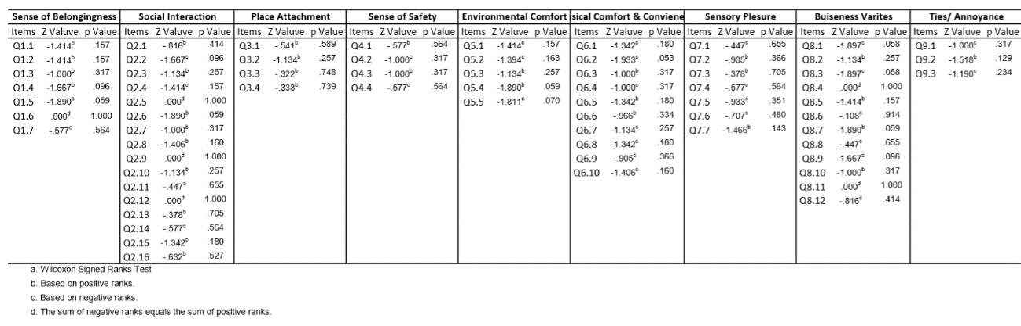
Table 3.4 Analysing and selecting the statements in Delphi
Item | Median |  | Interquartile Range |  | Top Two bands  (rank 5 and 4) of preference in % |  | Aggregate preference in % | Remarks
 | Round 1 | Round 2 | Round 1 | Round 2 | Round 1 | Round 2
Sense of Belonging
Q1.1 | 5.0 | 5.0 | 1.0 | 1.0 | 88.9 | 100.0 | 94.4 | Selected
Q1.2 | 3.0 | 3.0 | 1.5 | 1.0 | 33.3 | 33.3 | 33.3 | Not Selected
Q1.3 | 4.0 | 5.0 | 2.0 | 1.5 | 66.7 | 77.8 | 72.2 | Selected
Q1.4 | 3.0 | 4.0 | 1.5 | 1.5 | 77.8 | 88.9 | 83.3 | Selected
Q1.5 | 4.0 | 3.0 | 0.5 | 1.0 | 55.6 | 22.2 | 38.9 | Not Selected
Q1.6 | 3.0 | 3.0 | 0.5 | 0.0 | 22.2 | 11.1 | 16.7 | Not Selected
Q1.7 | 3.0 | 0.5 | 3.0 | 1.0 | 11.1 | 0.0 | 5.6 | Not Selected
Social Interaction
Q2.1 | 3.0 | 3.0 | 1.0 | 1.0 | 44.4 | 33.3 | 38.9 | Not Selected
Q2.2 | 4.0 | 5.0 | 1.5 | 1.0 | 77.8 | 100.0 | 88.9 | Selected
Q2.3 | 4.0 | 5.0 | 1.0 | 1.0 | 88.9 | 100.0 | 94.4 | Selected
Q2.4 | 5.0 | 5.0 | 1.0 | 0.0 | 100.0 | 100.0 | 100.0 | Selected
Q2.5 | 4.0 | 5.0 | 1.0 | 1.5 | 100.0 | 77.8 | 88.9 | Selected
Q2.6 | 4.0 | 4.0 | 1.0 | 1.0 | 77.8 | 100.0 | 88.9 | Selected
Q2.7 | 3.0 | 3.0 | 1.0 | 0.0 | 33.3 | 11.1 | 22.2 | Not Selected
Q2.8 | 4.0 | 4.0 | 1.5 | 1.0 | 77.8 | 55.6 | 66.7 | Not Selected
Q2.9 | 4.0 | 4.0 | 1.0 | 1.0 | 88.9 | 88.9 | 88.9 | Selected
Q2.10 | 3.0 | 3.0 | 1.0 | 1.0 | 22.2 | 0.0 | 11.1 | Not Selected
Q2.11 | 5.0 | 5.0 | 1.0 | 1.0 | 88.9 | 100.0 | 94.4 | Selected
Q2.12 | 3.0 | 3.0 | 1.5 | 1.0 | 44.4 | 44.4 | 44.4 | Not Selected
Q2.13 | 3.0 | 4.0 | 1.0 | 1.0 | 44.4 | 66.7 | 55.6 | Not Selected
Q2.14 | 5.0 | 5.0 | 1.0 | 0.5 | 100.0 | 100.0 | 100.0 | Selected
Q2.15 | 4.0 | 5.0 | 1.0 | 0.5 | 100.0 | 100.0 | 100.0 | Selected
Q2.16 | 4.0 | 4.0 | 2.0 | 0.5 | 66.7 | 100.0 | 83.3 | Selected
Place Attachment
Q3.1 | 4.0 | 5.0 | 1.5 | 1.0 | 77.8 | 88.9 | 83.3 | Selected
Q3.2 | 4.0 | 4.0 | 1.0 | 1.5 | 100.0 | 77.8 | 88.9 | Selected
Q3.3 | 3.0 | 3.0 | 2.0 | 2.0 | 33.3 | 33.3 | 33.3 | Not Selected
Q3.4 | 4.0 | 3.0 | 2.0 | 1.0 | 55.6 | 33.3 | 44.4 | Not Selected
Sense of Safety
Q4.1 | 3.0 | 3.0 | 1.0 | 0.5 | 33.3 | 22.2 | 27.8 | Not Selected
Q4.2 | 5.0 | 5.0 | 1.0 | 0.5 | 100.0 | 100.0 | 100.0 | Selected
Q4.3 | 5.0 | 5.0 | 0.5 | 1.0 | 100.0 | 100.0 | 100.0 | Selected
Q4.4 | 5.0 | 5.0 | 0.5 | 0.0 | 100.0 | 100.0 | 100.0 | Selected
Environmental Comfort
Q5.1 | 4.0 | 5.0 | 1.0 | 1.0 | 88.9 | 100.0 | 94.4 | Selected
Q5.2 | 3.0 | 4.0 | 1.0 | 1.5 | 55.6 | 100.0 | 77.8 | Selected
Q5.3 | 5.0 | 4.0 | 1.0 | 1.0 | 100.0 | 88.9 | 94.4 | Selected
Q5.4 | 4.0 | 5.0 | 1.5 | 1.0 | 77.8 | 100.0 | 88.9 | Selected
Q5.5 | 3.0 | 4.0 | 1.0 | 1.0 | 66.7 | 100.0 | 83.3 | Selected
Physical Comfort & Convenience
Q6.1 | 4.0 | 4.0 | 0.5 | 0.5 | 77.8 | 100.0 | 88.9 | Selected
Q6.2 | 4.0 | 4.0 | 1.0 | 1.0 | 55.6 | 100.0 | 77.8 | Selected
Q6.3 | 3.0 | 3.0 | 0.5 | 1.0 | 22.2 | 11.1 | 16.7 | Not Selected
Q6.4 | 3.0 | 3.0 | 1.0 | 1.0 | 11.1 | 22.2 | 16.7 | Not Selected
Q6.5 | 4.0 | 3.0 | 1.0 | 0.5 | 55.6 | 22.2 | 38.9 | Not Selected
Q6.6 | 3.0 | 3.0 | 1.0 | 0.5 | 22.2 | 0.0 | 11.1 | Not Selected
Q6.7 | 4.0 | 5.0 | 1.0 | 1.0 | 88.9 | 88.9 | 88.9 | Selected
Q6.8 | 4.0 | 5.0 | 1.0 | 0.5 | 100.0 | 100.0 | 100.0 | Selected
Q6.9 | 4.0 | 4.0 | 1.5 | 1.0 | 66.7 | 88.9 | 77.8 | Selected
Q6.10 | 4.0 | 5.0 | 1.5 | 0.5 | 77.8 | 100.0 | 88.9 | Selected
Sensory Pleasure
Q7.1 | 4.0 | 4.0 | 1.0 | 1.0 | 100.0 | 100.0 | 100.0 | Selected
Q7.2 | 4.0 | 3.0 | 1.0 | 1.0 | 55.6 | 33.3 | 44.4 | Not Selected
Q7.3 | 5.0 | 4.0 | 1.0 | 1.0 | 88.9 | 100.0 | 94.4 | Selected
Q7.4 | 5.0 | 5.0 | 1.0 | 1.0 | 100.0 | 100.0 | 100.0 | Selected
Q7.5 | 4.0 | 4.0 | 1.0 | 2.0 | 55.6 | 66.7 | 61.1 | Not Selected
Q7.6 | 5.0 | 5.0 | 1.0 | 1.0 | 88.9 | 100.0 | 94.4 | Selected
Q7.7 | 4.0 | 3.0 | 1.0 | 0.5 | 66.7 | 11.1 | 38.9 | Not Selected
Business varieties
Q8.1 | 4.0 | 5.0 | 0.5 | 1.0 | 77.8 | 100.0 | 88.9 | Selected
Q8.2 | 4.0 | 3.0 | 1.0 | 0.0 | 55.6 | 11.1 | 33.3 | Not Selected
Q8.3 | 4.0 | 5.0 | 2.0 | 1.0 | 66.7 | 100.0 | 83.3 | Selected
Q8.4 | 3.0 | 3.0 | 1.0 | 1.0 | 33.3 | 33.3 | 33.3 | Not Selected
Q8.5 | 4.0 | 5.0 | 1.5 | 1.0 | 88.9 | 88.9 | 88.9 | Selected
Q8.6 | 3.0 | 3.0 | 1.0 | 1.5 | 33.3 | 44.4 | 38.9 | Not Selected
Q8.7 | 4.0 | 5.0 | 1.5 | 1.0 | 77.8 | 100.0 | 88.9 | Selected
Q8.8 | 5.0 | 5.0 | 1.0 | 1.0 | 100.0 | 100.0 | 100.0 | Selected
Q8.9 | 4.0 | 5.0 | 2.0 | 1.0 | 66.7 | 100.0 | 83.3 | Selected
Q8.10 | 5.0 | 4.0 | 1.0 | 1.0 | 100.0 | 100.0 | 100.0 | Selected
Q8.11 | 3.0 | 3.0 | 0.5 | 0.5 | 22.2 | 22.2 | 22.2 | Not Selected
Q8.12 | 5.0 | 5.0 | 1.0 | 1.0 | 88.9 | 100.0 | 94.4 | Selected
Ties/ Annoyance
Q9.1 | 3.0 | 3.0 | 1.0 | 1.0 | 33.3 | 44.4 | 38.9 | Not Selected
Q9.2 | 4.0 | 5.0 | 1.5 | 1.0 | 77.8 | 100.0 | 88.9 | Selected
Q9.3 | 3.0 | 4.0 | 1.0 | 2.0 | 44.4 | 55.6 | 50.0 | Not Selected
Bold values represent the values within cut-off range and shading represent the selected items

Inferences
Focus group survey has helped in understanding the significance of various active and passive motives to visit the neighbourhood commercial street; Also, the activities and type of engagements along with the physical and environmental characteristics of the street which supports and encourage their visits and interactions. It has also been realised that opportunities for interaction with street or other people are primarily derived from activities or use of the spaces present over there. Thus, apart from opportunities for interaction, it is also necessary to identify the factors determining the uses of spaces over the street, i.e. the number of users, types of use and frequency of use of those spaces. Hence, apart from the context, there is a need of exploring all types of activities that are being performed at neighbourhood commercial street at Lucknow. Moreover, with the help of expert opinion survey covering all possible dimensions of preferred third place with sufficient consensus, an extensive list of statements (forty-two items) has been framed to derive final contextual framework for preferred third place at neighbourhood commercial street at Lucknow.

Evaluative framework for perceived attributes of the built environment setting
To any neighbourhood development, the surrounding built environment has the key to success because outdoor built environment of any area is like a living area of any residence, which must be vibrant, beautiful, barrier free, welcoming in nature, in respect to physical parameters, aesthetics and, finishes. To achieve the better built environment of any setting in urban realm, urban designers and architects are always deeply concerned for better physical characteristics (Bentley, Alcock, Murrain, McGlynn, & Smith, 1985; Carmona, Heath, Oc, & Tiesdell, 2010; Krier, 1991; Cullen, 2012; Bacon, 1967; Zucker, 1970). More recently, by fetching the knowledge from research conducted in the social and behavioural sciences, and environmental psychology, urban designers have accentuated numerous perceptual qualities that affect peoples’ choice of environments. Comfortable microclimatic condition or protection from sun and wind may play a major role in determining use of outdoor spaces (Aggarwal, 2001; Chen, 2006; Gehl, Cities for people, 2010) and thus increases the opportunity of chance encounter may also help in strengthening social relations. Convenience of use or acceptable walking distance and barrier free environment includes the concept of accessibility and comfortable walking environment (Chen, 2006; Dempsey, 2009) could be another strong point in making a choice by the user. In terms of visual appearance, visual appearance tries to capture the aesthetic appeal factor of the interactional spaces that may regulate the use (Chen, 2006; Dempsey, 2009; Gehl, Cities for people, 2010; Skjaeveland, Gilding, & Maeland, 1996). Maintenance and management are very important attribute of any interactional space (Chen, 2006; Dempsey, 2009; Hoogland, 2000; Yau, 2010). Cullen (2012) has indicated that with better maintenance and management of built environment the number of friends and acquaintances of the user may increase.
With the increasing form of literature in urban design there is an increasing number of attributes of the built environment that are considered to be important in determining the quality of the built environment, and hence its use. These characteristics now include physical and land-use characteristics and aspects of control and management of the environment (Mehta, 2006). Rapoport identified technology, safety, environmental variables, climate and weather, topography, distance, presence and availability of services, culture, and physical and perceptual characteristics as factors affecting the pedestrian use of streets (Rapoport A. , 2013). In a review of literature on only the perceptual factors, Ewing (Ewing, Clemente, Handy, Brownson, & Winston, 2006) identified 52 qualities of the environment. Working with an expert panel of urban designers, they studied nine of the most comprehensive perceptual qualities that may be appropriate to attract people over the area and make the street walkable and live; each of which was a result of tens of physical characteristics of the built environment. In totality, there are likely scores of macro- and micro-scale characteristics that affect people’s attitudes, preferences, and decisions to use a built environment.
Since, this part of the study is concerned with the micro scale physical characters tics, while other macro scale parameters over the study area i.e. all three neighbourhood commercial streets, Bhootnath, Gole market and, Kapoorthala market; are same and constant all through and hence not influence the study of micro scale physical characteristics in particular. In previous studies, literature review has helped to identify the variety of characteristics which are known to be important for users to any public space, further, direct, indirect observation along with field inventory and photographs, videos were taken and, a behavioural mapping of the study area has been carried out. Interviews and surveys have supplemented the study. All together they provided a frame of empirical evidence on the aspects of the street environment that contributed to retaining people on neighbourhood commercial streets and supporting social interaction. Along with all these aspects, certain aspects were also indicated during observation and interview, which make/provide users a sense of comfort, interest and, meaning in their stationary, sustained, and lingering activities, and social interaction. Responsiveness of the space is directly connected to the elements of design and their association; Ian Bentley suggested that, .... built environment should provide its users with an essentially democratic setting, enriching their opportunities by maximising the degree of choice available to them (Bentley, Alcock, Murrain, McGlynn, & Smith, 1985). The characteristics like permeability, richness, volume scale of the space in respect to user, enclosure level, enclosure type, visual accessibility and focal points of the spaces etc. are the important characteristics which turn user for any stationary, sustained and lingering activities and help them to feel interesting, comfortable and, meaningful. This part of the study limited its attention to the characteristics related to this realm of user-attention.

Measuring Characteristics of Settings
A list of characteristics (Table 3.5) was framed based on literature review, survey and interviews which were conducted by the author. These are the characteristics which make user feel interesting, comfortable and, meaningful; and turn them for stationary, sustained and lingering activities. Most of the characteristics are objective based, means they will be measured in in terms of number or will be done on Likert scale (see appendix C), but few are of subjective type to be measured by the urban designer and architects. For subjective type of characteristics, one urban designer and one architect were assigned to do the measurement while author has visited the whole stretch of street and assess and verify the measurement done by the team further, the average value has been calculated from both the readings. Since the measuring index of third place is liveliness of the street and that was in range between one to ten for all block segments to establish a correlation in SPSS, and measurement of this subjective characteristics were in form of numeric values or percentage, so it has been converted to decimal numeric, like 63% score was converted into 6.3 score.
Table 3.5 Selected characteristics of the street environment
Sl. No | Street characteristics
1 | Variety of goods and services
2 | Permeability of street wall façade
3 | Personalization of the façade
4 | Street wall façade articulation
5 | Foreground cover under shade or shadow
6 | Number of community places
7 | Sense of safety after dark
8 | Availability of seating or sitting spaces
9 | Availability of other street furniture and physical artefacts
10 | Cleanness status of the area
11 | Pedestrian centred strategies and condition

Data collection and techniques
Focus group survey has helped in understanding the significance of physical and environmental characteristics in frequent face to face interaction and other activities for better social and psychological relations over the street. It has also been realised that opportunities for social and psychological relations are primarily derived from activities or use of the spaces. Thus, apart from opportunities for social and psychological relations, it is also necessary to identify the factors determining the uses of spaces, i.e. the number of users, types of use, frequency of use of those spaces and, their time duration of any use/ activity, along with reasons behind those observations.
For above observations and reading, mixed-method strategy of inquiry and data analysis (Creswell, 2014) has been adopted for both qualitative as well as quantitative data. During enquiry, qualitative and quantitative data were collected simultaneously and merged at the time of analysis to add dimension to the findings. For data collection, variety of techniques including direct observation reinforced by field notes, snapshots, videos; walk-by observation; pedestrian counts; as well as survey and interviews of the people involved in any activity over the neighbourhood commercial street taken as case, were employed. It is suggested that a design of survey is very important in such type of research because it is useful when investigators want to find out in detail about a phenomenon (Zeisel, 1984). Additionally, case-study provides useful knowledge to suggest possible relationship between various factors (Yin, 2003; Zeisel, 1984), in other words, without context and visual observation, qualitative research has no meaning; qualitative research lives and breathes through seeing the context (Miles & Huberman, 1994).
Hence, by employing a mixed-method strategy using qualitative and quantitative methods, the research attempted to be exploratory and inductive, as well as confirmatory and deductive. “Quantitative research excels at summarizing large amounts of data and reaching generalizations based on statistical projections. Qualitative research excels at ‘telling the story’ from the participant's viewpoint, providing the rich descriptive detail that sets quantitative results into their human context.” (Trochim, 2004).

Behavioural mapping
Behaviour mapping has always been considered as a powerful tool for understanding the qualitative phenomenon of social research (Gehl, 1987). The purpose of this tool is recording the range of activities conducive to specific settings. In this research behaviour observation was used to understand the types of activities and intensity of use of various spaces either as part of their daily functional activities or for any recreational purpose. Also, the time duration in which they were engaged in various activity on the street.
Behavioural mapping links the design feature of the setting or location with behaviour in both time and space (Bechtel & Zeisel, 1987). The behaviour mapping of this study includes pedestrian counts, walk-by observations, and direct observations; and was conducted in accordance with five elements suggested by Ittelson (1970): (i) A graphic rendering of the area (s) observed; (ii) A clear definition of the human behaviours observed, counted, described, and diagrammed; (iii) A schedule of repeated times during which the observation and recording takes place; (iv) A systematic procedure followed in observing; (v) A coding and counting system, which minimizes the effort required in recording observations (Bechtel & Zeisel, 1987). Other survey techniques in behavioural mapping were directly adopted from the procedure followed by a recent researcher of this field Mehta, V. in behavioural mapping part of his research (Mehta, 2006).

Observation period
Observation has been made during September to November 2016, which was also the pleasant season of Lucknow, temperature was in between 26℃ to 32℃ with relative humidity between 55%-85% and wind velocity was 4-8 km/hrs. Cloud were passing, while, no observation has been made during rain over the street. Observation were carried out randomly at blocks and block segment level from 8:00 AM to 11:00 PM in weekdays and weekends.

Duration of stay intervals
The studies regarding observed time span for behaviour observation in public place done so far indicates the duration of activities recorded in five-minute intervals (Eubank-Ahrens B. , 1991). Since in Lucknow, the population is quite high and in result crowd over the streets too, while facilities like proper sitting spaces, benches, sheds, canopies are almost missed; also, it has been noticed that significant number of people were just staying there for a short time even less than a minute; so, in this case, it was considered important to record this duration of stay as a separate category. As a result, 15 seconds to less than one minute was added as one of the categories to record duration of stay.

Determining optimal size of block-segment
It has been noticed that within one block, activities are changing, even some part has no activity at all and are almost blank. It was better to reduce the large block module size to 55-60 foot in length, so that concentration over the blocks can be made and the survey could be carried out without loss of any valuable information. With this approach time could be saved to take two adjacent blocks segments with very high level of activity as well as very low level of activity.

Reliability of observations
Though, pedestrian counts, walk by observations, and direct observations were carried out manually by the author, but at the same time in same setting video shorts were also taken to check the discrepancies. This technique has been adopted for each time slot for each block/ block segment of the neighbourhood commercial street. After each survey, it has been cross-checked and validated. 1-2% of marginal error has been found specially in peak hours pedestrian count, the other point was regarding age of the user, it was difficult to judge the age of few female users if they were in a burka. Both the incongruities were considered within acceptable limit hence insignificant to their effect on the research.

Pedestrian counts
Author counted all pedestrian with the technique of screen line, which was imaginary marked to check the crossings of user in both the directions at block level. Along with this, two cameras were adjusted to capture the movements and obviously the counts in both the directions over the block. The time slot for each recording were taken for 10-15 minutes and, at the end of the slot, data taken by both the modes were cross verified. Further these data were converted into hourly pedestrian volume at each screen line and finally at blocks level.
Table 3.6 Codes for pedestrian counts in walk-by observations, and direct observations
Assigned Code | Description
1 | Adult male (approximately 20 to 60 years)
2 | Adult female (approximately 20 to 60 years)
3 | Older adult male (approximately over 60 years)
4 | Older adult female (approximately over 60 years)
5 | Teenager (approximately 13 to 19 years)
6 | Child (approximately less than 12 years)
In manual mode, different codes have been allotted for distinct population category as listed (Table 3.6, Table 3.7), with the help of allotted codes, size of each category were noted. The data survey was conducted 11 times each on weekdays and weekends (Table 3.8).
Table 3.7 Symbols used in recording pedestrian counts
Symbols | Description
J | Running/jogging
C | Cycling (on the sidewalk)
P | Walking pets
Sk | Skateboarding or rollerblading
Pr | Pushing a stroller

Table 3.8 Schedule of pedestrian counts for behavioural mapping for the three study areas
Pedestrian Counts
Weekdays | Weekends
8 AM – 9 AM
9 AM – 10 AM | 9 AM – 10 AM
10 AM – 11 AM | 10 AM – 11 AM
12 PM – 1 PM | 12 PM – 1 PM
1 PM – 2 PM | 1 PM – 2 PM
4 PM – 5 PM | 4 PM – 5 PM
5 PM – 6 PM | 5 PM – 6 PM
6 PM – 7 PM | 6 PM – 7 PM
7 PM – 8 PM | 7 PM – 8 PM
8 PM – 9 PM | 8 PM – 9 PM
9 PM – 10 PM | 9 PM – 10 PM
 | 10 PM – 11 PM

Walk by observations
The main aim of this observation was to record the activities of user viz-a-viz stationary, sustained, lingering, and social activities. Author has attempted to record the conversation of the groups even, but was the tough task and people became conscious for the recording instrument and surveyor and did not behave naturally. In this case, audio recording has been eliminated from the survey design. For user activity observation, author slowly walked through the block till the end and record the location, activity and, posture of the user came across.
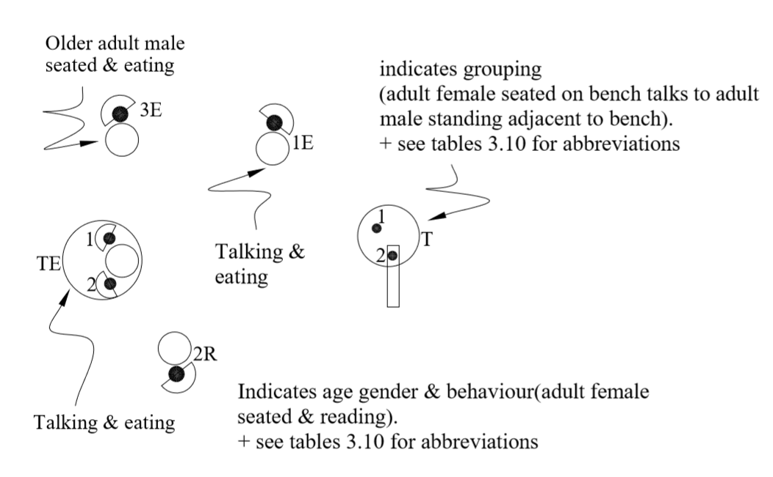
Figure 3.1 Notations used in walk-by observations to record behaviour and activities
For the mapping, location of the user was marked in plan and elevation of the block or block segment; activities were recorded with allotted symbols (Error! Reference source not found.) along with proper description on note sheets and location marks; various postures were assigned with a distinct code/ symbol (Table 3.10), that were marked on block plan with description sheet. Mapping and noting were also enabled with apparent age which was divided in four categories- children, teenagers, adults (approximately 20 to 60 years), and old age (approximately above 60 years). Walk by observations were conducted 15 times each on weekdays and weekends between 8:00 AM to 11:00 PM.

Table 3.9 Schedule of walk-by observations for behavioural mapping for the three study areas
Walk-by Observations
Weekdays | Weekends
8 AM – 9 AM | 8 AM – 9 AM
9 AM – 10 AM | 9 AM – 10 AM
10 AM – 11 AM | 10 AM – 11 AM
11 AM – 12 AM | 11 AM – 12 AM
12 PM – 1 PM | 12 PM – 1 PM
1 PM – 2 PM | 1 PM – 2 PM
2 PM – 3 PM | 2 PM – 3 PM
3 PM – 4 PM | 3 PM – 4 PM
4 PM – 5 PM | 4 PM – 5 PM
5 PM – 6 PM | 5 PM – 6 PM
6 PM – 7 PM | 6 PM – 7 PM
7 PM – 8 PM | 7 PM – 8 PM
8 PM – 9 PM | 8 PM – 9 PM
9 PM – 10 PM | 9 PM – 10 PM
10 PM – 11 PM | 10 PM – 11 PM

Table 3.10 Symbols used in recording walk-by observations and direct observations
Symbol | Description
L | Lying/sleeping
P | Walking pets
Sk | Skateboarding or Rollerblading
T | Conversing
Pr | Pushing a stroller
E | Eating/drinking
R | Reading or using a Laptop computer
Sh | Shopping
Ws | Window-shopping
G | Playing a game or Performing
Sm | Smoking
V | Vending

Direct observations and field notes
Direct observation was the most significant of all the techniques employed to collect behavioural information and was used in both a structured and unstructured manner. Human behaviour may be studied at different scales ranging from global or molar to molecular (Bechtel & Zeisel, 1987). Molecular human behaviour deals with the minute detailing in human behaviour like the minute gesture and expression of the user in any built setting while, molar behaviour is concerned with observing the actions of a limited number of people engaging with their environment. Since scale of molar behaviour is more concern to any environmental behaviour research, which involves the study of human behaviour in their environment. Direct observations were made to record the molar behaviour i.e. details about the activity performed by the user, their posture, kind of interaction, contacts among people, people interaction with the physical environment, and their duration of stay.

Structured direct observation
The main purpose of this observation is to detail description along with location, surrounding of the activity performed by the user. As previously noted, the three-neighbourhood commercial street of the study area were divided in 26 blocks. Each block was observed by the author concerning the activity of the users, detail description, location was marked on plan and elevation of the block, time duration of each activity performed by each individual were recorded as per the category (Table 3.11): 15 seconds to less than one minute, one minute to less than five minutes, five minutes to less than 10 minutes, 10 minutes to less than 15 minutes, and over 15 minutes, and corresponding score as given in Table 3.12 has assigned to every activity stay at each block/ block
Table 3.11 Notations for recording Duration of Stay of people on the street
Symbol | Description
 | 15 Second to 1 Minute
 | 1 Minute to 5 Minutes
 | 5 Minute to 10 Minutes
 | 10 Minute to 15 Minutes
 | More than 15 Minutes
Table 3.12 Assigned Score for Duration of Stay of the user
Duration of stay | Assigned Score
15 Second to 1 Minute | 01.0
1 Minute to 5 Minutes | 03.0
5 Minute to 10 Minutes | 07.5
10 Minute to 15 Minutes | 12.5
More than 15 Minutes | 15.0
segment over the street. The assigned scores were aggregated to arrive at a total score for duration of stay for each block-segment. Direct 15-minute observations of activities were conducted nine times each on weekdays and weekends at each block-segment in the three study areas (Figure 4.1).

Unstructured direct observation
During the previous surveys done, data has been recorded for pedestrian counts, walk-by observations, and direct observation which shows the detailing of activities took place by the people. All three neighbourhood streets with all the blocks and block segments were done with data by the author. The data collected so far clearly reveals an image of the block or block segment, but the opinion or viewpoint of the user is silent. In understanding environmental behaviour relationship, it is suggested that a research should provide “..about motives, you must have some word that names the act (names what took place, in thought or dead), and another that names the scene (the background of the act, he situation in which it occurred); also you must indicate what person or kind of person (agent) performed the act, what means or media he used (agency), and the purpose (Burke, 1945). With the previous observations, variables like what, where or when, who and with whom and, how, have been addressed but only one variable was missed ‘why’, which gained through the survey, interviews or questionnaires.

Survey and interview
To accomplish the gap discussed above, survey and interview instrument was used for - why people did what they were observed doing. Various options ae available for the survey and interview in research which includes telephone surveys, e-mail surveys, personal diaries, focus groups, and face-to-face interviews. Since the survey includes the visuals and activity photographs took place at the block, as well as user interview; it is found difficult to go with telephone, e-mail or any other option rather face to face interview which is an effective mode to get in-depth information to understand the users’ feelings, perceptions, and attitudes toward the street environments that were being observed in the three study areas. Though during focus group survey at time of formative research, few macro level information was recorded with the people present over the street, but for this, a separate interview with supplementary questions set (see Appendix C) were designed and presented to the active users of the neighbourhood commercial street of study area to get information about the user as, why they prefer to use certain blocks or block-segments more than others. This encompassed getting insight on users’ perceptions and attitudes toward the businesses and other uses on the blocks, their location, operation and management, and the physical characteristics of the environment including its management and maintenance.

Sampling
For the purpose of data collection, six teams of surveyors were deployed to follow the user and get it filled. Full effort has been given in designing the questionnaire. It was observed that average number of people were interested to fill especially the older age people. three old age and long associated people of the street gave time at their home residing in neighbouring areas. About four people were chased in café coffee day at Kapoorthala market who were the regular visitor of the street and got the sample form filled. Same as this, five people were chased at Rastogi stationaries at Bhootnath market to get the form filled and some other females were asked to fill the form who were engaged in mehndi at mehndi art vendor over Bhootnath area. At Gole market area, Ritz continental was the best spot where people usually came for gol-gappa and other snacks. A total of 61 samples recorded which was more than required sample size. From 61 samples, 23 were from Kapoorthala, 21 were from Bhootnath, and 15 were from Gole market area. An average time for interview was 25-35 minutes, while at home, CCD, or at mehndi art vendor it was long conversation specially for open ended questions. Care has been taken for recording data at each and every bock/ block segment of study area at neighbourhood commercial street.

Measuring Liveliness
Liveliness or lengthy stay used to represent any area in a comparative scale measurement. Once the activities in third place dimension were identified as, stationary, lingering, and sustained activities particularly those activities that are social in nature; were recorded through walk-by and direct observations. Using the data collected from walk-by and direct observations, a Liveliness Index was determined for each of the 88 block-segments by calculating 1) the number of people engaged in some stationary and sustained activity at the setting, 2) the number of people in groups of two or more engaged in some social activity, and 3) their duration of stay. The ultimate target is to get the stay duration of the total users engaged in stationary as well as in social activities as, ‘third place’ in context of neighbourhood commercial street is defined as a street with the presence of a number of people engaged in a variety of predominantly stationary, lingering, and sustained activities, particularly those activities that are social in nature.
As discussed earlier, observations were conducted and analysed at the scale of a block-segment that was 50 to 60 feet in length of block of the neighbourhood commercial street. The survey and questionnaire implored user responses at the scale of a street block. Hence, a Liveliness Index was also calculated for each street block to enable correlation between the user attitudes and perceptions and the liveliness of the street at the scale of the block. The results of the following measures were adjusted for the length of block (~200-foot length): 1) the number of people engaged in some stationary and sustained activity at the block, 2) the number of people in groups of two or more engaged in some social activity, and 3) their duration of stay.

Characteristics of respondents
Through review of literature, understanding of focus group survey, and interviews, a list of characteristics at individual level (respondent) has been identified, who were the active visitor of neighbourhood commercial street. Almost 1/3 of the respondents were from the neighbourhood areas while other were from the other nearby areas of Lucknow. Respondents were including residents of the neighbourhood area, vendors, workers, and visitors of the study area. Since Lucknow is an educational hub also, most of candidates from nearby districts were here for their coaching and preparation for competitive examination, are very active user of the street in study area. Structure of the respondents are listed in Table 3.13.
Table 3.13 Characteristics of respondents
Characteristics of respondent | Measurement type | Measurements
Speaking language | Descriptive | Hindi, Bhojpuri, English
Age | Categorical | 18-24; 25-29; 30-34;35-39; 40-44; 45-49; 50-54; 55-59; 60-64; 65-70
Gender | Categorical | Female; Male
Marital status | Categorical | Never married; Married; Widowed/widower; Separated
Education | Categorical | 5th-8th standard; 10th standard; 12th standard; Diploma/certificate; Graduate; Postgraduate; Professional; PhD
Occupation | Categorical | Student; Home maker; Retired; Service; Self-employed; Business

Selection of study area- Neighbourhood commercial street
All three neighbourhood commercial streets of the study area are located in Lucknow city, trans-Gomti area at 26.873º N 80.982ºE and, are the major commercial streets of the residential neighbourhoods. An attempt has been made to select blocks within study area where macro-scale characteristics including housing and commercial density of the area, type of people living in the area, proximity to natural magnets, cultural institutions, academic institutes, transport nodes and so on; would remain common or of same nature. Thus, the selected blocks in each of the study area were part of the same urban context as well as with similar micro-scale characteristics of the environment. The blocks selected within the study area are in about range of hundred fifty-meter diameters, so chances of variation in macro-scale factors amongst the blocks are least.
The selected streets comprise mostly the buildings of same age except few and have the age of 30-35 years of construction. The height of the buildings lies mostly from one to four storeys and have the usage of small independent local business to some outlets of a national chain. The selected study areas are considered for shopping, dining and entertainment destination by the people in and around the area.

Data Analysis Technique
Since the first objective of this research is to extract underlying structure among the variables and derive an appropriate contextual framework based on collected data from the literature and focus group survey for preferred third place designation at neighbourhood commercial street of Lucknow. Factor analysis has been seen as a method of data reduction and summarisation: take many variables and explain them with a few factors or components or dimensions (O'Rourke, Hatcher, & Stepanski, 2005). The common objective of factor analysis is to represent a set of variables in terms of a smaller number of latent variables. The analysis meets the demand of this research and its first objective; so, study has identified exploratory factor analysis (EFA) for testing the non-hypothesized factor structure (main difference with confirmatory factor analysis) and the relationship between observed and latent (unobserved) variables or factors that represent third place designation. This research included the concept of parallel analysis technique using parallel syntax engine (O'Connor, 2000) to identifying optimum number of factors to be retained rather eigenvalue consideration given by Kaiser (1960).

Reliability and validity of the model
There are few widely accepted reliability and validity measures of EFA that have been considered in this research:
- Factor loading represents the reliability of an item measuring a factor; if the standardised loading is more than 0.5 then the item is considered as reliable ( (Hair, Black, Babin, & Anderson, 2014).
- Cronbach’s alpha is a popular indicator of internal consistency of a measurement scale, and, has been followed as more than 0.7 (Nunnally, 1978).
- Composite reliability includes the extent of unexplained or error variance into the reliability measure and, it has been considered to be more than 0.7 (Fornell & Larcker, 1981).
CR= (Σλ_{i})² / [(Σλ_{i})²+(Σδ_{i})]
Where, λi= Standardized factor loading of ith item,
n= Number of items.
- Average variance extracted (AVE) by a factor is an indicator of convergence validity ( (Fornell & Larcker, 1981) by assessing the number of items measured by a factor ((≥0.4).
AVE= (Σλ_{i}²)/ n
Where, λi= Standardized factor loading of ith item,
n= Number of items.

Conclusion
This chapter has presented a case study based mixed method approach, adopted in this research. Following the qualitative methods in the formative research, it has summarized broad pool of items for measuring preferred third place designation from the Oldenburg’s theory, other related available literatures and focus group survey. Further, it has identified an appropriate contextual framework based on user perception for preferred third place designation over neighbourhood commercial street at Lucknow, and also the characteristics of the users as well as study area. Further, it has identified the perceived attributes of the built environment setting that may influence third place activities over the street and showed the approach to measure the liveliness of the area. Beside this, it has described the stages of data collection that includes not only the focus group survey but also behaviour observation including structured and un-structured observations. With the adoption of quantitative methods as final analysis techniques it specifies the reliability and validation approach to identify underlying factor structure of analysis in context of preferred third place designation.

Chapter 04: Characteristics of the Study Area

Chapter overview
This chapter introduces to the study area, exploring the characteristics of the neighbourhood commercial streets, and their respective blocks and block segments which has been identified for this research.

The Study areas
The area taken for the study and data extraction, were of the three neighbourhood commercial streets located in Lucknow city, trans-Gomti area at 26.873º N 80.982ºE. The city of Lucknow divides in two part by a river Gomti, namely the main city and trans-Gomti area. Its population is slightly less than main city area and is relatively more developed and have contemporary planning than main city. The population of this area is mostly migrated from other surrounding less developed cities. The area used mostly for residential purposes except few business centres at Indira Nagar, Gomti nagar and at Sitapur road (Figure 4.1). The all three study areas are well connected with city transit system and have similar macro level land uses.
All three streets studied are the major commercial street in the neighbourhood and are the oldest development having age of nearly 40-45 years. Almost all buildings have sidewalk with no set back in front with one to four storeys high. The occupancy of each floor is different and varied businesses. The taken study area may be classified as predominantly residential neighbourhoods with most of their daily commercial, cultural, entertainment and other amenities catered for by the businesses and other uses on the neighbourhood commercial streets. In addition, the people of surrounding and nearby areas, consider these destinations for shopping, dining, and entertainment.

Bhootnath Market
Bhootnath market area is a diverse, vibrant, and lively commercial area of the Indira nagar mixed-use development. Earlier at the time of planning, this was the first
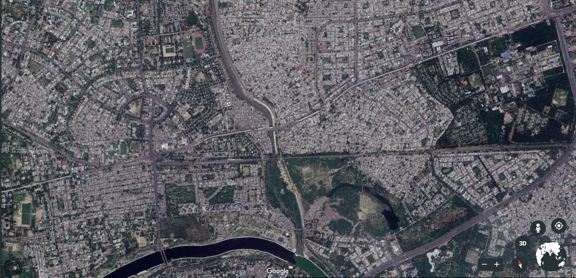
T r a n s – G o m t i a r e a, L u c k n o w
River Gomti
Kapoorthala market area
Gole market area
Bhootnath market area
Figure 4.1 Location plan- three study area in trans Gomti area of Lucknow
designated marketplace of the Indira nagar residential scheme planned by the Uttar Pradesh awas vikas parishad. With the growth in population of the area, and increasing demand of shopping needs, Bhootnath market area became large, and cater the whole surrounded area for their daily needs, amenities and other shopping demands. Currently a wide range of single and multi-family dwellings, various types and scales of retail, office, public and semi-public use can be found in and around the Bhootnath market area. A higher secondary school, a very famous religious place (temple) can be seen in its close proximity.
Bhootnath market stretch connects the Indira nagar church road and Faizabad road with its both ends, consisting four blocks at either side of the stretch. Complete stretch has the variety of food stores, local chain, national chain outlets, garments shops, stationary shops, pharmacies, flower shops, kid’s toys shops, bank, small offices, small raining institutes and many other chat corners with paan and cigarettes kiosks etc. in its block (Figure 4.3). An underground parking with a playground over its terrace is the major open space for the residents of the surrounding areas; other small tea stalls, fruit and vegetables karts, and other movable food stalls can be easily seen at its both sides. Also, the major transit stops like city bus, tempo stand, rickshaw stand is located at its both the end, while a station of metro rail transit system (MRTS) is also proposed at its one end over the Faizabad road (Figure 4.2).
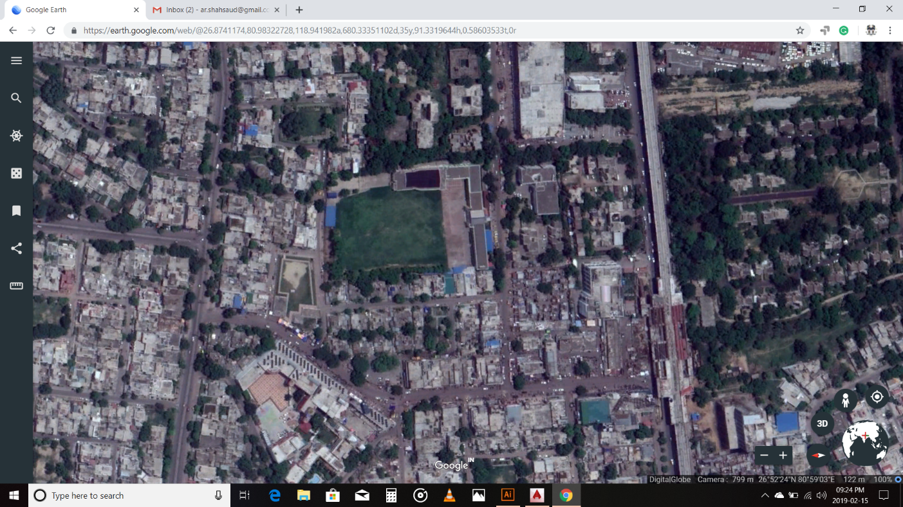
Figure 4.2 Satellite map of Bhootnath market area
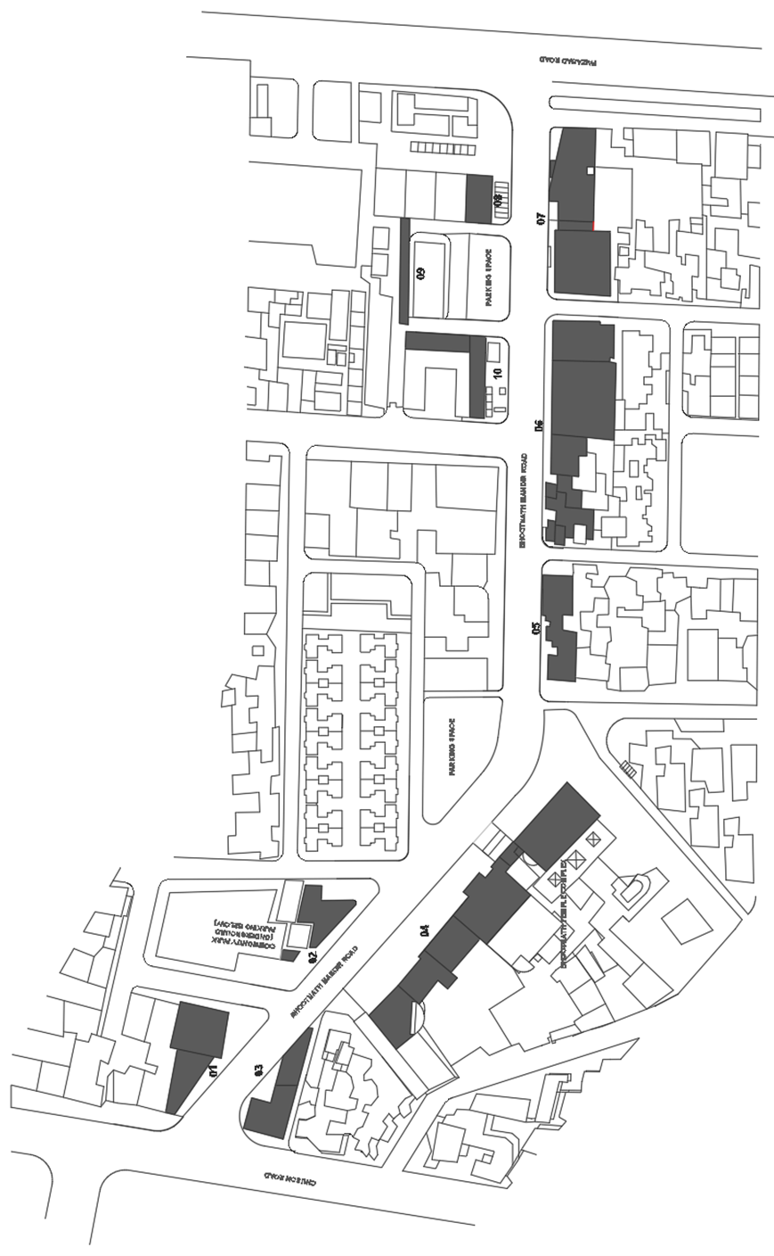
Figure 4.3 Map showing the ten blocks studied on Bhootnath market area
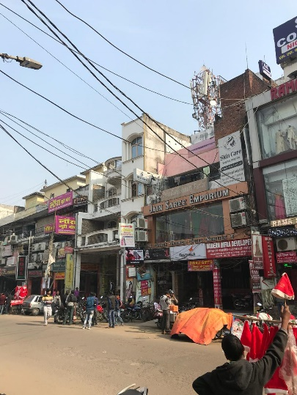 | 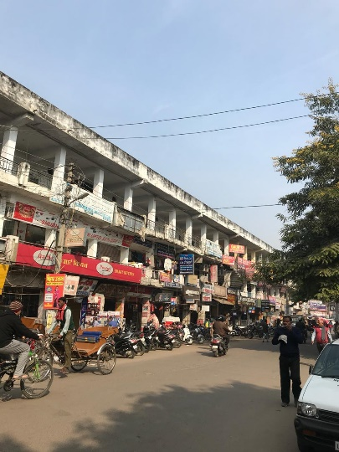 |  | 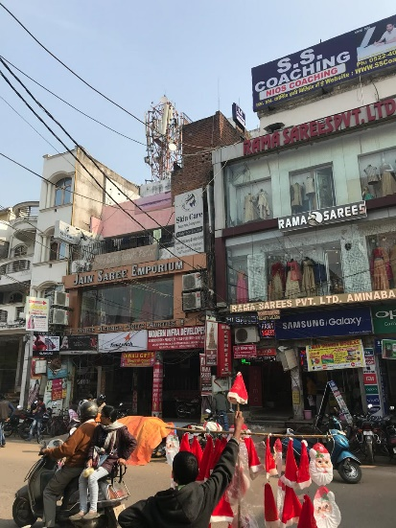
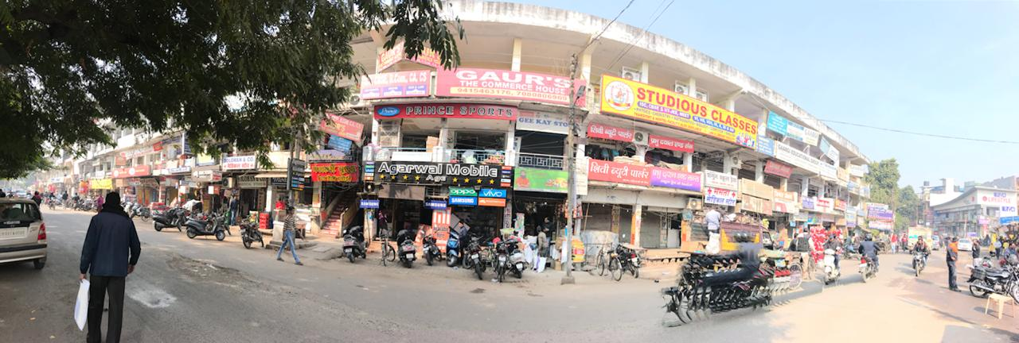
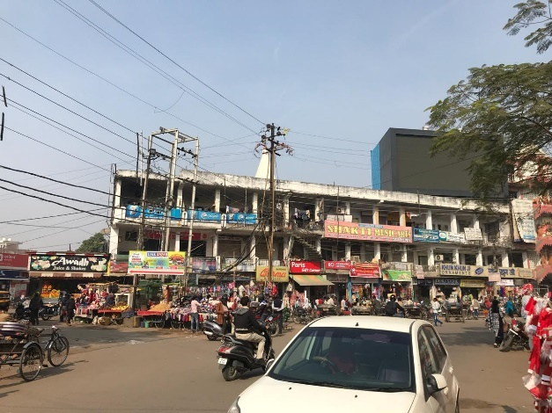 |  | 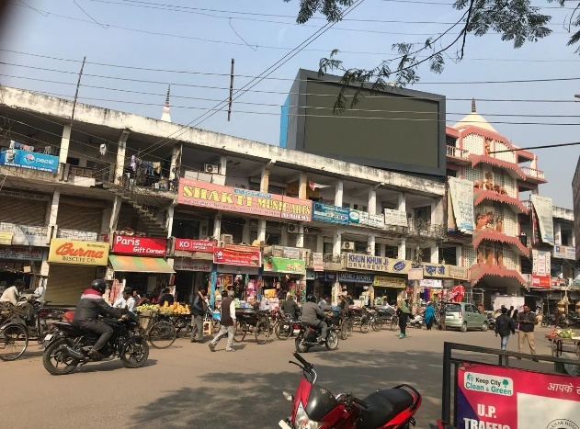
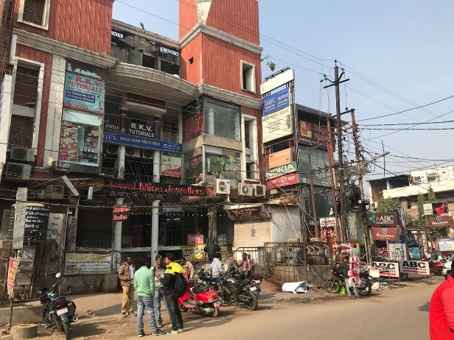 |  | 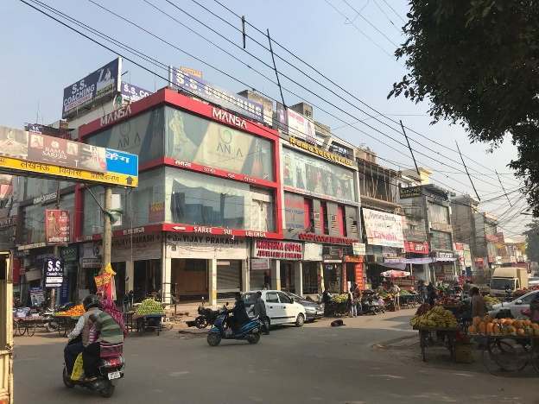
Figure 4.4 Views of the blocks on Bhootnath market area
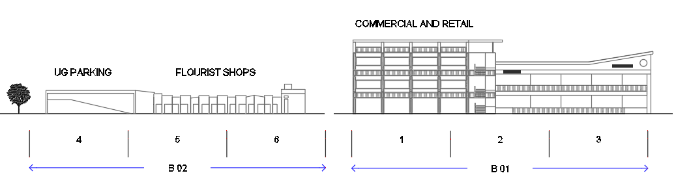
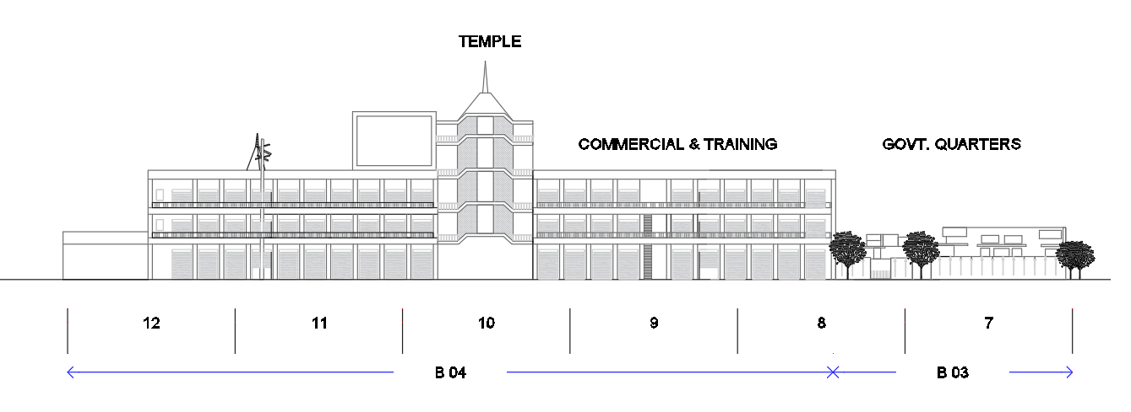
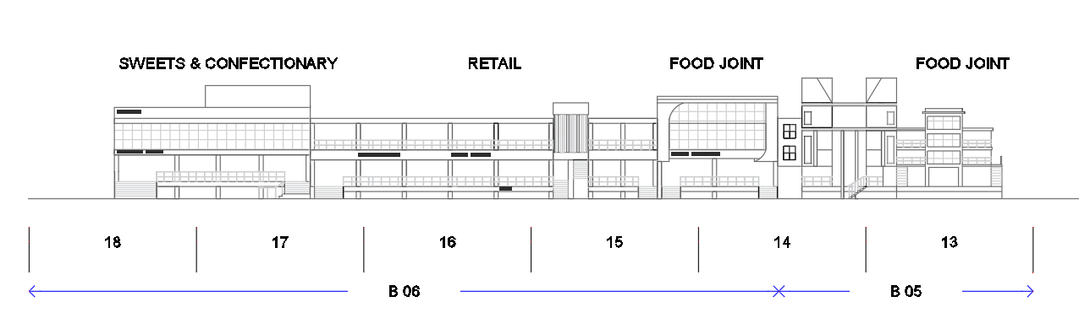
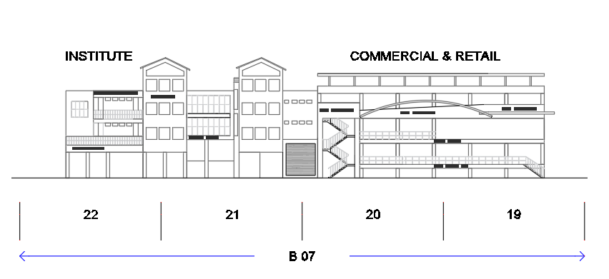
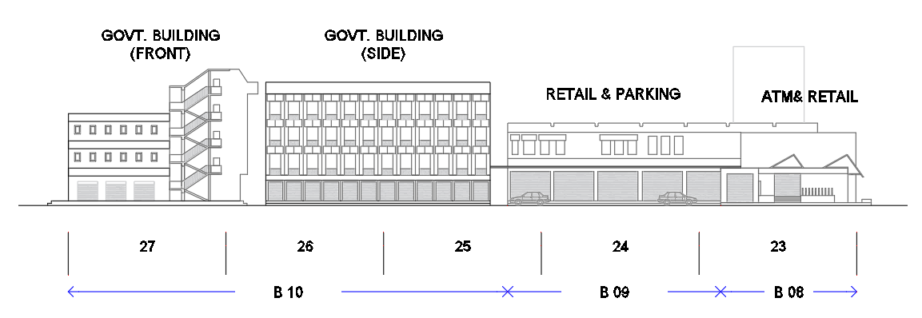
Figure 4.5 Drawing of the blocks studied on Bhootnath market area

Gole Market
Gole market is almost at the junction of Mahanagar colony which is a posh residential area of the Lucknow in a trans-Gomti area, and Nishatganj which is a mixed-use development having small dwellings and small-scale shops of multiple varieties including local zardozi shops, tailoring shops, mechanic garages and other grocery items retail etc... Since the market area is surrounded by the both types of residential impression, it turns into a local commercial hub for users of all the class and strata. Along with the high-end branded shops it consists of jewellery shops of varied brands, local retail chains, national retail chains, coffee shops, food joints, Bakery, garments shops, stationary shops, Gandhi ashram (fabric store), training institutions like typing, computer software’s, hardware’s, sweet shops, boutiques, ATM, banks, and other small offices. On every Wednesday this caters as venue for conventional bazar ‘Budh Bazar’ for mainly the economically weaker people but also have the items for daily usages in every house like ceramics items, flowerpots, mats, brooms and other likewise items.
Gole market is the node which connects Mahanagar at its one end, while Indira nagar, Faizabad road, Hazaratganj, Kapoorthala at its other end. At its east and west side, there are two higher secondary schools Mont Carmel girls’ school and Montfort inter college respectively. The connecting roads of this node are good in width with divider and side pathways for pedestrians, while at the blocks it is covered with single and double height veranda. There are five independent blocks are placed at island, surrounded by roads, in other side of the stretch it has two blocks and an underground parking space in between. The terrace of the underground parking is used as open public park for the peoples of the area. The blocks are single to three storeys high without any front setback or any kind of similar architectural features. The Gole market island is encircled by three nodes as Classic T Square, Gole Square, and a Mahanagar nursing home T. All the three nodes are fully encumbered with varied transit modes viz-a-viz tempo, city buses, E-Rikshaws etc... In a new development, Metro rail transit system corridor is also passing at a distance of about 100 meters from this area.
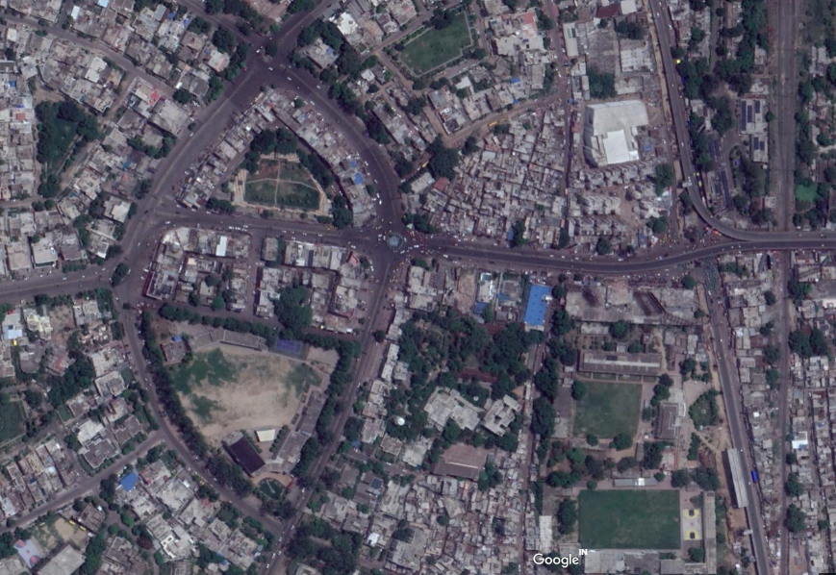
Figure 4.6 Satellite map of Gole market area

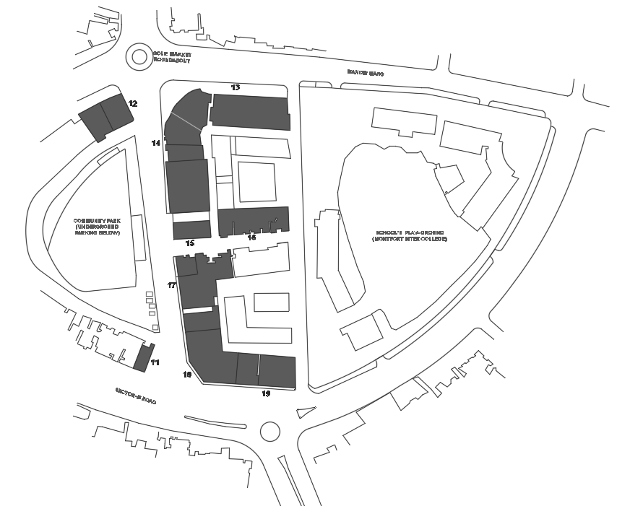
Figure 4.7 Map showing the ten blocks studied on Gole market area

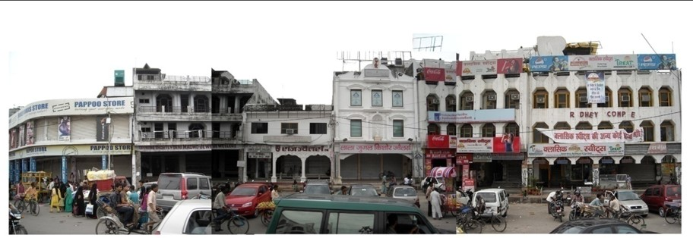
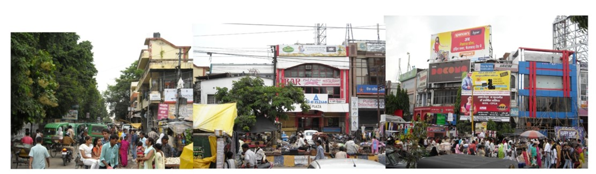
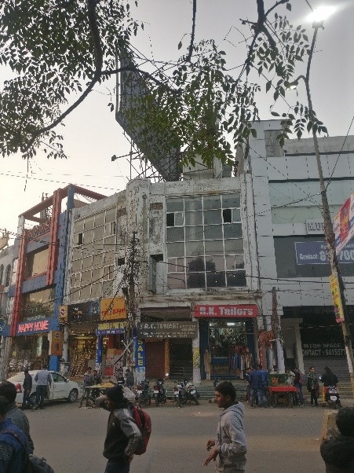 | 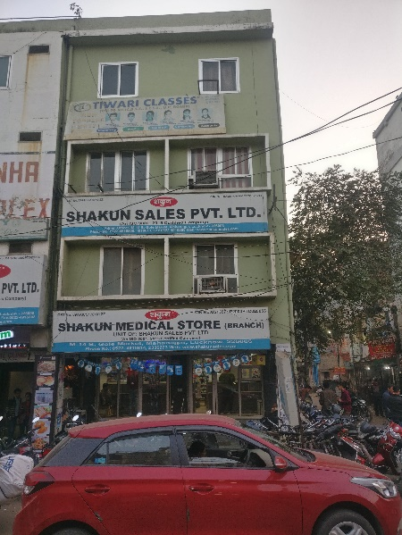 |  | 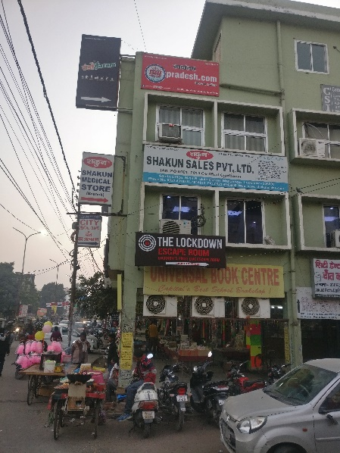
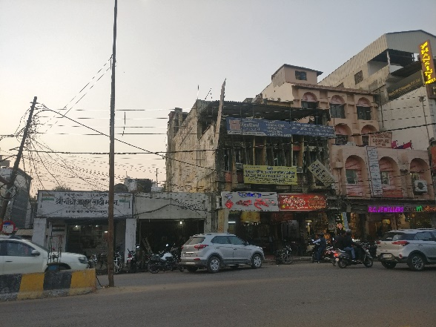 |  | 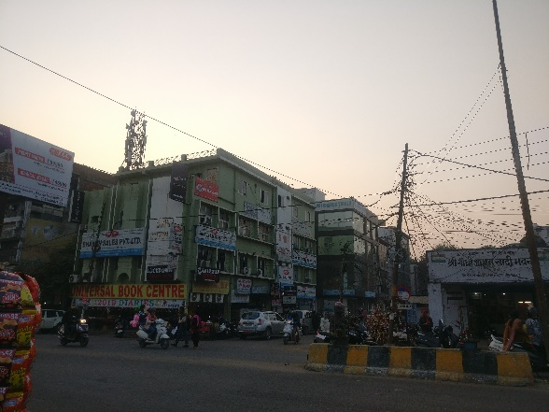
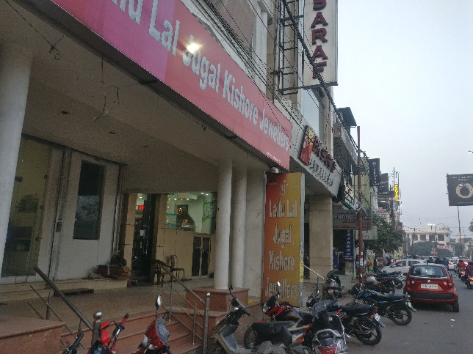 |  | 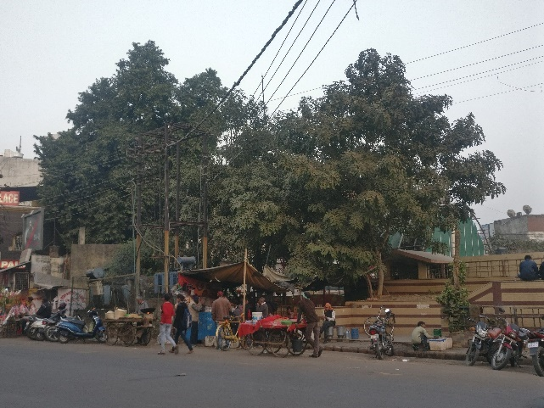
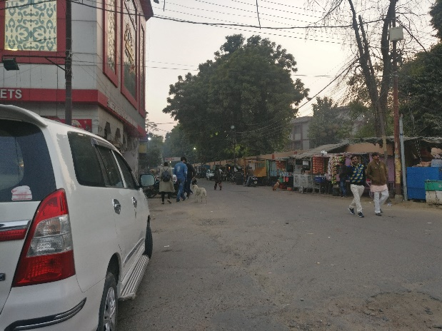 |  | 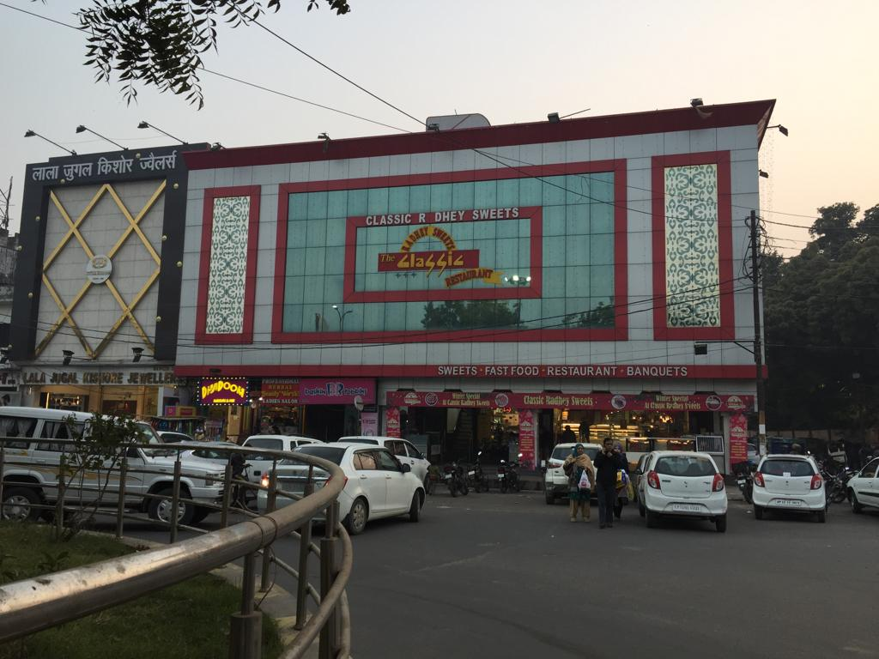
Figure 4.8 Views of the blocks on Gole market area

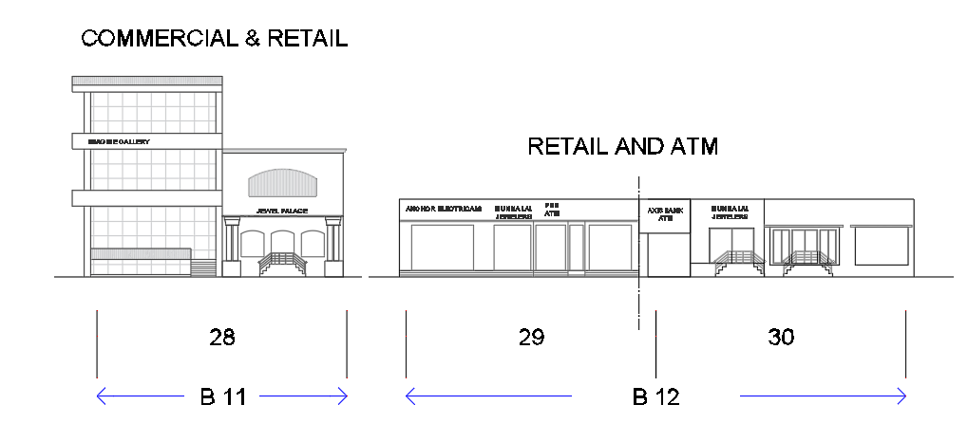
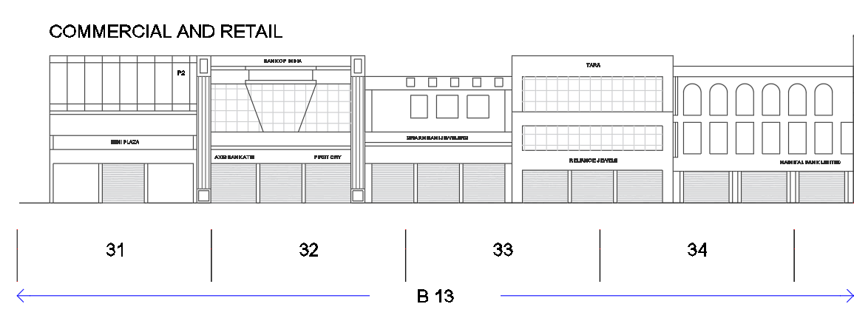
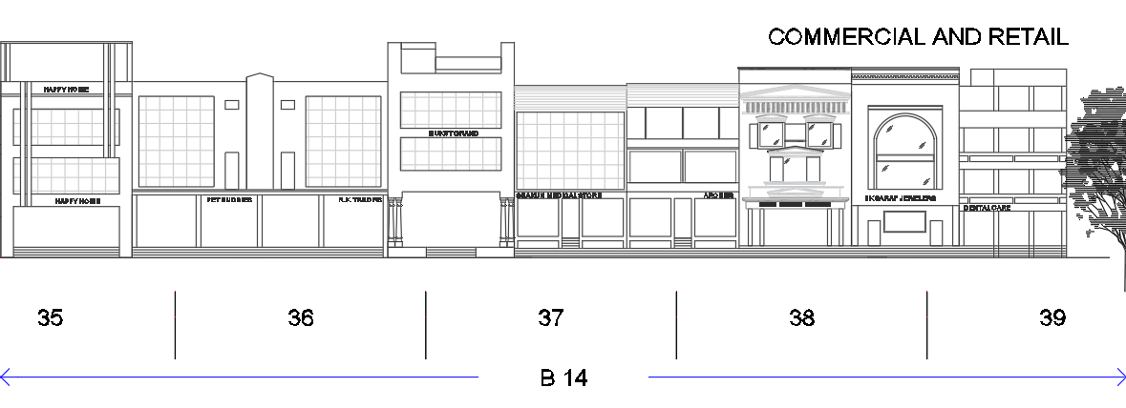
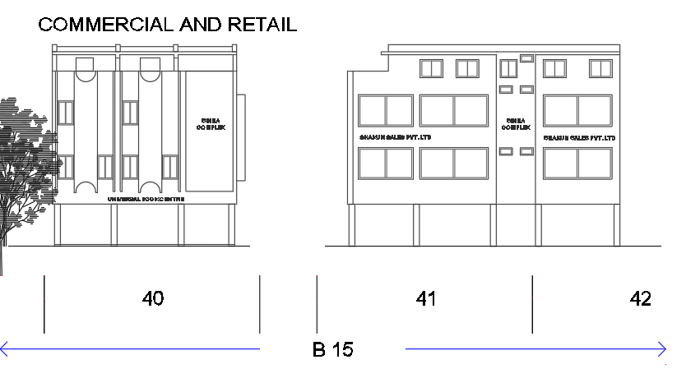
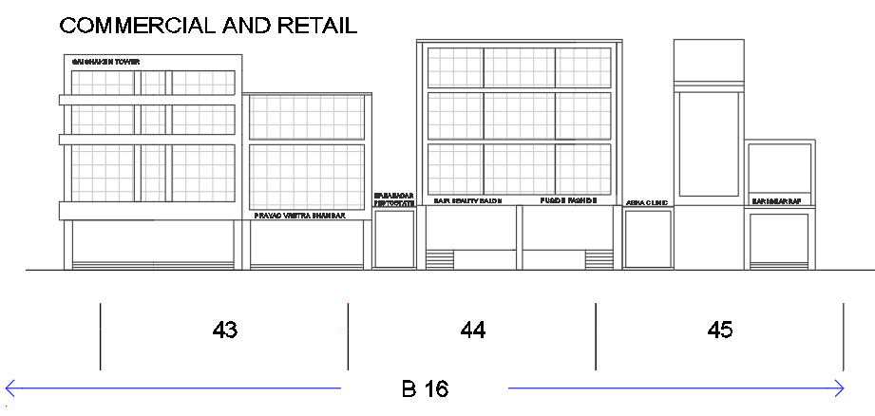
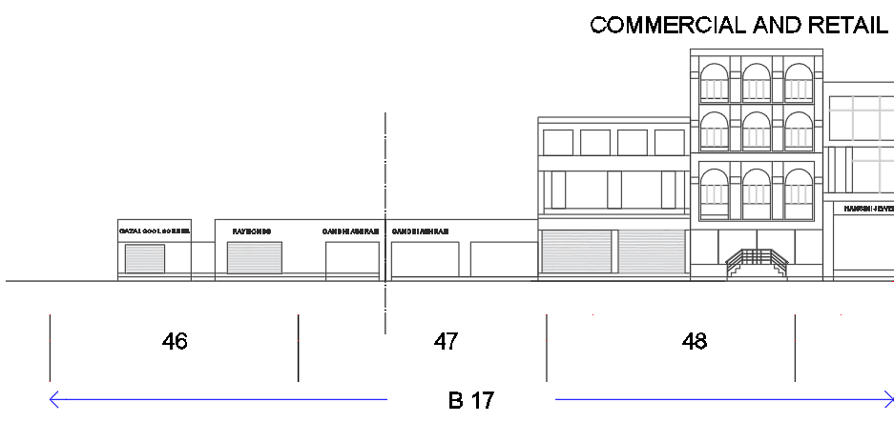
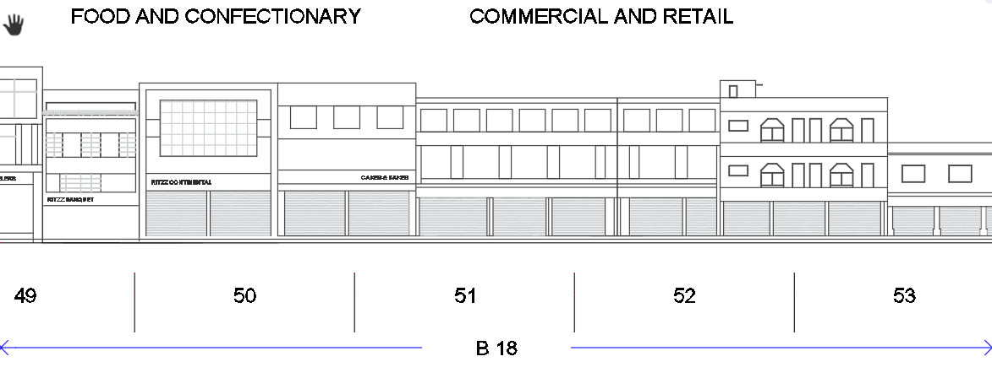
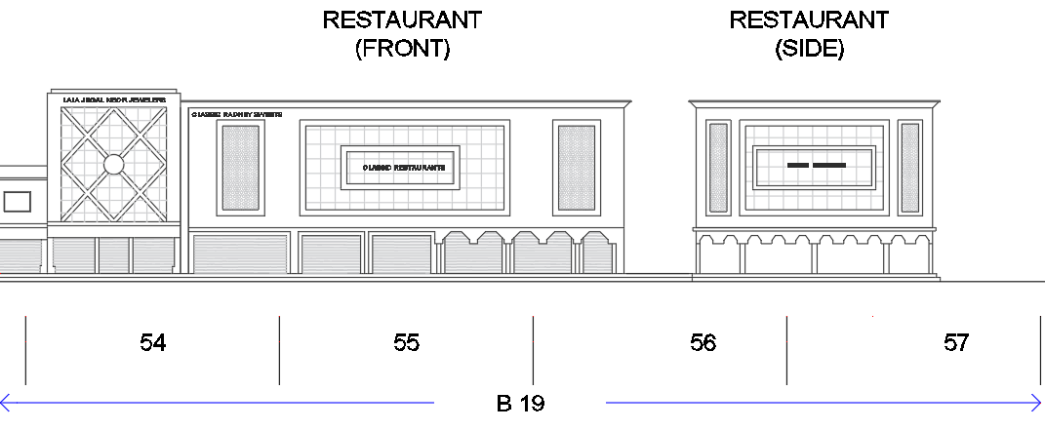
Figure 4.9 Drawing of the blocks studied on Gole market area

Kapoorthala Market
Like the Bhootnath market, this is also the oldest neighbourhood marketplace of the trans-Gomti area. Kapoorthala market comes into the Aliganj residential scheme, at the time of inception, head office of ‘Sahara India group’ along with its’ newspaper ‘Rastriya Sahara’ press unit was already there, beside these two buildings, development authority has proposed a small shopping complex along with local development authority’s maintenance office for their residential scheme. This market is well connected to Hazaratganj and Vikas Nagar through its Kursi road while, by Mandir Marg it goes to Gole market area and, via Kapoorthala road it connects to Aliganj main Marg. Major transit stops are here including local city buses, auto, tempo, e-rikshaw, manual rickshaw etc.
A variety of commercial, cultural, and entertainment establishments are located on Kapoorthala street. Between Kapoorthala square to Kapoorthala Jama masjid; there are five blocks at Sahara India Bhawan stretch while, six blocks are at Gita Vastralaya side, amongst these six blocks, three blocks are directly accessed from main Kapoorthala road while other three blocks are located at down lane of the main street.
Most of the blocks are established on this street are one to three storeys high except Sahara India Bhawan and Sahara India Press which are ten and six storeys respectively. Though, major part of the block one is occupied by the Sahara India itself but one fourth stretch of the first block and other three blocks have the variety of shops, outlets including coffee shops, fast food corners, stationary shops, bakeries, florists, photo studios, garments shops, mobile and computer hardware’s/ software’s, small offices, training institutes and so on (see Figure 00). Additionally, there is a single screen theatre at the back side of Sahar India Bhawan along with some print houses, coaching institutes and a major food joint (Tundey Kababi). Rest of the surrounding of this Kapoorthala market area is higher income group residential houses having gated enclosure with proper infrastructure and parks.

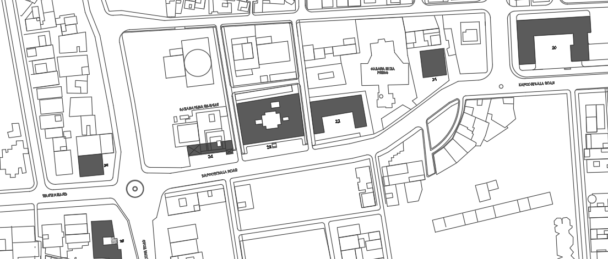
Figure 4.10 Map showing the ten blocks studied on Kapoorthala market area
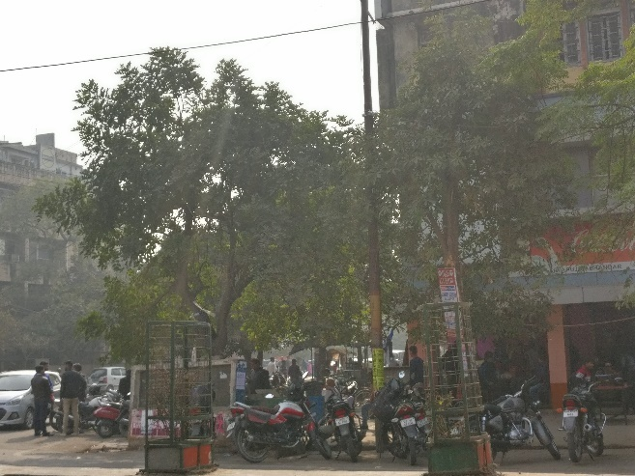 | 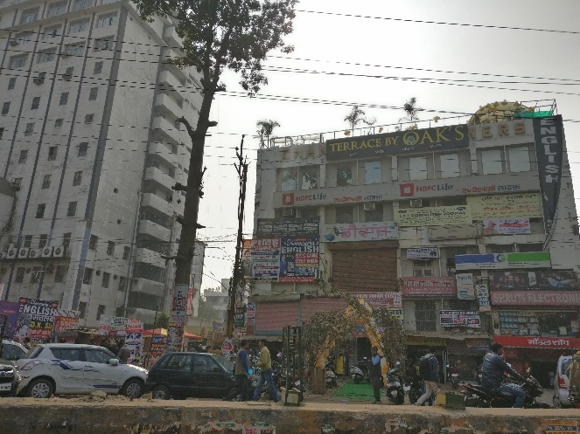
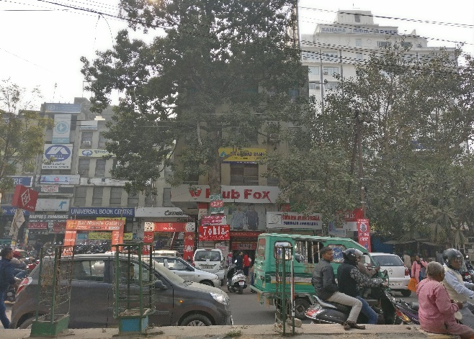 | 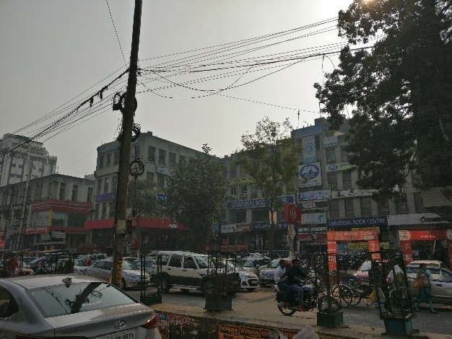
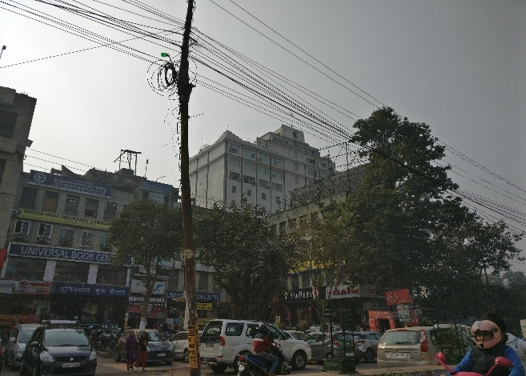 | 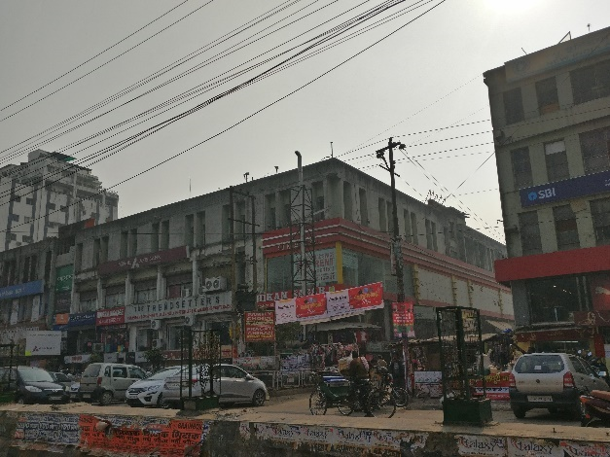
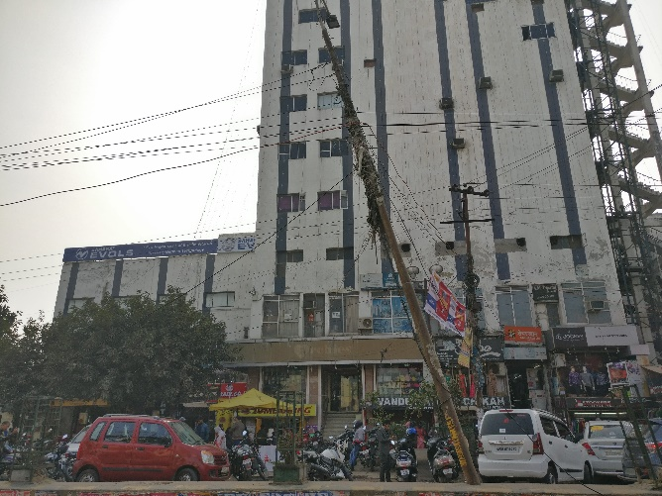 | 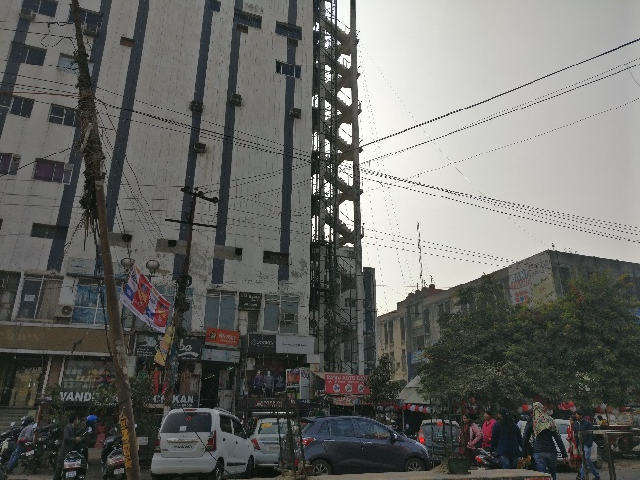
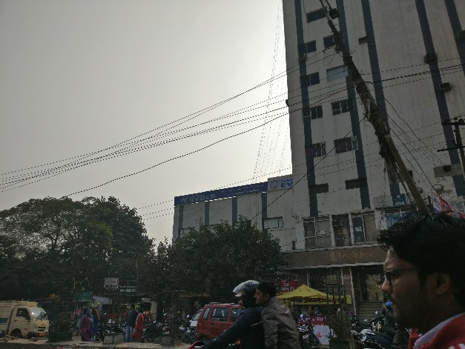 | 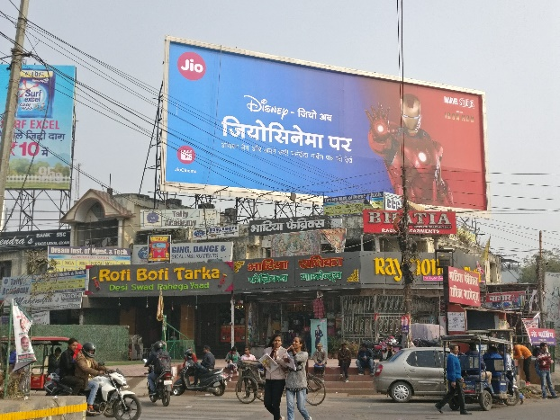
Figure 4.11 Views of the blocks on Kapoorthala market area
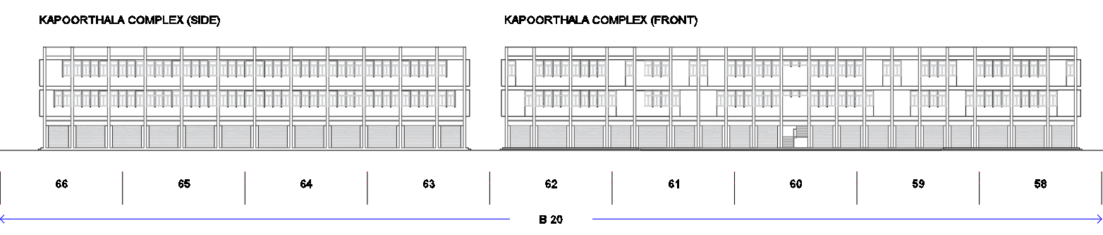
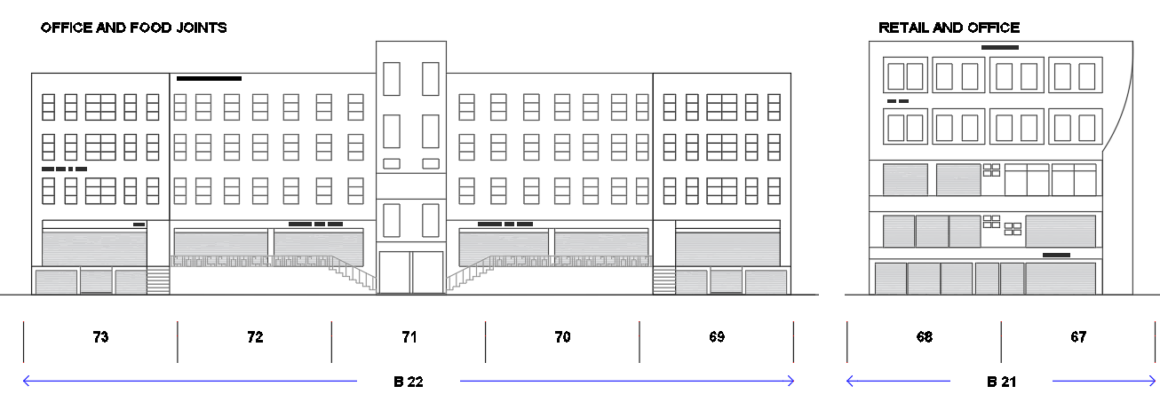
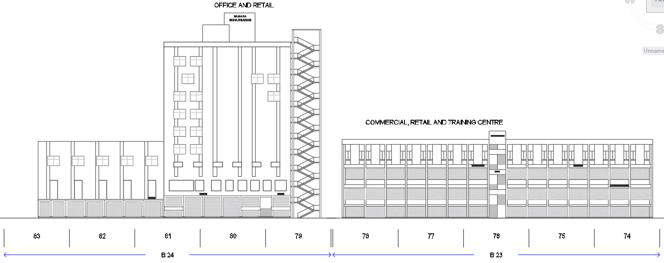
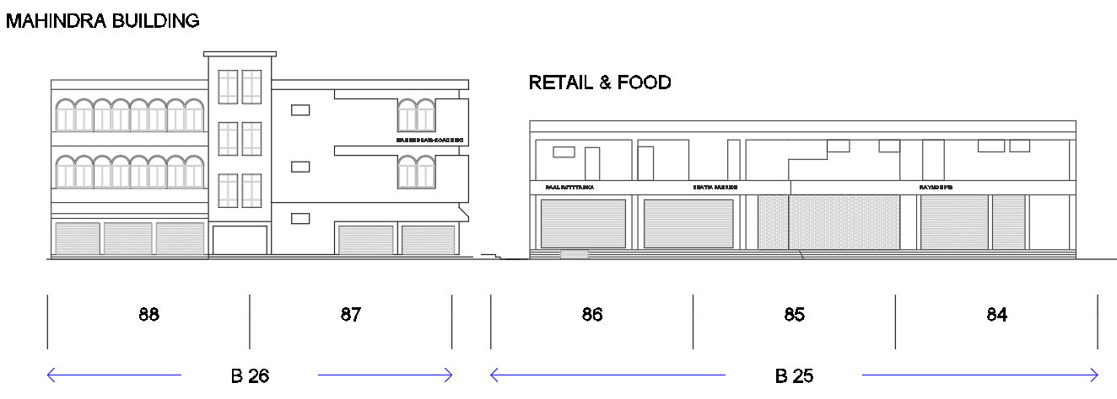
Figure 4.12 Drawing of the blocks studied on Kapoorthala market area
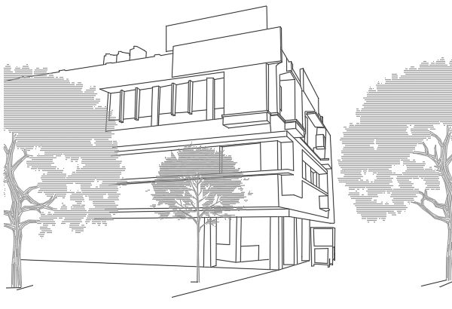
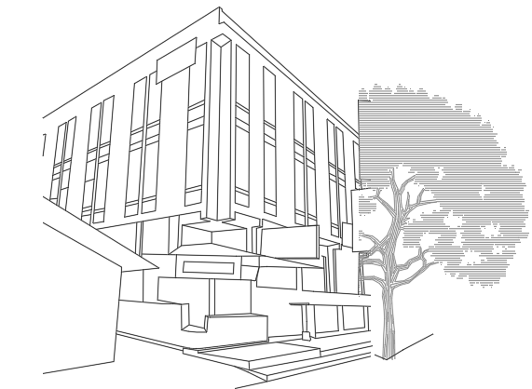
Figure 4.13 Perspective views of the blocks on Kapoorthala market area

Chapter 05 Findings and Discussion

Chapter overview
This chapter consists of four sections that present the findings of observations, surveys, and interviews, to the objectives framed for this research. The first section develops a progression to derive a dimensional scale for the third-place designation over a neighbourhood commercial street based on the perception of active user of the street; followed by a preliminary assortment of items through the review of the literature (Chapter 2) and formative research. Second section discusses the user activities in dimension of third place and further measure the core characteristic of preferred third place (liveliness) at block and block segment level. Third section accrues the findings of relationship between liveliness and street characteristics which had been selected in preceding chapter (chapter 3). Section four reveals the relationship among the street characteristics in dimension of preferred third place designation and discusses the results of multivariate regression and factor analysis. The chapter concludes with a section on the summary of findings.

Selection of dimensions and items for third place framework

Operationalisation of third place designation over neighbourhood commercial street
The operationalisation originated with reviewing the literature (Chapter 2) on concepts of ‘third place’ and its’ main attribute like sociability. Further with exploration in this comprehensive term sociability; sense of community, neighbourhood cohesion, neighbouring was identified. In progression, the review of empirical studies on users’ behaviour and activities over the neighbourhood commercial street and a few relevant studies on behavioural and environmental studies, helped in identifying various items or self-reported statements, to deriving a framework for third place over a neighbourhood commercial street. All the items/ statements identified and included belonged to at least one of the nine theoretical dimensions, which are explained below:
A) Sense of belongingness or in other words psychological sense of community denotes the individuals emotional connect towards the community. In most of the cases sense of belongingness gets stronger with passing of time and holds individual’s commitment, belief and experiences of being part of the community. For some of the researchers, it is the attitudinal (Hochschild, 2011) or integration (Hoogland, 2000) dimension of social cohesion. The definition of Chan et al. (2006) and Schiefer and Noll (2017) shows adequate support for this dimension.
B) The other most important pier came up with the help of literature is Social interaction, it expresses the behavioural domain of social relations (Hochschild, 2011) and broadly considers four positive aspects such as (Abu-Ghazzeh, 1990; Brown, Brown, & Perkins, 2004; Hoogland, 2000; Skjaeveland, Gilding, & Maeland, 1996): i) frequency of interaction ii) amount of social support or help, iii) participation in related activities, and iv) strength of ties between the users. According to Granovetter (1973), "the strength of a tie is a (probably linear) combination of the amount of time, the emotional intensity, the intimacy (mutual confiding) and the reciprocal services which characterize the “tie" (p. 1361). Marsden and Campbell (1984) recognize that ‘closeness’ or intensity of the relationship between two people as the acquaintance, friend or neighbour, is the best possible measure of the tie-strength. In spite of, consolidation of numerous aspects, studies over the years reflects neighbourliness as a unidimensional concept.
C) The emotional bonding of the user with the space, neighbour, surrounding, and activities associated with them, is termed as place attachment. According to Canter, environments or places are defined by, and understood as, the physical characteristics of the place, the activities in them, and the meanings that they hold for people (Canter, 1991). Hochschild Jr. (2011) deliberates this dimension as the attitudinal aspects of user towards a place. This dimension reinforces with the definition given by Schiefer and Noll (2017). Although, place attachment is supposed to develop gradually over many years from the affective, cognitive and behavioural process amongst the user of the environment, but sometimes place attachment with the newly developed can be as significant as the older and used one.
D) Though, most of researchers found positive aspects in socializing, but it may contain negative aspects too. Researchers identify the importance of understanding negative aspects of social relations (Abu-Ghazzeh, 1990; Dempsey, 2009; Skjaeveland, Gilding, & Maeland, 1996) for protecting the psychological health of the residents. Neighbour annoyance captures the negative aspects of residents’ social relations (Skjaeveland, Gilding, & Maeland, 1996). Thus, neighbour annoyance is considered as another significant dimension of social cohesion, and in result to third place designation.
E) Bridging ties signifies social ties that develop between user from frequent face to face contacts and common usage of various spaces (Granovetter, 1973; Skjaeveland, Gilding, & Maeland, 1996). Unlike the bridging ties of the different social groups (Putnam, et al., 2004), the concept here considers only the ties (Granovetter, 1973; Putnam, et al., 2004) that develop between nearby but unfamiliar users, and generate behaviours like small talks and greetings in shared spaces. According to Skjaeveland, Gilding, & Maeland (1996) ‘…The sum of such casual, public contact at a local level – most of it fortuitous, most of it associated with errands, all of it metered by the person concerned and not thrust upon him by anyone – is a feeling for the public identity of people, a web of public respect and trust, and a resource in time of personal or neighbourhood need…’. Lowly, un-purposeful and random as they may appear, sidewalk contacts are the small change from which a city’s wealth of public life may grow (Jacobs J. , 1961). For ethnically varied small-scale neighbourhoods, bridging ties might be a significant dimension.
F) Sense of safety is one of the components of human need pyramid suggested by Maslow (1954). Real and perceived safety sense are the resultant of built environment, and vice versa, meaning the sense of safety might suggest a different approach to the built-environment setting. Preceding research has shown that the sense of safety on the street is affected by these environmental characteristics: the physical condition and maintenance of the environment; the configuration of streets and spaces; the types of land uses; the alterations and modifications made to the environment; and the presence or absence of, and the kind of people. Some studies show that people perceived streets to be safer where there were trees, and the grass was maintained (Kuo, Sullivan, Coley, & Brunson, 1998) and also where stores, bars, restaurants or other land usage except residential on the street (Perkins, Wandersman, Rich, & Taylor, 1993). Thus, sense of safety on neighbourhood commercial street has been considered as an important component in framing the dimensions of third place.
G) Environmental Comfort in Indian scenario specially in Lucknow region, where all three seasons having equal weightage in time duration, eventually adds up to making it become an important aspect. During the summers when temperature goes up to 45℃-48℃, in contrast, during winters when it goes down to 0℃, and even when the average annual precipitation is nearly 1000 mm.; it becomes a rather necessary preference of the user to go in shade either of verandas, trees, awnings, canopies, or overhangs for protection. Present literature on the effects of environmental factors on human behaviour shows that comfortable microclimatic conditions, including temperature, sunlight, shade, and wind are significant in subsidiary outdoor activities (Pushkarev & Zupan, 1975; Cohen, Moss, & Zube, 1979; Gehl, 1987; Rapoport A. , 2013). So, it could be realized that environmental comfort might be a significant dimension for third place designation.
H) Third place is known for the place where people can easily and comfortably access and walk without any physical barriers. After offering a good environmental comfort, it is necessary for the people to give them physical comfort so that they can linger on the streets and make them live; and in return, street can be designate as a third place. Researchers in their studies have identified that physical characteristics and uses contributes in retaining people over public spaces and possibly supporting social behaviour including sitting spaces (Rapoport A. , 2013; Joardar & Neill, 1978; Linday, 1978; Whyte, The social life of small urban spaces, 1980; Hass-Klau, 1999); other street furniture and physical artefacts (Marcus & Francis, 1997; Joardar & Neill, 1978; Gehl, 1987); generous sidewalk width (Whyte, 1980); trees (Joardar & Neill, 1978; Whyte, 1980; Sullivan, Kuo, & Depooter, 2004);
I) Sensory pleasure over the environment refers to the built environment experienced through the sensory organs such as ears, nose, skin and eyes to be pleasant. It is argued that to attain sensory pleasure pedestrians prefer a high level of complexity resulting from variety and novelty (Rapoport A. , 2013; Alexander, 1977; Bentley, Alcock, Murrain, McGlynn, & Smith, 1985; Gehl, 1987); as well as order and coherence (Kaplan & Kaplan, 1989; Nasar & Julian, 1995). Researchers note that sensory stimuli at the streets are perceived from, but are not limited to, the features of the edges of buildings that define the street, including fenestration, shop windows and the goods in them, canopies, awnings, signage, and so on; the street and sidewalk, including vehicles, street furniture and all other physical artefacts on it; natural features, such as landscape elements and trees; and people and their activities, including movements, sounds, etc. (Cullen, 2012; Gehl, 1987; Jacobs A. B., 1993; Appleyard, Gerson, & Lintell, 1981; Rapoport A. , 2013; Lofland & Lofland, 1998). Since the momentous, it might be another important dimension of this research.
J) Business varieties have been proved by the multiple scholars as the main reason to attract people over any area. Jacob considers that, where stores, bars, restaurants or other similar usage ensues on the street, streets become lively and safe for the people (Perkins, Wandersman, Rich, & Taylor, 1993; Jacobs J. , 1961). Most of the scholar noted that beside other social activities, watching people and meeting their primary goal is shopping; variety in businesses attracts people to visit the street.
The formative research section (Chapter 3) has shown the process of identifying more context-specific statements for deriving the appropriate contextual framework for preferred third place from the nine identified contexts.

Results of formative research
In the first stage of formative research, eight focus group surveys and later the expert opinion survey with nine experts helped in identifying forty-two context specific list of statements/ items, to frame dimensions of preferred third place over a neighbourhood commercial street (Table 5.1). Here, a statement containing ‘I’ represented the respondent and containing ‘you’ represented the attitude and feelings of focus group.
Table 5.1 Selected list of statements for third place framework
Q. No. | Selected Statements/ Items | Measuring Scale
1.1 | How many block segments can you recognise in one single look? | 5- 4- 3- 2- 1-  (10+) (7-9) (4-6) (1-3) (0)
5.2 | How many people have you seen in jogging and evening walk activities over this street?
1.3 | How many phases of earlier modifications, you can recollect? | 5- 4- 3- 2- 1-  (4or4+) (3) (2) (1) (0)
2.2 | How many new connections you have made with visiting over this street?
2.4 | How many block segments you want to retain at any cost over this street?
2.5 | How many block segments over this street may be replaced by some other better block segment of your choice?
3.1 | How often you recall the earlier time of this place?
4.4 | How many crimes you got to know over this street for last 6 months?
1.4 | Here I feel like, I am part of this community and area. | 5- Completely Agree  4- Agree  3- Neither agree nor disagree  2- Disagree  1- Completely disagree
2.3 | At the time of personal crisis, I used to walk over this street and watch the people.
2.6 | Whenever I get free time after work and home, I wish to spend here.
2.9 | I feel myself associated with the dhaba environment here.
2.11 | Perception about interactive environment of this place, amongst my friends is very good.
2.14 | Provisions of gathering spaces are sufficient which contribute to make this street live.
2.15 | Late night opening of stalls and street vendors make this street live.
2.16 | How many prospective fields you can suggest to work to make it more live? A) Buildings upkeep B) Amenities C) Maintenance D) Upkeep | 5- 4- 3- 2- 1-  (No Change) (1) (2) (3)(All)
3.2 | If you find any opportunity to relocate, would you prefer to relocate from this area? | 5- Completely Agree  4- Agree  3- Neither agree nor disagree  2- Disagree  1- Completely disagree  5- Completely Agree  4- Agree  3- Neither agree nor disagree  2- Disagree  1- Completely disagree
4.2 | Do you feel safe walking over this street after dark?
4.3 | Is it safe for women to walk alone at night over this street?
5.1 | Walking over this street make me fresh and cheerful in all the seasons.
5.3 | Pedestrian dominating characteristics are good in this area.
5.4 | Shades over the street and open spaces reinforce the liveliness.
5.5 | Some more personalisation could enhance business and individuality of shops.
6.1 | Sitting spaces and provisions of benches encourage the liveability at this place.
6.2 | On street parking is more convenient rather off street at basement here.
6.7 | This has a clear side bay for walking, socializing etc. apart from main metallic road.
6.8 | The space where we used to gather has variety for activities e.g. nos. benches platforms all side enclosed so it doesn't disturb and support us.
6.9 | Corridors give the good feeling in lingering activities.
6.10 | Its barrier free environment supports to elderly users.
7.1 | Spaces are enclosed so that gives good sense.
7.3 | Building enclosures are good & aesthetically pleasing.
7.4 | Neat and clean environments make it beautiful.
7.6 | Greenery and open spaces fascinate us to stay there for moments.
8.1 | Most of our shopping needs can be fulfilled here
8.3 | Market of this area comes under our price range.
8.5 | Ice cream staffs of all variety available here which is in daily routine of my children's.
8.7 | Multiple shops for same things so that I can check the price competitiveness.
8.8 | Extensive street side food stalls attract the people and make the street live.
8.9 | Eatery shops are normally open till night.
8.10 | Tea stalls/Coffee shops are open till night.
8.12 | Almost all kind of shops are here one stop point for my complete family.
9.2 | Is it very easy for a newcomer to get along with this neighbourhood commercial street?

Deriving dimensional scale for preferred third place

Data
For developing a dimensional scale targeting to all the dimensions reviewed for preferred third place over neighbourhood commercial street, the data was collected through active users of the street surveys and poised 205 samples. The list of statements/ items, identified after two rounds of the expert opinion survey (Table 5.1), was used as a tool to assess the user perception for preferred third place of the neighbourhood commercial street (study area). During the interview, each of the respondents was asked to indicate their feelings, associations, as well as agreement and disagreement on a five-point Likert scale. The coding of specific statements/ items was modified and reduced up to 4 or 4+ to arrive at higher scores, indicating better opinion of the user for preferred third place. In one single question which was of negative nature, the scale was kept revered to arrive at higher scores, indicating preferred third place.

Analysis
Before deriving the dimensions of preferred third place (factors) through factor analysis of collected data for each of the statements/ items (independent variables), adequacy of sample size was checked, two principle were considered: 1) Kaiser-Meyer-Olkin (KMO) sampling adequacy; 2) Correlation matrix and their loadings amongst themselves. The KMO sampling adequacy on the SPSS 20 was good and ranked at level of 0.817 which showed better adequacy (Kaiser, An index of factorial simplicity, 1974). In correlation matrix of the variables it was found that every variable was significantly corelated while two variables had low loadings.
The analysis began on SPSS 20 software, with principal component method and extraction were based on Eigenvalues score which must be greater than score 1 (Kaiser, 1960). In analysis number of construct extraction were decided by the score of Eigenvalues, which further checked with Brian O'Connor parallel analysis syntax engine (O'Connor, 2000). As dimension reduction techniques seek to identify items with a shared variance, communality scores were checked and kept the variables having score ≥ 0.4; while, it is advisable to remove any item with a communality score less than 0.2 (Child, 2006). Whether to rotate the factors and the type of rotation used; before going to varimax rotation which is the most popular orthogonal rotation technique, Direct Oblimin rotation were used to get to the desired constructs (Field & Miles, 2010). Result were suppressed with small coefficients having absolute value <.6 to get the higher loaded variables in factor formation. It was also checked that proportion of the total variance explained by the retained factors was 63.56% which was more than 50% as desired in factor analysis. The analyses were later amassed by successive reliability and validity tests. The findings are discussed in the following section.

Result
At the very first step of the collected data set, all pre-requisite before factor analysis were checked; to check the significant correlation amongst the variables, all variables were selected for bivariate correlation matrix and found significantly corelated, the highly correlation found was .748 (≤.8) (Field & Miles, 2010), so the chances of multicollinearity was less although they are not a necessary condition. In model one, rotation type was kept by default as none. For 42 variables and 205 sample cases in research data set, the item Q5.4 had the lowest communalities as .489 (≥.4), which is within limit though at bottom threshold. So, no variable was removed. In factor determination part (Total Variance Explained), there are 9 components (Table 5.2, Table 5.3, Table 5.4) which had the eigenvalue ≥1 (between 14.666 to 1.048). The number of factors extracted by Kaiser’s criterion was quite high, so another attempt was made to fix the appropriate number of factors and extract the factors more meaningful (Model 2). To fix the appropriate number of factors, parallel analysis had been carried out in SPSS using Brian O'Connor's syntax (found at: https://people.ok.ubc.ca/brioconn/nfa...), which shows the retained factors in accordance with the random data eigenvalues (Table 5.5).
Table 5.2 Components variance explained of Model 1
Total Variance Explained
Component | Initial Eigenvalues |  |  | Extraction Sums of Squared Loadings
 | Total | % of Variance | Cumulative % | Total | % of Variance | Cumulative %
1 | 14.666 | 34.919 | 34.919 | 14.666 | 34.919 | 34.919
2 | 3.653 | 8.698 | 43.617 | 3.653 | 8.698 | 43.617
3 | 3.036 | 7.228 | 50.844 | 3.036 | 7.228 | 50.844
4 | 1.966 | 4.681 | 55.525 | 1.966 | 4.681 | 55.525
5 | 1.770 | 4.214 | 59.739 | 1.770 | 4.214 | 59.739
6 | 1.604 | 3.820 | 63.559 | 1.604 | 3.820 | 63.559
7 | 1.310 | 3.118 | 66.677 | 1.310 | 3.118 | 66.677
8 | 1.182 | 2.815 | 69.492 | 1.182 | 2.815 | 69.492
9 | 1.048 | 2.496 | 71.988 | 1.048 | 2.496 | 71.988
10 | .980 | 2.334 | 74.322
11 | .951 | 2.263 | 76.585
12 | .828 | 1.971 | 78.556
13 | .720 | 1.714 | 80.270
14 | .691 | 1.646 | 81.915
15 | .681 | 1.623 | 83.538
16 | .648 | 1.542 | 85.080
17 | .615 | 1.463 | 86.543
18 | .550 | 1.308 | 87.852
19 | .462 | 1.101 | 88.952
20 | .450 | 1.072 | 90.024
21 | .435 | 1.037 | 91.061
22 | .419 | .998 | 92.059
23 | .345 | .822 | 92.881
24 | .307 | .730 | 93.611
25 | .290 | .691 | 94.302
26 | .265 | .632 | 94.934
27 | .249 | .592 | 95.526
28 | .242 | .577 | 96.104
29 | .235 | .560 | 96.663
30 | .184 | .438 | 97.101
31 | .171 | .407 | 97.508
32 | .153 | .365 | 97.873
33 | .150 | .358 | 98.231
34 | .137 | .325 | 98.556
35 | .123 | .293 | 98.849
36 | .105 | .251 | 99.100
37 | .090 | .215 | 99.315
38 | .082 | .196 | 99.511
Extraction Method: Principal Component Analysis.
Table 5.3 Scree plot of Model 1
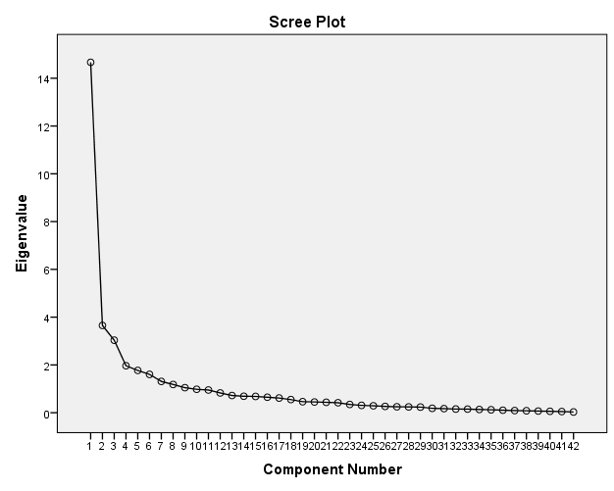
Table 5.4 Component Matrix of Model 1
Component Matrixª
 | Component
 | 1 | 2 | 3 | 4 | 5 | 6 | 7 | 8 | 9
Q1.1- How many blocks or block segment can you recognise in one single look? | .750 | -.160 | .335 | .140 | -.058 | .017 | .019 | .007 | .004
Q1.3- How many phases of earlier modifications, you can recollect? | .583 | .110 | .366 | -.109 | -.201 | .211 | -.060 | -.248 | -.135
Q1.4- Here I feel like, I am part of this community. | .706 | -.003 | .265 | -.080 | -.184 | -.120 | -.300 | -.100 | .068
Q2.2- How many new friends you have made by visiting here? | .334 | .257 | .682 | .283 | .174 | -.005 | -.103 | .092 | -.114
Q2.3- At the time of personal crisis, I used to walk over this street and watch the people. | .695 | .125 | .479 | .117 | -.034 | -.091 | -.066 | .118 | .032
Q2.4- How many block/ block segments you want to retain at any cost over this street. | .316 | .000 | -.081 | .343 | -.100 | -.486 | .270 | .263 | -.254
Q2.5- How many block/ block segments you want to remove from this street. | .119 | -.033 | -.154 | -.069 | .072 | .071 | -.512 | .481 | .398
Q2.6- Whenever I get free time after work and home, I wish to spend here only. | .480 | .184 | .516 | -.248 | .159 | -.076 | -.001 | -.067 | -.009
Q2.9- I feel myself associated with the dhaba environment here. | .550 | -.081 | -.116 | -.236 | -.089 | .245 | -.390 | -.177 | -.012
Q2.11- Perception about this place interactive environment, amongst my friends is very good. | .644 | .098 | -.341 | -.083 | -.226 | -.107 | -.055 | .018 | .108
Q2.14- How many more open pockets do you wish to have over this street? | .451 | .214 | -.391 | .264 | -.160 | -.260 | -.356 | -.085 | -.195
Q2.15- Late night opening of stalls and street vendors make this street live. | .384 | .432 | -.457 | -.157 | -.147 | .100 | .039 | .162 | -.018
Q2.16- How many prospective fields you can suggest to work to make it more live? A) Buildings upkeep B) Amenities C) Maintenance D) Upkeep | .034 | .703 | -.203 | -.394 | -.130 | .134 | .071 | .168 | -.224
Q3.1- How often you recall the earlier time of this place? | .591 | -.029 | .471 | .033 | -.305 | .089 | -.073 | -.025 | -.190
Q3.2- If you find any opportunity to relocate, would you prefer to relocate from this area? | .798 | -.243 | .331 | -.065 | -.089 | -.062 | .120 | .127 | .010
Q4.2- How safe do you feel walking over the street here after dark? | .742 | -.150 | .214 | -.091 | .011 | -.250 | .177 | -.031 | -.045
Q4.3- Is it safe for women to walk alone at night over this street? | .578 | -.205 | .309 | -.313 | .062 | .191 | .227 | .018 | .234
Q4.4- How many crimes you got to know over this street for last 6 months? | .196 | .192 | .032 | .521 | .359 | .328 | .090 | .279 | .095
Q5.1- Walking over this street make me fresh and cheerful in all the seasons. | .657 | -.163 | -.047 | -.078 | -.092 | .436 | .080 | -.049 | .215
Q5.2- How many people have you seen in jogging and evening walk activities over this street? | .547 | -.089 | -.007 | -.192 | -.212 | .141 | .165 | .472 | -.183
Q5.3- Pedestrian dominating characteristics are good in this area | .812 | .004 | -.156 | .093 | -.206 | .001 | .103 | .015 | .012
Q5.4- Shades over the street and open spaces reinforce the liveliness. | .186 | .523 | .080 | .118 | .324 | -.179 | -.052 | -.144 | .000
Q5.5- Some more personalisation could enhance business and individuality of shops. | .032 | .833 | .052 | -.117 | .047 | .338 | .044 | -.064 | -.101
Q6.1- Sitting spaces and provisions of benches encourage the liveability at this place. | -.265 | .618 | .120 | -.239 | .245 | -.041 | .146 | .210 | -.140
Q6.2- On street parking is more convenient rather off street at basement here. | .130 | .212 | -.049 | -.536 | .522 | -.176 | .086 | -.138 | .078
Q6.7- This has a clear side bay for walking, socializing etc. apart from main metallic road. | .786 | .162 | -.099 | -.178 | .074 | -.071 | .235 | -.067 | .098
Q6.8- The space where we used to gather has variety for activities e.g. nos. benches platforms all side enclosed so it doesn't disturb and support us. | .855 | -.193 | .022 | .001 | .064 | -.034 | .047 | .007 | -.037
Q6.9- Corridors give the good feeling in lingering activities. | .734 | -.066 | -.170 | -.203 | .162 | -.343 | -.141 | -.113 | -.073
Q6.10- Its barrier free environment supports to elderly users. | .623 | .396 | -.060 | -.014 | -.149 | -.177 | -.195 | -.087 | -.092
Q7.1- Spaces are enclosed so that gives good sense. | .844 | .080 | -.200 | .023 | -.009 | -.019 | -.011 | .164 | .114
Q7.3- Building enclosures are good & aesthetically pleasing. | .802 | -.011 | -.308 | -.145 | -.138 | .026 | .153 | -.075 | .041
Q7.4- Neat and clean environments make it beautiful. | -.427 | .502 | .158 | .344 | -.151 | .121 | .080 | -.244 | .112
Q7.6- Greenery and open spaces fascinate us to stay there for moments. | -.302 | .581 | .049 | .224 | -.180 | -.182 | .079 | -.158 | .437
Q8.1- Most of our shopping needs can be fulfilled here | .592 | .217 | -.060 | .065 | -.380 | -.086 | .163 | -.147 | .197
Q8.3- Market of this area comes under our price range. | .658 | .218 | -.251 | .287 | -.125 | .123 | .287 | .005 | .152
Q8.5- Ice cream staffs of all variety available here which is in daily routine of my children's. | .807 | -.001 | .130 | .089 | .253 | -.163 | .073 | .063 | .181
Q8.7- Multiple shops for same things so that I can check the price competitiveness | .666 | .075 | -.267 | .258 | .312 | -.050 | -.007 | -.049 | -.003
Q8.8- Street side foods are available here. | .779 | -.024 | -.086 | .074 | .295 | .127 | -.079 | -.149 | .059
Q8.9- Eatery shops are normally open till night. | .717 | -.125 | -.050 | .203 | .277 | .334 | -.056 | -.089 | -.147
Q8.10- Tea stalls/Coffee shops are open till night. | .689 | .088 | -.238 | .235 | .118 | .311 | -.142 | -.029 | -.289
Q8.12- Almost all kind of shops are here one stop point for my complete family. | .665 | .022 | -.254 | .012 | .262 | -.164 | -.106 | .048 | .061
Q9.2- Is it very easy for a newcomer to get along with this neighbourhood commercial street? | .115 | -.468 | -.425 | .069 | .167 | .092 | .288 | -.278 | -.140
Extraction Method: Principal Component Analysis.
a. 9 components extracted.
Following table (Table 5.5) came up after running Brian O'Connor parallel analysis syntax engine for the data set having 205 sample cases, 42 variables and, with principal component method. Brian O'Connor parallel analysis syntax matches the mean Eigenvalue up to six components of model number 1 (till Eigenvalue 1.604); after that, the suggested mean Eigenvalue became higher than Eigenvalue extracted (Eigenvalue 1.310) in Model 1 (Table 5.2). In revised model 2, the extraction was based on fixed number of factors which was kept as six as suggested in Brian O'Connor parallel analysis; for better coefficient and eliminating cross loading issues, a nonorthogonal rotation was made through Oblimin rotation method with Kaiser normalization in SPSS analysis. It has been observed in communalities that Q2.5 was very poorly loaded with .054, which was abolished from the further analysis. In pattern matrix, all variables were loaded significantly while the component five had only one and component six had no variable
Table 5.5 Random Data Eigenvalues based on Brian O'Connor syntax engine
Run MATRIX procedure:

PARALLEL ANALYSIS:

Principal Components

Specifications for this Run:
Ncases 205
Nvars 42
Ndatsets 100
Percent 95

Random Data Eigenvalues
Root Means Prcntyle
1.000000 1.987385 2.077646
2.000000 1.880634 1.964391
3.000000 1.789142 1.863164
4.000000 1.715337 1.768704
5.000000 1.643885 1.708932
6.000000 1.582249 1.644240
7.000000 1.529953 1.578380
8.000000 1.478750 1.536490
9.000000 1.426525 1.469401
10.000000 1.376066 1.416533
11.000000 1.330946 1.371537
12.000000 1.289250 1.327574
13.000000 1.249003 1.290019
14.000000 1.205652 1.238533
15.000000 1.167368 1.202337
16.000000 1.130444 1.163216
17.000000 1.090872 1.122932
18.000000 1.053496 1.085300
19.000000 1.019137 1.054529
20.000000 .982951 1.012122
21.000000 .950149 .985096
22.000000 .915761 .948233
23.000000 .887418 .921567
24.000000 .854562 .885127
25.000000 .825172 .859842
26.000000 .794100 .824271
27.000000 .763518 .792269
28.000000 .733902 .764727
29.000000 .708034 .738925
30.000000 .682978 .713957
31.000000 .648939 .680830
32.000000 .622454 .647578
33.000000 .594134 .620097
34.000000 .567534 .595887
35.000000 .539948 .568353
36.000000 .514078 .545162
37.000000 .486394 .515724
38.000000 .460206 .490017
39.000000 .428743 .451369
40.000000 .398720 .423919
41.000000 .367547 .392287
42.000000 .326665 .359166

------ END MATRIX -----
(Table 5.6). Correlations between variables and factors could be ignored in oblique rotation. Ideally, each variable load only on one factor, and each factor has at least three variables that load highly on it.
Table 5.6 Pattern Matrix of Model 2
Pattern Matrixª
 | Component
 | 1 | 2 | 3 | 4 | 5 | 6
Q2.14- How many more open pockets do you wish to have over this street? | .736
Q2.11- Perception about this place interactive environment, amongst my friends is very good. | .689
Q8.1- Most of our shopping needs can be fulfilled here | .621
Q2.15- Late night opening of stalls and street vendors make this street live. | .605
Q7.3- Building enclosures are good & aesthetically pleasing.
Q6.10- Its barrier free environment supports to elderly users.
Q5.3- Pedestrian dominating characteristics are good in this area
Q8.3- Market of this area comes under our price range.
Q7.1- Spaces are enclosed so that gives good sense.
Q2.4- How many block/ block segments you want to retain at any cost over this street.
Q6.7- This has a clear side bay for walking, socializing etc. apart from main metallic road.
Q5.5- Some more personalisation could enhance business and individuality of shops. |  | .901
Q2.16- How many prospective fields you can suggest to work to make it more live? A) Buildings upkeep B) Amenities C) Maintenance D) Upkeep |  | .791
Q6.1- Sitting spaces and provisions of benches encourage the liveability at this place. |  | .652
Q2.3- At the time of personal crisis, I used to walk over this street and watch the people. |  |  | .780
Q3.1- How often you recall the earlier time of this place? |  |  | .779
Q2.2- How many new friends you have made by visiting here? |  |  | .740
Q3.2- If you find any opportunity to relocate, would you prefer to relocate from this area? |  |  | .693
Q2.6- Whenever I get free time after work and home, I wish to spend here only. |  |  | .682
Q1.3- How many phases of earlier modifications, you can recollect? |  |  | .651
Q1.1- How many blocks or block segment can you recognise in one single look? |  |  | .647
Q1.4- Here I feel like, I am part of this community. |  |  | .635
Q4.2- How safe do you feel walking over the street here after dark?
Q4.3- Is it safe for women to walk alone at night over this street?
Q9.2- Is it very easy for a newcomer to get along with this neighbourhood commercial street?
Q8.5- Ice cream staffs of all variety available here which is in daily routine of my children's.
Q6.8- The space where we used to gather has variety for activities e.g. nos. benches platforms all side enclosed so it doesn't disturb and support us.
Q4.4- How many crimes you got to know over this street for last 6 months? |  |  |  | .798
Q8.9- Eatery shops are normally open till night. |  |  |  | .685
Q8.10- Tea stalls/Coffee shops are open till night. |  |  |  | .634
Q8.7- Multiple shops for same things so that I can check the price competitiveness
Q8.8- Street side foods are available here.
Q6.2- On street parking is more convenient rather off street at basement here. |  |  |  |  | .798
Q6.9- Corridors give the good feeling in lingering activities.
Q7.4- Neat and clean environments make it beautiful.
Q8.12- Almost all kind of shops are here one stop point for my complete family.
Q5.1- Walking over this street make me fresh and cheerful in all the seasons.
Q2.9- I feel myself associated with the dhaba environment here.
Q7.6- Greenery and open spaces fascinate us to stay there for moments.
Q5.4- Shades over the street and open spaces reinforce the liveliness.
Q5.2- How many people have you seen in jogging and evening walk activities over this street?
Extraction Method: Principal Component Analysis.
Rotation Method: Oblimin with Kaiser Normalization.
a. Rotation converged in 42 iterations.
Table 5.7 Component Correlation Matrix of Model 2
Component Correlation Matrix
Component | 1 | 2 | 3 | 4 | 5 | 6
1 | 1.000 | -.057 | .285 | .319 | .230 | .169
2 | -.057 | 1.000 | -.043 | -.066 | -.057 | -.165
3 | .285 | -.043 | 1.000 | .296 | .216 | .121
4 | .319 | -.066 | .296 | 1.000 | .197 | .082
5 | .230 | -.057 | .216 | .197 | 1.000 | .166
6 | .169 | -.165 | .121 | .082 | .166 | 1.000
Extraction Method: Principal Component Analysis.
Rotation Method: Oblimin with Kaiser Normalization.
In above component correlation matrix of model 2 (Table 5.7), the perceptible point were the coefficients, which were neither too weak nor greater than .5 (≥.5). In this case one more attempt had been carried out with orthogonal rotation as Varimax rotation method in revised model 3. In Model 3, sample adequacy was found .818 (≥.7), and Bartlett’s test of sphericity was 0.00000 (≤.05) (Kaiser, 1974); which showed the good sample size and appropriateness of data for factor analysis (Table 5.8). Further, in communalities score (Table 5.9), almost all the variables had a good loading (h^2) except three variables that were moderately loaded (Q2.9 and Q5.2). In total variance explained, the first component itself scored 35.74% variance, while other five components were added under 10% of variance. Altogether total six components were scored 65.02% of variance in cumulative (Table 5.10).
Table 5.8 Sampling Adequacy and Data sphericity test
KMO and Bartlett's Test
Kaiser-Meyer-Olkin Measure of Sampling Adequacy. |  | .818
Bartlett's Test of Sphericity | Approx. Chi-Square | 7232.911
 | df | 820
 | Sig. | .000
Table 5.9 Component communalities of Model 3
Communalities
 | Initial | Extraction
Q1.1- How many blocks or block segment can you recognise in one single look? | 1.000 | .722
Q1.3- How many phases of earlier modifications, you can recollect? | 1.000 | .582
Q1.4- Here I feel like, I am part of this community. | 1.000 | .630
Q2.2- How many new friends you have made by visiting here? | 1.000 | .757
Q2.3- At the time of personal crisis, I used to walk over this street and watch the people. | 1.000 | .757
Q2.4- How many block/ block segments you want to retain at any cost over this street. | 1.000 | .462
Q2.6- Whenever I get free time after work and home, I wish to spend here only. | 1.000 | .620
Q2.9- I feel myself associated with the dhaba environment here. | 1.000 | .438
Q2.11- Perception about this place interactive environment, amongst my friends is very good. | 1.000 | .609
Q2.14- How many more open pockets do you wish to have over this street? | 1.000 | .570
Q2.15- Late night opening of stalls and street vendors make this street live. | 1.000 | .599
Q2.16- How many prospective fields you can suggest to work to make it more live? A) Buildings upkeep B) Amenities C) Maintenance D) Upkeep | 1.000 | .728
Q3.1- How often you recall the earlier time of this place? | 1.000 | .673
Q3.2- If you find any opportunity to relocate, would you prefer to relocate from this area? | 1.000 | .822
Q4.2- How safe do you feel walking over the street here after dark? | 1.000 | .686
Q4.3- Is it safe for women to walk alone at night over this street? | 1.000 | .612
Q4.4- How many crimes you got to know over this street for last 6 months? | 1.000 | .583
Q5.1- Walking over this street make me fresh and cheerful in all the seasons. | 1.000 | .666
Q5.2- How many people have you seen in jogging and evening walk activities over this street? | 1.000 | .409
Q5.3- Pedestrian dominating characteristics are good in this area | 1.000 | .735
Q5.4- Shades over the street and open spaces reinforce the liveliness. | 1.000 | .465
Q5.5- Some more personalisation could enhance business and individuality of shops. | 1.000 | .831
Q6.1- Sitting spaces and provisions of benches encourage the liveability at this place. | 1.000 | .586
Q6.2- On street parking is more convenient rather off street at basement here. | 1.000 | .656
Q6.7- This has a clear side bay for walking, socializing etc. apart from main metallic road. | 1.000 | .700
Q6.8- The space where we used to gather has variety for activities e.g. nos. benches platforms all side enclosed so it doesn't disturb and support us. | 1.000 | .775
Q6.9- Corridors give the good feeling in lingering activities. | 1.000 | .759
Q6.10- Its barrier free environment supports to elderly users. | 1.000 | .605
Q7.1- Spaces are enclosed so that gives good sense. | 1.000 | .759
Q7.3- Building enclosures are good & aesthetically pleasing. | 1.000 | .783
Q7.4- Neat and clean environments make it beautiful. | 1.000 | .608
Q7.6- Greenery and open spaces fascinate us to stay there for moments. | 1.000 | .545
Q8.1- Most of our shopping needs can be fulfilled here | 1.000 | .554
Q8.3- Market of this area comes under our price range. | 1.000 | .656
Q8.5- Ice cream staffs of all variety available here which is in daily routine of my children's. | 1.000 | .766
Q8.7- Multiple shops for same things so that I can check the price competitiveness | 1.000 | .687
Q8.8- Street side foods are available here. | 1.000 | .722
Q8.9- Eatery shops are normally open till night. | 1.000 | .763
Q8.10- Tea stalls/Coffee shops are open till night. | 1.000 | .706
Q8.12- Almost all kind of shops are here one stop point for my complete family. | 1.000 | .601
Q9.2- Is it very easy for a newcomer to get along with this neighbourhood commercial street? | 1.000 | .471
Extraction Method: Principal Component Analysis.
Table 5.10 Components variance explained of Model 3
Total Variance Explained
Component | Initial Eigenvalues |  |  | Extraction Sums of Squared Loadings |  |  | Rotation Sums of Squared Loadings
 | Total | % of Variance | Cumulative % | Total | % of Variance | Cumulative % | Total | % of Variance | Cumulative %
1 | 14.653 | 35.738 | 35.738 | 14.653 | 35.738 | 35.738 | 8.204 | 20.009 | 20.009
2 | 3.652 | 8.908 | 44.647 | 3.652 | 8.908 | 44.647 | 7.610 | 18.562 | 38.570
3 | 3.020 | 7.365 | 52.012 | 3.020 | 7.365 | 52.012 | 3.928 | 9.580 | 48.150
4 | 1.964 | 4.790 | 56.802 | 1.964 | 4.790 | 56.802 | 2.960 | 7.220 | 55.370
5 | 1.768 | 4.312 | 61.113 | 1.768 | 4.312 | 61.113 | 2.242 | 5.468 | 60.838
6 | 1.603 | 3.909 | 65.022 | 1.603 | 3.909 | 65.022 | 1.716 | 4.184 | 65.022
7 | 1.260 | 3.074 | 68.096
8 | 1.110 | 2.706 | 70.802
9 | .984 | 2.401 | 73.203
10 | .951 | 2.320 | 75.523
11 | .932 | 2.273 | 77.796
12 | .730 | 1.781 | 79.577
13 | .692 | 1.688 | 81.265
14 | .682 | 1.662 | 82.928
15 | .648 | 1.580 | 84.507
16 | .619 | 1.511 | 86.018
17 | .563 | 1.374 | 87.392
18 | .475 | 1.159 | 88.552
19 | .454 | 1.107 | 89.658
20 | .442 | 1.079 | 90.738
21 | .420 | 1.025 | 91.762
22 | .349 | .850 | 92.613
23 | .310 | .757 | 93.370
24 | .294 | .716 | 94.086
25 | .282 | .687 | 94.773
26 | .250 | .609 | 95.382
27 | .248 | .606 | 95.988
28 | .235 | .573 | 96.562
29 | .184 | .450 | 97.012
30 | .172 | .419 | 97.430
31 | .158 | .385 | 97.815
32 | .151 | .367 | 98.183
33 | .137 | .334 | 98.517
34 | .123 | .300 | 98.817
35 | .106 | .257 | 99.074
36 | .090 | .221 | 99.295
37 | .082 | .201 | 99.495
38 | .070 | .170 | 99.665
39 | .059 | .145 | 99.810
40 | .048 | .117 | 99.926
41 | .030 | .074 | 100.000
Extraction Method: Principal Component Analysis.
In rotated component matrix (Table 5.11, Table 5.12), factors were extracted, 1st factor was loaded with ten variables, 2nd factor was loaded with ten variables and, 3rd factor was loaded with four variables. Factor 4 had only two variables with loadings 0.74 and 0.63 loadings, and was not satisfying the criteria of minimum 3 variables association in one factor (Raubenheimer, 2004) , so it was believed that factor exists, but since it was not currently supported by variables enough, it had been dropped from results. Same case is with factor 5 which had only one factor; and factor 6 had no variables associated, so was palpable eliminated. Apart from included items in above five factors, remaining items were found insignificant in component matrix. The final three accountable extracted factors had cumulative variance 52.01% and, had a high loading which was inacceptable range for the research as the case was of behavioural and psychological context (Kaiser & Rice, 1974).
Table 5.11 Rotated Component Matrix in 6 factors of Model 3
Rotated Component Matrixª
 | Component
 | 1 | 2 | 3 | 4 | 5 | 6
Q7.3- Building enclosures are good & aesthetically pleasing. | .779
Q2.11- Perception about this place interactive environment, amongst my friends is very good. | .751
Q7.1- Spaces are enclosed so that gives good sense. | .713
Q5.3- Pedestrian dominating characteristics are good in this area | .709
Q2.15- Late night opening of stalls and street vendors make this street live. | .691
Q8.3- Market of this area comes under our price range. | .668
Q2.14- How many more open pockets do you wish to have over this street? | .649
Q6.7- This has a clear side bay for walking, socializing etc. apart from main metallic road. | .619
Q8.1- Most of our shopping needs can be fulfilled here | .615
Q6.10- Its barrier free environment supports to elderly users. | .613
Q6.9- Corridors give the good feeling in lingering activities.
Q8.12- Almost all kind of shops are here one stop point for my complete family.
Q2.9- I feel myself associated with the dhaba environment here.
Q5.1- Walking over this street make me fresh and cheerful in all the seasons.
Q5.2- How many people have you seen in jogging and evening walk activities over this street?
Q2.3- At the time of personal crisis, I used to walk over this street and watch the people. |  | .794
Q3.2- If you find any opportunity to relocate, would you prefer to relocate from this area? |  | .787
Q3.1- How often you recall the earlier time of this place? |  | .768
Q1.1- How many blocks or block segment can you recognise in one single look? |  | .730
Q1.4- Here I feel like, I am part of this community. |  | .685
Q2.6- Whenever I get free time after work and home, I wish to spend here only. |  | .677
Q2.2- How many new friends you have made by visiting here? |  | .667
Q1.3- How many phases of earlier modifications, you can recollect? |  | .666
Q4.2- How safe do you feel walking over the street here after dark? |  | .647
Q4.3- Is it safe for women to walk alone at night over this street? |  | .620
Q8.5- Ice cream staffs of all variety available here which is in daily routine of my children's.
Q6.8- The space where we used to gather has variety for activities e.g. nos. benches platforms all side enclosed so it doesn't disturb and support us.
Q5.5- Some more personalisation could enhance business and individuality of shops. |  |  | .826
Q6.1- Sitting spaces and provisions of benches encourage the liveability at this place. |  |  | .656
Q2.16- How many prospective fields you can suggest to work to make it more live? A) Buildings upkeep B) Amenities C) Maintenance D) Upkeep |  |  | .653
Q7.6- Greenery and open spaces fascinate us to stay there for moments. |  |  | .610
Q7.4- Neat and clean environments make it beautiful.
Q9.2- Is it very easy for a newcomer to get along with this neighbourhood commercial street?
Q5.4- Shades over the street and open spaces reinforce the liveliness.
Q4.4- How many crimes you got to know over this street for last 6 months? |  |  |  | .740
Q8.9- Eatery shops are normally open till night. |  |  |  | .634
Q8.10- Tea stalls/Coffee shops are open till night.
Q8.7- Multiple shops for same things so that I can check the price competitiveness
Q8.8- Street side foods are available here.
Q6.2- On street parking is more convenient rather off street at basement here. |  |  |  |  | .786
Q2.4- How many block/ block segments you want to retain at any cost over this street.
Extraction Method: Principal Component Analysis.
Rotation Method: Varimax with Kaiser Normalization.
a. Rotation converged in 22 iterations.
Table 5.12 Component Transformation Matrix of Model 3
Component Transformation Matrix
Component | 1 | 2 | 3 | 4 | 5 | 6
1 | .674 | .630 | -.170 | .296 | .177 | -.001
2 | .240 | -.065 | .958 | .089 | .087 | .063
3 | -.611 | .756 | .214 | -.051 | -.074 | .033
4 | -.057 | -.075 | -.031 | .615 | -.571 | .534
5 | -.328 | -.141 | -.050 | .584 | .726 | .046
6 | -.061 | -.031 | .057 | .427 | -.319 | -.841
Extraction Method: Principal Component Analysis.
Rotation Method: Varimax with Kaiser Normalization.
After exploratory factor analysis and factor determination, validation checks were run. Though one check found satisfactory as KMO statistic of the data was 0.818 (≥.7) (Kaiser, 1974). The correlation matrix determinant was also higher than the critical value of 0.00001 (Table 5.8). The 6 factors explained 65.02% of the variance while three determinant factors had the cumulative variance 52.01%. As a check, reliability of the factor-structure, this research looked at Cronbach's alpha (≥0.7) (Nunnally, 1978); composite reliability (≥0.7) and; average variance extracted (≥0.4) (Fornell & Larcker, 1981) through the preferred third place factors. For factor 1, the Cronbach's alpha, Composite Reliability and average variance extracted (AVE) was 0.912, 0.896 and, 0.466 respectively; for factor 2, it was .911, 0.911 and, 0.499 respectively and; for factor 3, it was .733, 0.783 and, 0.478 respectively (Table 5.13). All the reliability scores were within acceptable range and the factors were found fit to explain the dimensions of preferred third place. Further in relation to research title as well as original scale, factor 1 had named as ‘Environmental and Physical comfort’; factor 2 had named as ‘Socialization’ and; factor 3 had named as ‘Land use characteristics & management’.
Table 5.13 Reliability check of extracted factors
Factor | Variables | Factor Loading | Cronbach's alpha | Composite Reliability (CR) | Average Variance Extracted (AVE)
(Factor 1) Environmental and Physical comfort | Q 7.3 | .779 | .912 | .896 | .466
 | Q 2.11 | .751
 | Q 7.1 | .713
 | Q 5.3 | .709
 | Q 2.15 | .691
 | Q 8.3 | .668
 | Q 2.14 | .649
 | Q 6.7 | .619
 | Q 8.1 | .615
 | Q 6.10 | .613
(Factor 2) Socialization | Q 2.3 | .794 | .911 | .908 | .499
 | Q 3.2 | .787
 | Q 3.1 | .768
 | Q 1.1 | .730
 | Q 1.4 | .685
 | Q 2.6 | .677
 | Q 2.2 | .667
 | Q 1.3 | .666
 | Q 4.2 | .647
 | Q 4.3 | .620
(Factor 3) Land use characteristics & Management | Q 5.5 | .826 | .733 | .783 | .478
 | Q 6.1 | .656
 | Q 2.16 | .653
 | Q 7.6 | .610

Discussion
The research ‘Built environment setting for preferred third place in urban realm’ and the case ‘neighbourhood commercial street of Lucknow’ was seen in two parts; first part is to see the insights of third place and its context, while the second part was to look into the built environment setting for preferred third place in urban realm at neighbourhood commercial streets of Lucknow.
This research aimed to measure third place context based on a derived multi-dimensional scale. Although after focus group survey and expert opinion, its context was derived and categorised into nine milieus, the results of exploratory factor analyses formed bigger construct of similar milieus and showed fit statistics for only three of the components/ factors, which further labelled according to their acumens. Identified factor 1 was the combination of items basically representing the milieu as Physical comfort and convenience, Environmental comfort, and Sensory pleasure; which constitutes about 5 items out of 10 item loadings, so it was better to have labelled this factor 1 as: ‘Environmental and physical comfort’. Factor 2 was the combination of items from sense of belongingness, social interaction, personal attachment, and sense of safety. All the 10 items were belonging to above four milieus. Since all the four milieus were oriented towards the social aspect of the neighbourhood commercial street, so it was labelled as socialization. The 3rd factor was the combination of 4 items of different milieus but representing the single parameter like, the item ‘Q5.5- Some more personalisation could enhance business and individuality of shop’, was the ultimate reflection of business type and usage which comes under land use quality of the street; second item ‘Q6.1- Sitting spaces and provisions of benches encourage the liveability at this place’ was basically controlled and managed by business owners and urban local bodies, so this again orientated towards the land use quality of street. The 3rd item ‘Q2.16- How many prospective fields you can suggest working to make it more live? A) Buildings upkeep B) Amenities C) Maintenance D) Upkeep’, all four objective options were in clear relation with land use quality and management of the street; while item 5 ‘Q7.6- Greenery and open spaces fascinate us to stay there for moments.’, this again was the outcome of a vison made for land use planning. So, according to the acumens of factor 2 and 3, it was labelled as ‘Socialization’; and ‘land use characteristics and Management’ respectively.
The objective of this section is to identify the usages and their intensity, enabled by the attributes of built environment which causes to make the space/ area as preferred third place. Through the literature review (chapter 2) it was evident that third places are the public place that host the regular, voluntary, informal, and happily anticipated gatherings of individuals beyond the realms of home and work (Oldenburg, 1998). Klang & Olson (1999) describe it as a place where individuals may come into contact with new and old friends. Thus, the third places are the designation for a space which has an embodied characteristic fostering social activities with a main moto of communication either with themselves or with other people present in the area. On a neutral ground, with clear absence of host or hostess, having a low-profile aura, and cheerful character supported by physical and environmental structures; third place should demonstrate a lively behaviour in whole. This part of the research looks into the core characteristic of the preferred third place viz-a-viz liveliness index and usage of the space enabled by its corresponding attributes of built environment.
Behaviour mapping has always been considered as a powerful tool for understanding the qualitative phenomenon of social research (Gehl, Life Between Buildings: Using Public Space, 1987). The purpose of this tool is recording the range of activities conducive to specific built environment settings. In this research behaviour observation was used to understand the types of activities and intensity of use of various spaces either as part of their daily functional activities or for any recreational purpose. Also, the time duration in which they were engaged in various activity on the street.

Calculating Liveliness and Analogous Mapping
This section discusses the user activities in dimension of third place and further measure the core characteristic of preferred third place (liveliness) at block and block segment level.
The primary obligation for any preferred third place is to have a socializing character which encourages interaction amongst the user. In a way liveliness is the virtual image for such obligations. In this research the term liveliness was taken as the core characteristic of the preferred third place which mean is to see the stay duration by number of people in a variety of activities cheering for socialization. Variation in any amongst three may result into variance in perceived liveliness of the area or space. Variety of activities includes the dynamic as well as static activities. Dynamic refers to the activity where number of people are walking through it; while seating, lingering, or standing in it signifies a predominantly static or stationary activity.

Stationary Activities
Stationary activities of the user are the major contributary factor in measuring liveliness of any area, it means more the stay duration in any short of stationary activity, more would be the liveliness. People prefer to be stationed at any place where they find comfort in their respective sense, so stationary activity was the key component and was measured through the behavioural mapping tool. At the study area, between 8:00 AM to 10:00 PM on weekdays and, between 9:00 AM to 10:00 PM on weekends, it was observed through data recorded that, though the people presence were high on street blocks or block segments but they were not necessarily generating any kind of stationary activities and specially the activities which reinforce the preferred third place characteristic.

Figure 5.1 Number of persons engaged in some type of stationary activity on weekdays and weekends on 01-27 block segments

Figure 5.2 Number of persons engaged in some type of stationary activity on weekdays and weekends on 27-57 block segments

Figure 5.3 Number of persons engaged in some type of stationary activity on weekdays and weekends on 58-88 block segments

Figure 5.4 Number of persons engaged in some type of stationary activity on weekdays and weekends on all 01-26 blocks
With the recorded data it was concluded that, total number of people engaged on all three streets were 47436, while at block segment number 10 of block 4, over Bhootnath area, maximum number of people (832) were engaged in any short of stationary activity while, at block segment number 45 of block number 16 over Gole market area had the least (184). The mean value of recorded data over Bhootnath market area was 575 person/ block segment; 482 person/ block segment was the mean value over Gole market area which had a minimum value amongst all three-study area; while 563 person/ block segment was the mean value over Kapoorthala market area (Figure 5.1, Figure 5.2, Figure 5.3, Figure 5.4).
If we saw Bhootnath market area data, it was revealed that the number of people engaged in any short of stationary activity floats between 384 to 832 person/ block segment which was highest range amongst all three-study area taken. Over Gole market area the range was 184-696 person/ block segment, which is comparatively low than Bhootnath market area; The range was 288-812 person/ block segment, which has an intermediate position amongst all three-study area. Walk by observations provides the information and reasons for the grading in people engagements over the street as well and clearly indicated peoples’ preferred locations over the block and streets.

Social Activities
Recorded data of the people engaged stationary activities which generates some sort of social characteristics, means the activities performed by the people with any companion, and that were 40084 out of 47436 (85%). This showed the people who were visiting any of the three-study area, were mostly preferring to stay for some moments and engaged themselves in some social activity. Social activities include the talking, eating or drinking, walking pets, window-shopping, enjoying dhaba culture, relaxing, jogging, playing a game or celebrating any occasion and executing or watching a performance.
For engagements in social activities, if we look at data (Figure 5.5, Figure 5.6, Figure 5.7, Figure 5.8), it indicates that maximum people prefer to stay and generate social activities (748 people) over the block segment no 10 of block 4 over Bhootnath area; while the least preference in same was at block segment number 45 of block 16 over Gole market area. With this relation it could be seen as the strong relationship between the locations with stationary activities and locations with stationary social activities means the locations which were preferred for stationary activities, were also preferred for social activities too.

Figure 5.5 Number of persons engaged in some type of social activity on weekdays and weekends on 01-27 block segments

Figure 5.6 Number of persons engaged in some type of social activity on weekdays and weekends on 27-57 block segments

Figure 5.7 Number of persons engaged in some type of social activity on weekdays and weekends on 58-88 block segments

Figure 5.8 Number of persons engaged in some type of social activity on weekdays and weekends on all 01-26 blocks
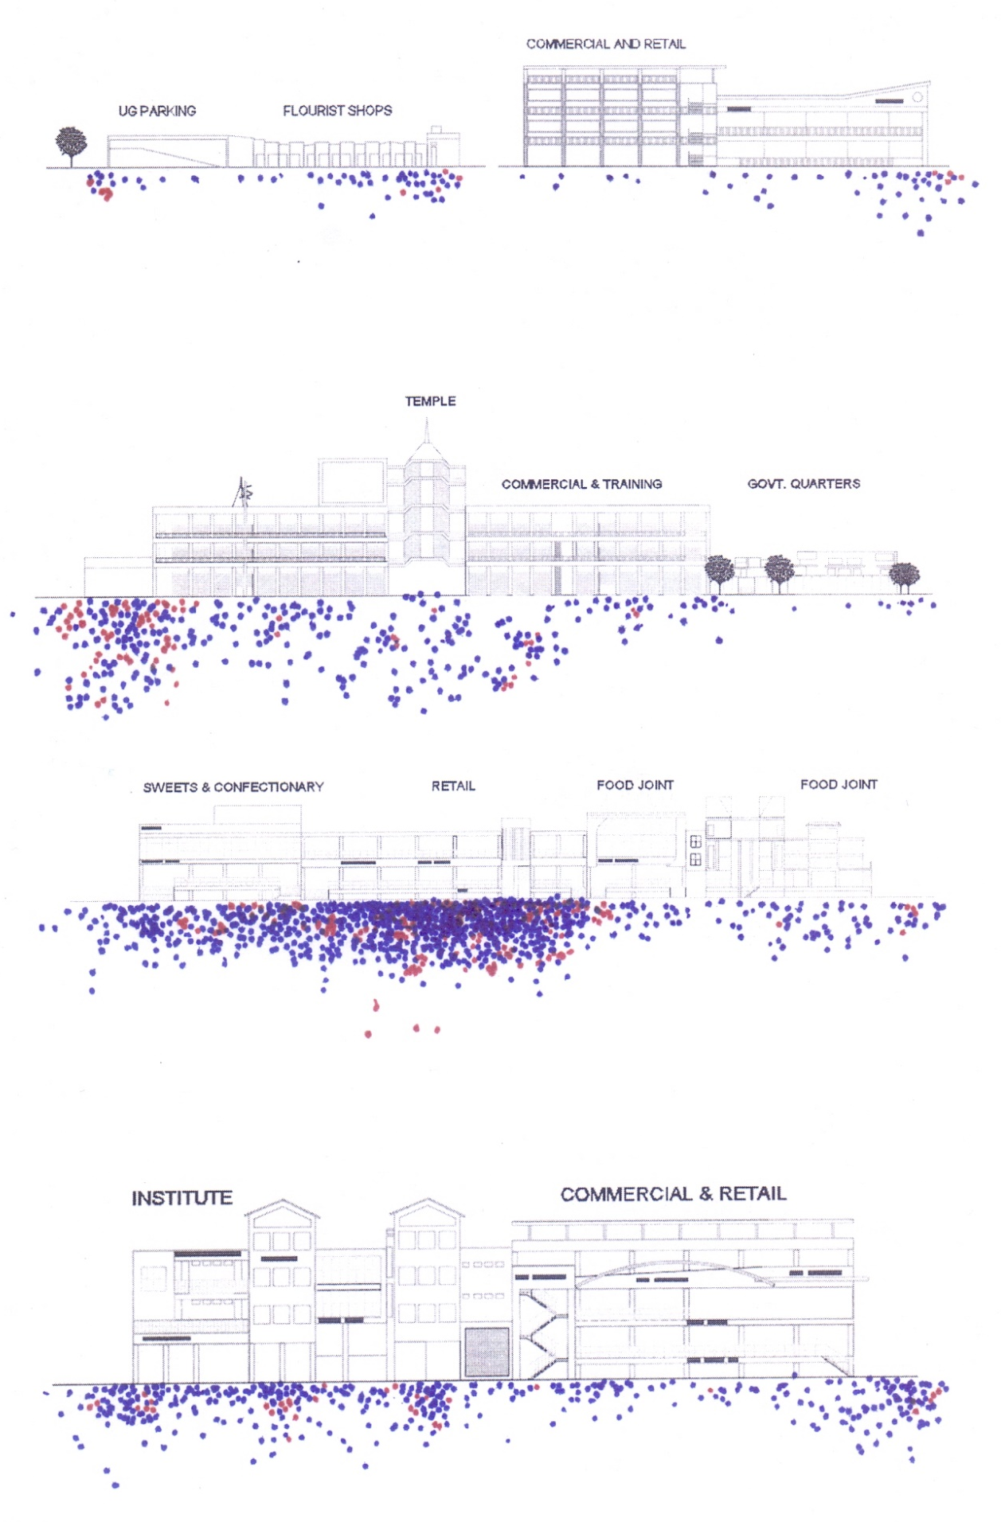

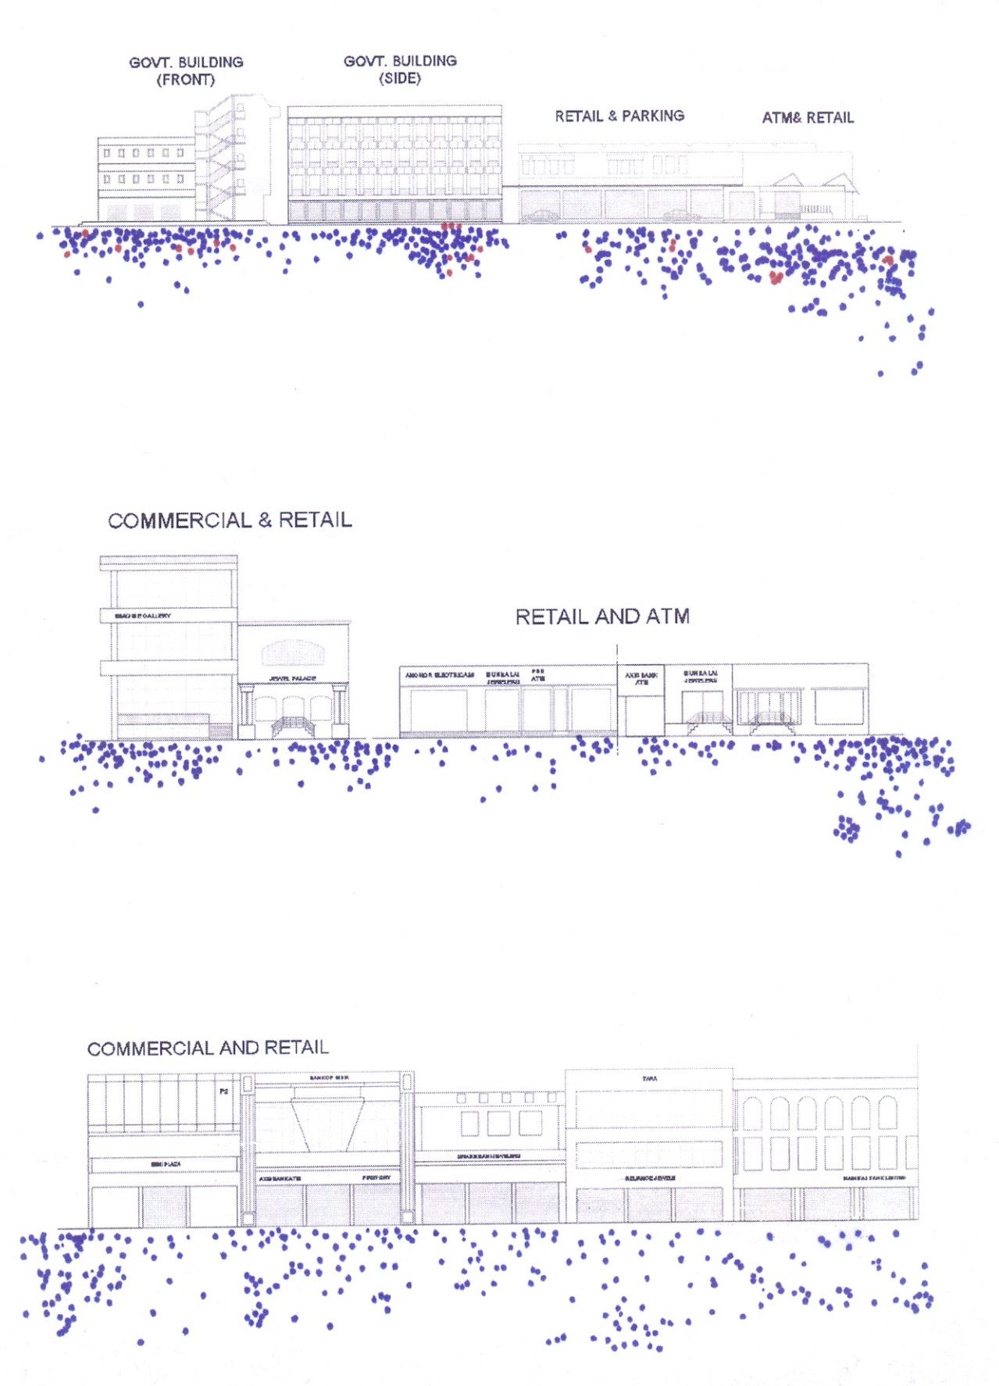

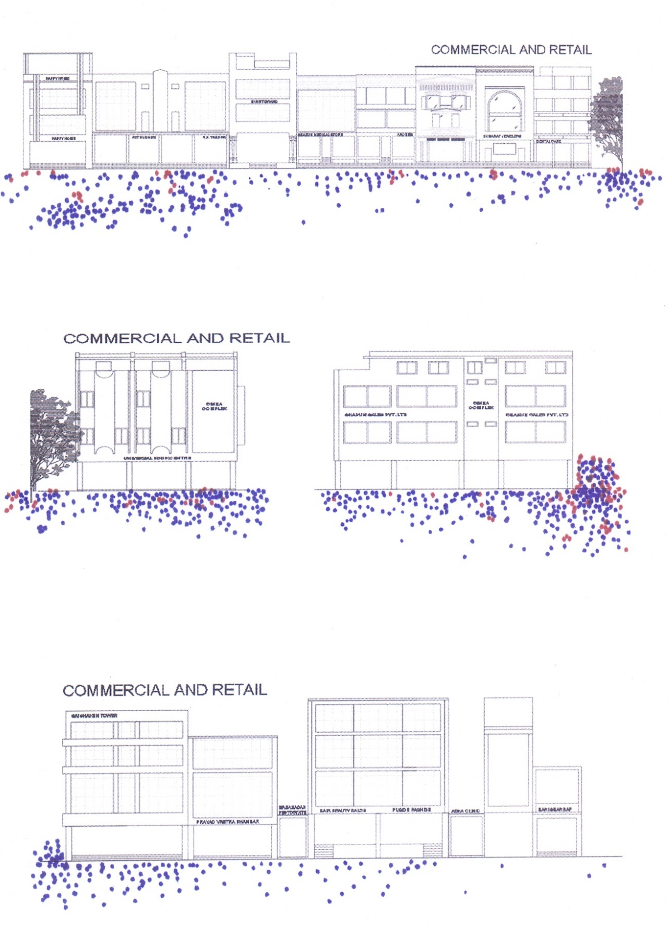

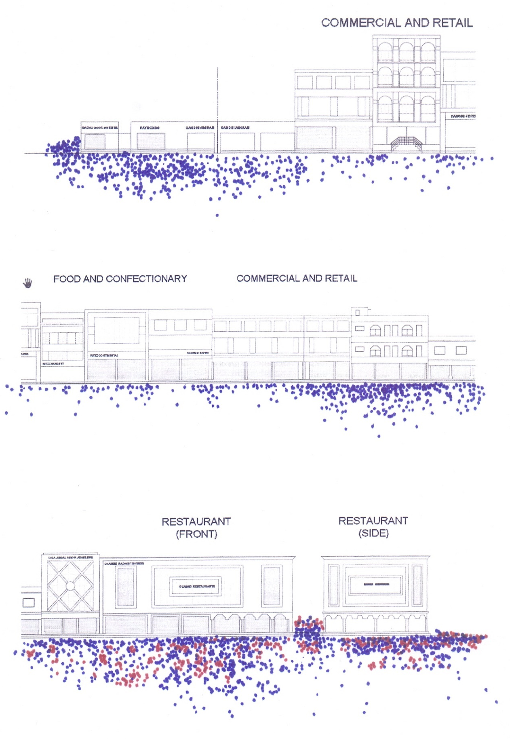

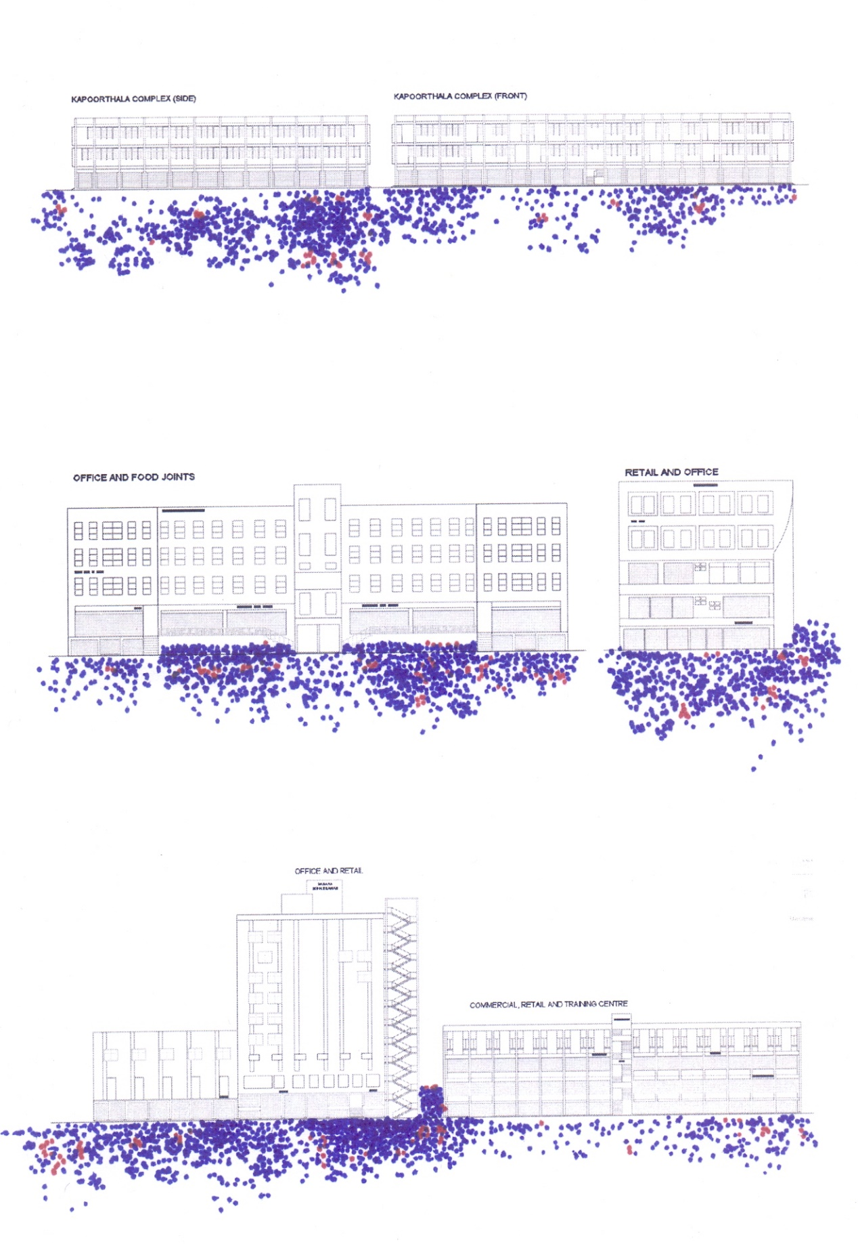
Figure 5.9 Behavioural map of people engaged in stationary and social activities

Duration of Stay
Lengthy stay means lively street; time duration spent over the area with engagement in stationary and social activities are strongly connected with the measurement of the liveliness in particular. Structured observation on weekdays and weekends over the streets showed the readings of people’s stay duration. Figure 5.10, Figure 5.11, Figure 5.12, Figure 5.13 shows the duration of stay between 15 seconds to more than 15 minutes of the people engaged in stationary as well as social activities. It was showed that at block 20, people’s stay time duration is quite high, more of the people are spending more than 15 minutes of time; while at block 4, the engagement in stationary and social activities are high but stay duration is low (between 15 seconds to 1 minutes). At block 6, 13, 18, 22, consistency can be seen in terms of time duration means almost the same amount of people were engaged for various time slots between 15 seconds to more than 15 minutes.
Block segment number 1 to 6 had showed the people’s engagements but for momentary, it may be because of, the block segment 1 was the starting point of the street to enter, where peoples are leaving their public or private vehicles, block segment 2-6 had the same characteristics as it could be because of underground parking at block segment no 4. The same case is with block segment number 69, which may be because of land use quality, there was a beer and wine shop in this block segment which most of the people preferred to take away rather than staying as no such seating arrangements were there. The case of block segment 87-88 is same as block segment no 1-3, as this is also at the end of the street and work as vehicle pick and drop point and, in result showed the high engagement but for a short duration of time. With the figure it is clearly indicated that people engaged in stationary and social activities for more time duration where they have either some seating arrangements or have some significant business nature.
Figure 5.10 Duration of stay of people in stationary and social activities on weekdays and weekends on all 01-26 blocks
Figure 5.11 Duration of stay of people in stationary and social activities on weekdays and weekends on 01-27 block segments
It could be easily concluded that a strong relationship exists between stay duration and the seating opportunity as well as business characters over the street to make the environment live and accounts in preferred third place.
Figure 5.12 Duration of stay of people in stationary and social activities on weekdays and weekends on 28-57 block segments
Figure 5.13 Duration of stay of people in stationary and social activities on weekdays and weekends on 58-88 block segments

Measuring liveliness index- Core characteristic for preferred third place
To check and compare the preferred third place, core characteristic as liveliness index was calculated of each block segments (N= 88) and, establish the further relations with various street attributes which contributes in making it as preferred third place.
Liveliness is actually the sum of time spent by each individual or group in any short of stationary or social activities. Using the observations and results of stationary activities as well as social activities happening at the block segments (length ~ 60 fit) or block (length ~ 200 fit), and people’s duration of stay at each block segment or block, liveliness index score was calculated and standardized.

Liveliness score = (A₁*X₁) +(A₂*X₂) +(A₃*X₃) +………(A_{n}*X_{n})
Where:
A₁, A₂, A₃…...A_{n} = Assigned score for various time duration (chapter 3, Table 3.12)
X₁, X₂, X₃…...…X_{n} = Number of people engaged in stationary or social activity for respective time duration
As discussed in the chapter 3, a Liveliness Index was calculated for each street block and block segments to be able to examine the relationships between user attitudes and perceptions gathered through surveys and interviews, and the liveliness of the street at the scale of the block and block segments (Table 5.14). Over the street, some blocks had the masjid and mandir which resulted in the accumulation of large amount of people observed before and after the prayers; this showed an unrealistic jump in liveliness index of the block/ street and thus these were exempted from the final liveliness index calculation. Another issue was uneven length of the blocks; which had been moderated to the average length of block present over the street. Accordingly, calculated liveliness index was adjusted (multiplied or divided) to match the average length (200fit) found.
Table 5.14 Liveliness index at Block segment and Block level
Study Area Name | Block No. | Block Segment number | Liveliness per Block Segment  (Length of Block Segment: 60') |  | Liveliness per Block  (Length of Block: 200')
 |  |  | Liveliness Score | Standardized Score | Liveliness Score | Standardized Score
Bhootnath Market | B 01 | 1 | 657 | 2.2 | 2587 | 4
 |  | 2 | 784 | 3.3
 |  | 3 | 887 | 4.3
 | B 02 | 4 | 809 | 3.6 | 200 | 0
 |  | 5 | 799 | 3.5
 |  | 6 | 896 | 4.3
 | B 03 | 7 | 547 | 1.2 | 1214 | 2
 | B 04 | 8 | 516 | 1.0 | 4004 | 6
 |  | 9 | 807 | 3.5
 |  | 10 | 1209 | 7.1
 |  | 11 | 1360 | 8.4
 |  | 12 | 1514 | 9.8
 | B 05 | 13 | 853 | 4.0 | 1896 | 3
 | B 06 | 14 | 1084 | 6.0 | 5230 | 8
 |  | 15 | 1539 | 10.0
 |  | 16 | 1532 | 9.9
 |  | 17 | 1456 | 9.3
 |  | 18 | 1452 | 9.2
 | B 07 | 19 | 1020 | 5.4 | 3663 | 6
 |  | 20 | 1012 | 5.4
 |  | 21 | 1116 | 6.3
 |  | 22 | 1249 | 7.4
 | B 08 | 23 | 1364 | 8.5 | 6164 | 10
 | B 09 | 24 | 1109 | 6.2 | 2517 | 4
 | B 10 | 25 | 813 | 3.6 | 3552 | 6
 |  | 26 | 959 | 4.9
 |  | 27 | 1159 | 6.7
Gole Market | B 11 | 28 | 1051 | 5.7 | 3503 | 6
 | B 12 | 29 | 890 | 4.3 | 3578 | 6
 |  | 30 | 1257 | 7.5
 | B 13 | 31 | 949 | 4.8 | 2992 | 5
 |  | 32 | 1016 | 5.4
 |  | 33 | 1061 | 5.8
 |  | 34 | 1015 | 5.4
 | B 14 | 35 | 904 | 4.4 | 2753 | 4
 |  | 36 | 1104 | 6.2
 |  | 37 | 697 | 2.6
 |  | 38 | 599 | 1.7
 | B 15 | 39 | 755 | 3.1 | 4755 | 8
 |  | 40 | 1108 | 6.2
 |  | 41 | 1055 | 5.7
 |  | 42 | 1363 | 8.4
 | B 16 | 43 | 665 | 2.3 | 1590 | 2
 |  | 44 | 600 | 1.7
 |  | 45 | 405 | 0.0
 | B 17 | 46 | 1228 | 7.3 | 2747 | 4
 |  | 47 | 1102 | 6.1
 |  | 48 | 555 | 1.3
 | B 18 | 49 | 543 | 1.2 | 2957 | 5
 |  | 50 | 602 | 1.7
 |  | 51 | 578 | 1.5
 |  | 52 | 1102 | 6.1
 |  | 53 | 1168 | 6.7
 | B 19 | 54 | 1349 | 8.3 | 4700 | 8
 |  | 55 | 1457 | 9.3
 |  | 56 | 1424 | 9.0
 |  | 57 | 1411 | 8.9
Kapoorthala Market | B 20 | 58 | 614 | 1.8 | 3512 | 6
 |  | 59 | 996 | 5.2
 |  | 60 | 725 | 2.8
 |  | 61 | 504 | 0.9
 |  | 62 | 1104 | 6.2
 |  | 63 | 1502 | 9.7
 |  | 64 | 1475 | 9.4
 |  | 65 | 1367 | 8.5
 |  | 66 | 1198 | 7.0
 | B 21 | 67 | 1360 | 8.4 | 4771 | 8
 |  | 68 | 1503 | 9.7
 | B 22 | 69 | 1260 | 7.5 | 4638 | 7
 |  | 70 | 1521 | 9.8
 |  | 71 | 1448 | 9.2
 |  | 72 | 1478 | 9.5
 |  | 73 | 1252 | 7.5
 | B 23 | 74 | 1010 | 5.3 | 2660 | 4
 |  | 75 | 963 | 4.9
 |  | 76 | 615 | 1.9
 |  | 77 | 546 | 1.2
 |  | 78 | 857 | 4.0
 | B 24 | 79 | 1502 | 9.7 | 4487 | 7
 |  | 80 | 1304 | 7.9
 |  | 81 | 1507 | 9.7
 |  | 82 | 1363 | 8.5
 |  | 83 | 1055 | 5.7
 | B 25 | 84 | 759 | 3.1 | 2741 | 4
 |  | 85 | 800 | 3.5
 |  | 86 | 908 | 4.4
 | B 26 | 87 | 999 | 5.2 | 3428 | 5
 |  | 88 | 1058 | 5.8

Discussion
The study and analysis performed in preceding section aimed to measure liveliness index of the block segment or block of the neighbourhood commercial street which was directly affected by the attributes of built environment setting. Apart from the unstructured direct observation; direct observations reveal about the comfort and desires of the people, and marked their behaviour, as where and how they wanted to stand, lean, and linger, and up to what duration; in other ways, who’s amongst them or which group wanted to use any space for what activity and for how much time.
Start with, behavioural mapping of the street and its associated spaces had given the above-mentioned required data. From there, activities accounted in preferred third place designation were marked, their time duration were recorded; and computed to achieve the liveliness index of the block segment or block. It is revealed in results of liveliness index data that some block segments which were not even had significant attributes were comparatively livelier that other block segments. For an instance, at block segment 79 and 81 of block 24 over Kapoorthala market area, this block segment had nothing except some open space with a coffee machine, while 81 had just a vacant part of land. People preferred these spaces just to stand and watch the street while at block segment 81, group of people used to perform some activities like guitar, violin and stayed there for longer period of time. However, it is very clear through the analysis that liveliness may increase if a greater number of people visiting even for a shorter duration; or a smaller number of people staying for a longer duration. In other words, to increase the liveliness, a rhythmic flow should be maintained or, there must have some magnet for lingering people.
Further, liveliness index data were standardized between 1 to 10 at block segment level and block level each, for comparative study and establishing relation between the activities and their enabled built environment attributes.

In this section of the chapter, research had tried to identify the relation if exist between the attributes of the built environment setting and, the activities and user behaviour over the street in context of preferred third place. Wide range of direct observations were carried out at the three study areas to map user-behaviour added with field notes, photographs, and short videos. Observations discovered that people interacted with several characteristics of the street, and certain qualities supported their activities and behaviours. These potentials and characteristics were often physical characteristics, but they also jumbled the kind of businesses on the street and how these businesses and the street space were managed and operated. These characteristics were followed as unstructured observation from the focus group survey at the beginning and interviews taken for the street environment to counterpart the structured observation data collected through observations. Together they provided a body of empirical information on the aspects of the street environment that contributed to retaining people on neighbourhood commercial streets and supporting preferred third place’s determinations.

Variety of goods and services
As revealed from the focus group survey, user of the street indicated about the multiple choices in their daily routine or other items, they were happy about the stationary shops, computer shops, mobile stores, food joints at one single block or along the street; and even they were quite satisfied in visiting multiple shops for any single item during
Table 5.15 Correlation matrix: variety of goods and services, and liveliness
Correlations
 |  | core characteristic of preferred third place (liveliness) | street characteristic 1: variety of goods and services
core characteristic of preferred third place (liveliness) | Pearson Correlation | 1 | .506**
 | Sig. (2-tailed) |  | .000
 | N | 88 | 88
street characteristic 1: variety of goods and services | Pearson Correlation | .506** | 1
 | Sig. (2-tailed) | .000
 | N | 88 | 88
**. Correlation is significant at the 0.01 level (2-tailed).
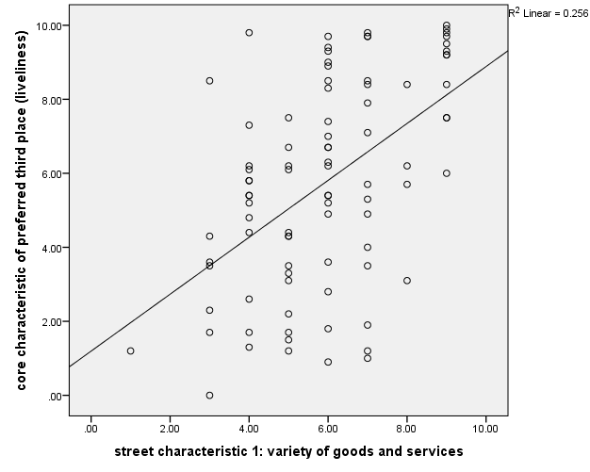
Figure 5.14 Relationship between variety of goods and services, and liveliness
their one single visit. So, in unstructured direct observation, variety of goods and services were seen as an important factor in determining their preferences for the block or street. In structured direct observation, (Table 5.15, Figure 5.14) it reveals that variety of goods and services were significantly correlated (Pearson’s Correlation r=.506, p˂.01), it means the block which had variety of goods and services were also livelier.

Permeability of street front
Sensing the inside from outside is an important phenomenon to make any space or area livelier, at the three-study area taken unstructured direct observations reveals during focus group survey that window shopping, fashion trends specially in females, toys display in case of kids, foods/ snacks specially smells attracts people to visit the block. Same in structured direct observation, analysis found that the street wall/ store front etc. which had more permeability were livelier and people preferred the block. The preferences of the people were in a kind of standing or in bowing posture with support of bikes parked, gossiping in front of these shops, stores or street walls even. Correlation matrix (Table 5.16, Figure 5.15) showed that variable as permeability of street wall façade is significantly correlated (Pearson’s Correlation r=.590, p˂.01) to dependent variable as liveliness.
Table 5.16 Correlation matrix: permeability of street wall façade, and liveliness
Correlations
 |  | core characteristic of preferred third place (liveliness) | street characteristic 2: permeability of street wall façade
core characteristic of preferred third place (liveliness) | Pearson Correlation | 1 | .590**
 | Sig. (2-tailed) |  | .000
 | N | 88 | 88
street characteristic 2: permeability of street wall façade | Pearson Correlation | .590** | 1
 | Sig. (2-tailed) | .000
 | N | 88 | 88
**. Correlation is significant at the 0.01 level (2-tailed).

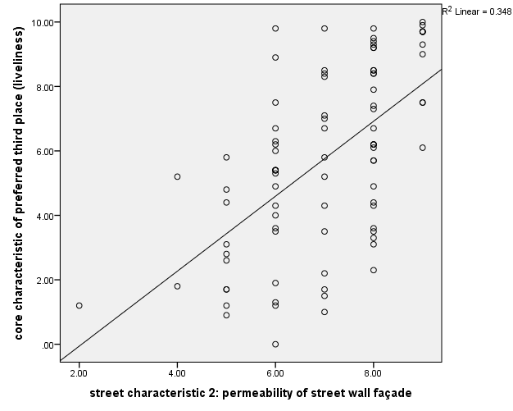
Figure 5.15 Relationship between permeability of street wall façade, and liveliness

Personalization of street front
The personalization of places serves many purposes: psychological security and symbolic aesthetic as well as the adaptation of the environment to meet the needs of specific activity patterns. Above all, however, personalization marks territory. The expression of territorial claim varied with the support of personalization, store fronts especially mobile, computer, and snacks vendors were claiming and extending their territory through distinguish paintings, displaying posters, with signage stands, bringing their goods and stack in front of their shops, or by putting chairs or benches in front of their shops and stores over the all three-study area. At block segment number 63 of block 20, snack vendor had put up their chulha in front of his shop and spare some space to a cigarette kiosk too; through this, he had tried to personalize his part and expanded his territory. Table 21 indicates the liveliness index of this block segment was 9.7 too. With similar other block segment data, result indicates that the block segment with a higher degree of personalization were better able to afford an increased level of territorial behaviour on the street and were thus livelier.
Table 5.17 and Figure 5.16 showed that both dependent and independent variables were strongly correlated (Pearson’s Correlation r=.647, p˂.01). The articulation of the building façade at the street level and at the entrance, played a significant role in forming transitional space between the street and interior that could be personalized and
Table 5.17 Correlation matrix: personalization of the façade, and liveliness
Correlations
 |  | core characteristic of preferred third place (liveliness) | street characteristic 3: personalization of the façade
core characteristic of preferred third place (liveliness) | Pearson Correlation | 1 | .647**
 | Sig. (2-tailed) |  | .000
 | N | 88 | 88
street characteristic 3: personalization of the façade | Pearson Correlation | .647** | 1
 | Sig. (2-tailed) | .000
 | N | 88 | 88
**. Correlation is significant at the 0.01 level (2-tailed).

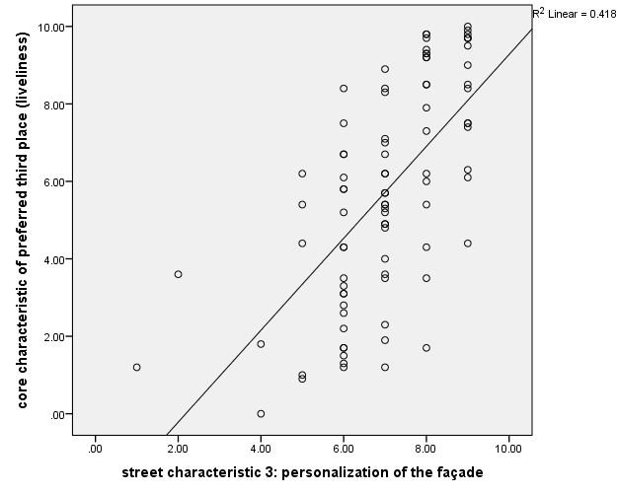
Figure 5.16 Relationship between personalization of the façade, and liveliness
territorialized by the storeowners. The presence of this space to mediate between the street and store’s interior space helped in supporting physical expressions of a claim to territory on the street.

Articulation of street front
The articulation of the street front is actually the articulation of building façade placed over the street; it is a characteristic that is determined by the architecture of the buildings located there. Physical characteristics and uses identified as causal to retaining people in public spaces and possibly supporting social behaviour include a high degree of articulation with nooks, corners, small setbacks in adjacent walls, and so on (Alexander, 1977; Joardar & Neill, 1978; Gehl, 1987; Whyte, 1980). Attractiveness and Interesting Appearance were measured on a visual rating scale, and related to stimuli from fixed, semi-fixed, and movable elements such as the articulation of the building façade, the openings at street level, lighting fixtures, furniture on the sidewalk, signs, plantings, displays, and a variety in these elements. Hence, articulation of street front was taken up as variables in an attempt to capture the sensory pleasure that the street environment as a setting was able to offer to its users. In context to research and study area taken, it was evident that articulation was not playing the role that may be because of extensiveness of signages, billboards, posters etc. were placed in a very haphazard way and the originality of façade articulation overlooked somehow. In analysis (Table 5.18, Figure 5.17) with the value of Pearson Correlation r =.155, it was found that the users were not noticing the articulation part but rather the other street characteristics.
Table 5.18 Correlation matrix: street wall façade articulation, and liveliness
Correlations
 |  | core characteristic of preferred third place (liveliness) | street characteristic 4: street wall façade articulation
core characteristic of preferred third place (liveliness) | Pearson Correlation | 1 | .155
 | Sig. (2-tailed) |  | .150
 | N | 88 | 88
street characteristic 4: street wall façade articulation | Pearson Correlation | .155 | 1
 | Sig. (2-tailed) | .150
 | N | 88 | 88
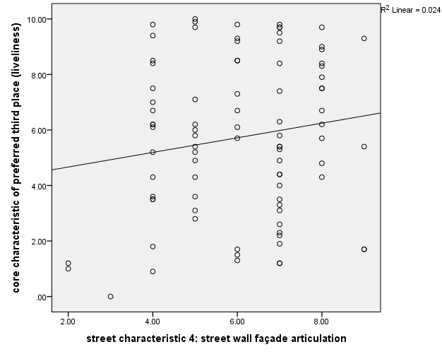
Figure 5.17 Relationship between street wall façade articulation, and liveliness

Foreground cover under shade and shelter
In region like Lucknow where 5-6 months are under hot sun, people’s preferences were obvious for under shaded spaces. People have seen to stand in group under the trees over the street of Bhootnath market area, most of the people were seen in covered verandas running along the street; some time they were seen involved in certain social activities under building sheds. During summer it was evident in structured direct observation that people prefer to go over these streets in evening rather in noon or during sunny time. Same as in rainy seasons it was revealed that people preferred the spaces which had shades like covered veranda, awning, trees, overhangs etc.; user comments on retaining the physical characteristics as well as suggestions for change to make the street more pedestrian-friendly included the availability of shade and shelter from the sun and rain with the help of trees, canopies, awnings and overhangs on these blocks of Bhootnath market, Kapoorthala market and Gole market area. This was consistent with the findings of the observations, Table 5.19 and Figure 5.18 indicates their mutual interdependence (Pearson’s Correlation r=.291, p˂.01), though it is interdependence is not very strong but showed that block-segments that provided greater opportunities for shade and shelter were also livelier
Table 5.19 Correlation matrix: foreground cover under shade or shadow, and liveliness
Correlations
 |  | core characteristic of preferred third place (liveliness) | street characteristic 5: foreground cover under shade or shadow
core characteristic of preferred third place (liveliness) | Pearson Correlation | 1 | .291**
 | Sig. (2-tailed) |  | .006
 | N | 88 | 88
street characteristic 5: foreground cover under shade or shadow | Pearson Correlation | .291** | 1
 | Sig. (2-tailed) | .006
 | N | 88 | 88
**. Correlation is significant at the 0.01 level (2-tailed).

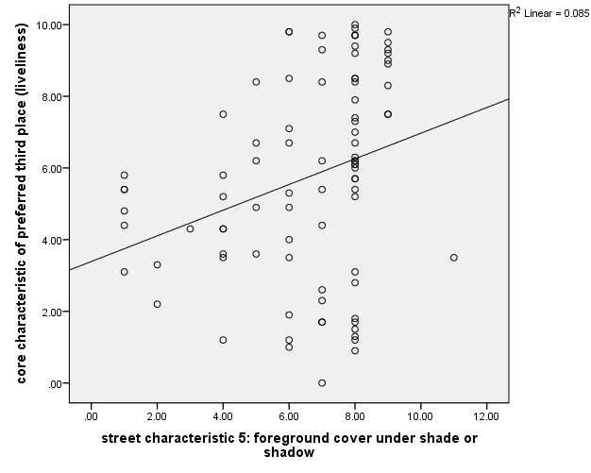
Figure 5.18 Relationship between foreground cover under shade or shadow, and liveliness

Community places
Community places are the destination where people prefer to spend time at to meet neighbours, friends and strangers, to chat, read, work, play games, listen to music, and so on. All three neighbour commercial streets of study area had some business points which act as community place for the people specially the resident and workers of surrounding neighbourhood areas. People reported and were seen engaged in a variety of activities at these businesses. These businesses supported a higher level of activity for longer durations compared to other businesses. In cases where the physical characteristics of the street, such as the ones identified in this study, were present these community places became anchors for liveliness. Over Bhootnath market area, block segment number 11,12, 17 had the famous gift shop, chaat wala vendor and babian restaurant respectively which acts as the community place for the people over and surrounded area; over Gole market, on block segment number 28,30,40,46, 56,57, it had some chaat vendor, tea stalls, cigarette kiosks, snacks stalls, and restaurants acts as community places for the people; while over Kapoorthala market area it was with the block segment number 59,63,70,71,72,79,80,81, which had some snacks stall, book stores, coffee shop, and nukkad café etc. which were demonstrating their presence as community place for the street (Table 5.20, Figure 5.19).
Table 5.20 Correlation matrix: number of community places, and liveliness
Correlations
 |  | core characteristic of preferred third place (liveliness) | street characteristic 6: number of community places
core characteristic of preferred third place (liveliness) | Pearson Correlation | 1 | .738**
 | Sig. (2-tailed) |  | .000
 | N | 88 | 88
street characteristic 6: number of community places | Pearson Correlation | .738** | 1
 | Sig. (2-tailed) | .000
 | N | 88 | 88
**. Correlation is significant at the 0.01 level (2-tailed).

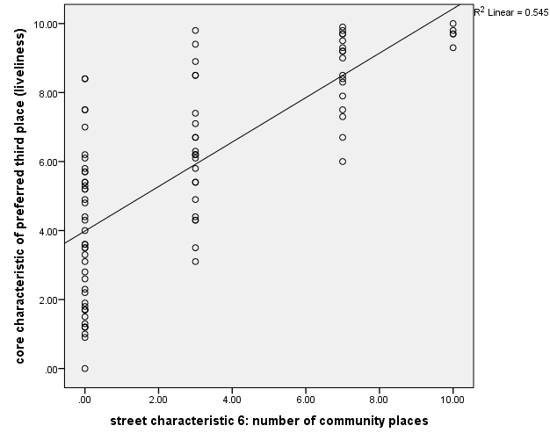
Figure 5.19 Relationship between number of community places, and liveliness

Sense of safety over street
It is suggested that desirable neighbourhood commercial streets would be ones that provide a sense of safety, and opportunities for social contact and interaction. Sense of safety provides an opportunity for socializing.
In this research, the base measurement of liveliness index was at block segment level, which was quite small as a unit, so block (200 fit) was taken to measure the sense safety over the street. In other point, general safety was replaced with ‘safety after dark’ which can give a sense for general safety in daytime also. Through observation, surveys and interviews it was seen that physical condition and state of maintenance, the perception of safety was not affected by physical condition. However, people perceived some of the blocks in each study area to be relatively less safe specially nearby the parking lots or at the blocks which has only day businesses (training centres, small offices, garments shops hardware stores etc.); the blocks which had the variety in businesses and food/ snacks shops or stores were seen as safer in user perception. People seen to be very confident in terms of sense of safety at the places where the opening hours of stalls or kiosks were till late night. Structured direct observation also reveals that women feel comparatively less safe over the block where street lighting fixtures, illumination levels after dark, no significant signs of anti-social activity or unruly behaviour recording were ambiguous (Table 5.21, Figure 5.20).
Table 5.21 Correlation matrix: sense of safety after dark, and liveliness
Correlations
 |  | core characteristic of preferred third place (liveliness) | street characteristic 7: sense of safety after dark
core characteristic of preferred third place (liveliness) | Pearson Correlation | 1 | .388**
 | Sig. (2-tailed) |  | .000
 | N | 88 | 88
street characteristic 7: sense of safety after dark | Pearson Correlation | .388** | 1
 | Sig. (2-tailed) | .000
 | N | 88 | 88
**. Correlation is significant at the 0.01 level (2-tailed).
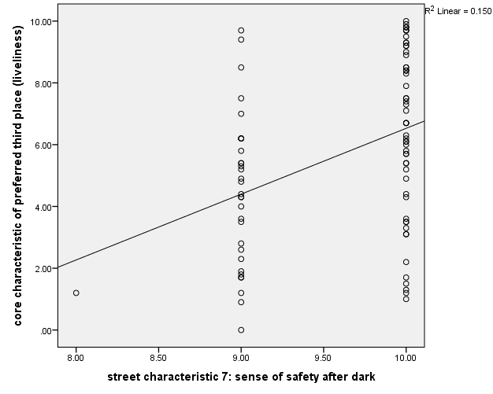
Figure 5.20 Relationship between sense of safety after dark, and liveliness

Seating opportunity
Seating opportunity has been identified as one of the most important characteristics in retaining people in public spaces and possibly supporting social behaviour (Whyte, 1980; Linday, 1978). The verdicts in this study incline to authenticate Whyte’s findings. People attracted more people, provision of seating opportunity attracts and retained people to a longer duration for socializing activities which ultimately impacted the liveliness of the space or area. Over all three-study area it has been seen in structured direct observation that people were in uncomfortable sitting posture depreciating the comfort in sitting in a proper posture in absence of commercial or non-commercial chairs, benches, they prefer to sit on the vehicles parked in front of the blocks or block segments. Apart from this people have been seen in sitting posture on steps, ledges or sometimes on bollards placed somewhere in proximity of block segments. Over the study area in all three neighbourhood commercial streets, people were seen to sit either on steps, pedestals, on parked two-wheeler vehicles or sometimes on benches provided by the shops or stores in proximity of block segment number 16,17,18,27,42,43,55,56,57,64,65,70,71,72,79,80,81,85,86. Table 5.22 and Figure 5.21 are showing the relationship of liveliness to the seating opportunities provided and validating (Pearson’s Correlation r=.653, p˂.01) the Whyte’s finding for this study area too.
Table 5.22 Correlation matrix: availability of seating or sitting spaces, and liveliness
Correlations
 |  | core characteristic of preferred third place (liveliness) | street characteristic 8: availability of seating or sitting spaces
core characteristic of preferred third place (liveliness) | Pearson Correlation | 1 | .653**
 | Sig. (2-tailed) |  | .000
 | N | 88 | 88
street characteristic 8: availability of seating or sitting spaces | Pearson Correlation | .653** | 1
 | Sig. (2-tailed) | .000
 | N | 88 | 88
**. Correlation is significant at the 0.01 level (2-tailed).

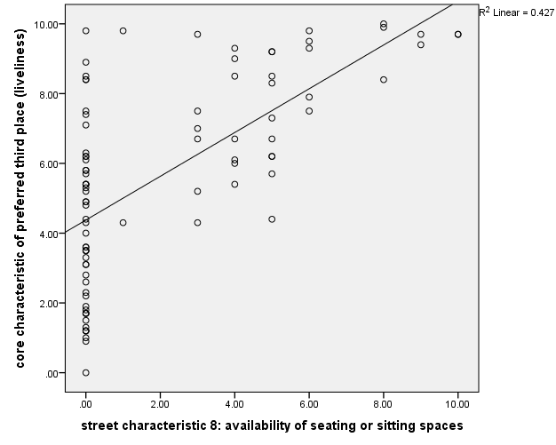
Figure 5.21 Relationship between availability of seating or sitting spaces, and liveliness

Other street furniture and physical artefacts
By personalizing a space, people transform the environment to meet their needs and specific activity patterns; physical artefacts play an important role in personalizing the block by defining the territory, providing psychological security and, a symbolic aesthetic. In this research it has been evident through unstructured as well as structured observations that other street furniture and physical artefacts attracts people (Table 5.23, Figure 5.22) and engaged them in social activities (Pearson’s Correlation r=.436, p˂.01).
Observations showed that less than 6 percent of over 47436 users carried out any stationary or social activities in the open part of the sidewalk away from physical artefacts. Physical artefacts on the sidewalk included building walls, show-windows, steps, fences, gates, benches, tables and chairs, planters, advertisement signs on the sidewalk, tree guards, bicycle stands, trashcans, light poles, sign posts, tree trunks, railings, fire hydrants, electrical panel boxes, post-boxes, parking barriers, vehicles parked near the sidewalk, and so on. These were objects on which the users sat or leaned or just stood next to.
Table 5.23 Correlation matrix: other street furniture and physical artefacts, and liveliness
Correlations
 |  | core characteristic of preferred third place (liveliness) | street characteristic 9: availability of other street furniture and physical artefacts
core characteristic of preferred third place (liveliness) | Pearson Correlation | 1 | .436**
 | Sig. (2-tailed) |  | .000
 | N | 88 | 88
street characteristic 9: availability of other street furniture and physical artefacts | Pearson Correlation | .436** | 1
 | Sig. (2-tailed) | .000
 | N | 88 | 88
**. Correlation is significant at the 0.01 level (2-tailed).

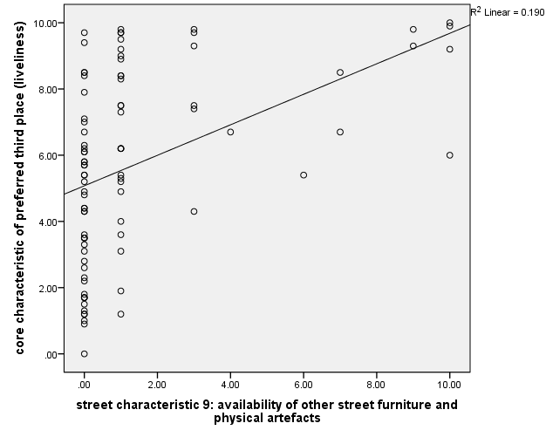
Figure 5.22 Relationship between other street furniture and physical artefacts, and liveliness

Swachhata (Cleanness) of the area
Swachhata (cleanness) has been taken as mission by government of India for the period 2014 to 2019 that aims to clean up the streets, roads and infrastructure of India's cities, towns, and rural areas. In this research (Table 5.24, Figure 5.23) it has been revealed that people prefer to choose the block or block segment and get themselves engaged in stationary or social activities where they find a clean setting (Pearson’s Correlation r=.653, p˂.01).
Table 5.24 Correlation matrix: cleanness status of the area, and liveliness
 |  | core characteristic of preferred third place (liveliness) | street characteristic 10: cleanness status of the area
core characteristic of preferred third place (liveliness) | Pearson Correlation | 1 | .402**
 | Sig. (2-tailed) |  | .000
 | N | 88 | 88
street characteristic 10: cleanness status of the area | Pearson Correlation | .402** | 1
 | Sig. (2-tailed) | .000
 | N | 88 | 88
**. Correlation is significant at the 0.01 level (2-tailed).

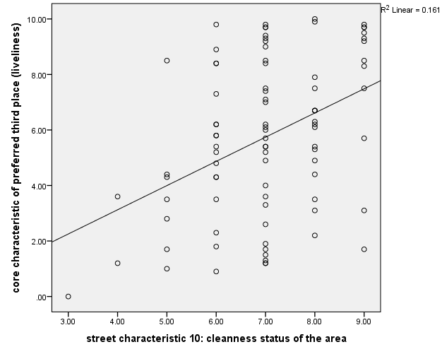
Figure 5.23 Relationship between cleanness status of the area, and liveliness

Pedestrian Centred Strategies and condition
The orientation of this research was pedestrian behaviour and their activities over the street to meet the user expectation was perceived it as preferred third place; so, it was important to determine whether the users perceived the street as a pedestrian-friendly environment or not. In focus group survey it was found that people prefer to sit, walk, and pedestrian friendly environment and physical comfort to engaged themselves in social activities. Results show that the blocks on the streets that were perceived as being more pedestrian-friendlier were also the ones that were livelier. Additionally, as discussed earlier, people emphasized pedestrian-friendliness as an important quality that they wanted to retain. In suggesting changes and additions, they prioritized it as a quality for the blocks that were not already pedestrian-friendly.
The most common suggestion for all three streets was to retain the existing variety and diversity of uses and stores as well as the physical and visual characteristics that made the street more pedestrian-friendlier. With the data (Table 5.25, Figure 5.24) recorded it has been indicated that pedestrian centred strategies positively affected the liveliness of the block or block segment (Pearson’s Correlation r=.653, p˂.01).
Table 5.25 Correlation matrix: Pedestrian Centred Strategies and Condition, and liveliness
Correlations
 |  | core characteristic of preferred third place (liveliness) | street characteristic 11: pedestrian centred strategies and condition
core characteristic of preferred third place (liveliness) | Pearson Correlation | 1 | .464**
 | Sig. (2-tailed) |  | .000
 | N | 88 | 88
street characteristic 11: Pedestrian Centred Strategies and Condition | Pearson Correlation | .464** | 1
 | Sig. (2-tailed) | .000
 | N | 88 | 88
**. Correlation is significant at the 0.01 level (2-tailed).

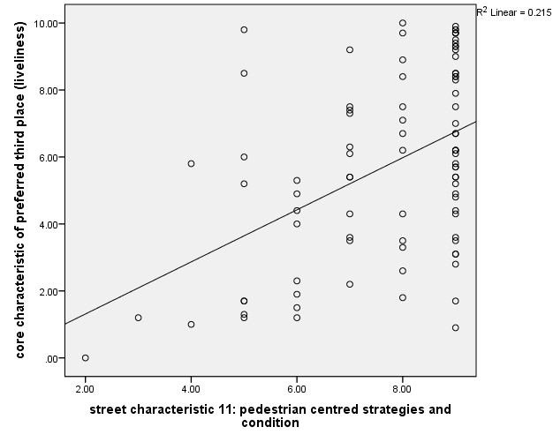
Figure 5.24 Relationship between Pedestrian Centred Strategies and Condition, and liveliness

Discussion
Assignation among the physical layout of the environment, the elements of behavioural environment (uses, activities, and management) and the places that have collective meanings for the community is indispensable for the social life on neighbourhood commercial streets at Lucknow, this could be easily seen through verdicts presented in the preceding pages. A physically well-designed street for people, with generous sidewalks, ample seating and other street furniture, tree-cover and other landscape elements, articulated street facades of buildings, barrier free design of the outdoors, and so on, becomes much more useful and meaningful for people when there are community-gathering places and a variety of activity-supporting stores and other land uses at the street, and vice versa.
If we see the block segment 59,60,61 of block 20 over Kapoorthala market area, it indicates the role of physical characteristics of the built setting as block segment 59 had the famous snacks counter and had some provision for commercial seating along with some out-door space to stand is richer in liveliness index in comparison to the block segment 60,61 which were just next to this. This emerged because block segment had some magnetic business variety along with better physical characteristics in settings rather than of block segment 60,61, which had a bank as business type, having just blank façade means with a low degree of permeability. This is evident that with variation in just two characteristics, a variance in their liveliness index may occur up to 5.2, 2.8, 0.9 (block segment 59,60,61) respectively. Same in case of personalization, which is strongly significant to the liveliness index while, the characteristic façade articulation didn’t show a good significance with the core characteristics of preferred third place. Number of community places emerged as strongly significant characteristics followed by seating opportunity. This research shows how the seamless activities over the street is influenced by the impact of attributes of the physical environment and designate the space or street as preferred third place other than others.

In this section, research had tried to identify the relation amongst street characteristics identified in chapter 3 and analysed for their significance in establishing a preferred third place over neighbourhood commercial street at chapter 5. Eleven identified characteristics were attempted to establish a relationship with core characteristics of preferred third place (liveliness), it has been observed that the ‘street characteristics 4: street wall façade articulation’ was not significantly correlated, which was revealed in previous analysis section. Table 5.26 shows the correlations between these characteristics and liveliness of the neighbourhood commercial street.
Table 5.26 Relationship between characteristics of street and liveliness
 | Street Characteristics | r- value
Pearson Correlation | street characteristic 1: variety of goods and services | .506**
 | street characteristic 2: permeability of street wall façade | .590**
 | street characteristic 3: personalization of the façade | .647**
 | street characteristic 4: street wall façade articulation | .155
 | street characteristic 5: foreground cover under shade or shadow | .291**
 | street characteristic 6: number of community places | .738**
 | street characteristic 7: sense of safety after dark | .388**
 | street characteristic 8: availability of seating or sitting spaces | .653**
 | street characteristic 9: availability of other street furniture and physical artefacts | .436**
 | street characteristic 10: cleanness status of the area | .402**
 | street characteristic 11: pedestrian centred strategies and condition | .464**
**. Correlation is significant at the 0.01 level (2-tailed).
To start with a multivariate regression analysis (Table 5.27, Table 5.28) with all the eleven street characteristics and this sowed that together these variables explained 71.5% variation in liveliness index across all the 88 different block-segments on three neighbourhood commercial streets (adjusted R2=0.674, F=17.31, Sig. of F=0.000). Table 5.29 of multivariate regression showed the street characteristic 3: personalization of the façade (coef. =0.403, t=2.257, p<0.05) was significant and had a positive impact on core characteristics of preferred third place-liveliness; another variable street characteristic 6: number of community places (coef. =0.346, t=4.227, p<0.05) was also significant; the street characteristic 8: availability of seating or sitting spaces (coef. =0.189, t=2.117, p<0.05) was seen as significant variable and; the street characteristic 11: pedestrian centred strategies and condition (coef. =0.385, t=2.839, p<0.05) was also significant and impacted positively on core characteristics of preferred third place- liveliness. Further, a comparison between correlation and multivariate analysis here showed that street characteristic like personalization of the façade, number of community places,
Table 5.27 Model fit statics of the 11 street characteristics
Model Summary^{b}
Model | R | R Square | Adjusted R Square | Std. Error of the Estimate | Change Statistics
 |  |  |  |  | R Square Change | F Change | df1 | df2 | Sig. F Change
1 | .845ª | .715 | .674 | 1.602 | .715 | 17.316 | 11 | 76 | .000
a. Predictors: (Constant), street characteristic 11: pedestrian centred strategies and condition, street characteristic 9: availability of other street furniture and physical artefacts, street characteristic 5: foreground cover under shade or shadow, street characteristic 4: street wall façade articulation, street characteristic 2: permeability of street wall façade, street characteristic 7: sense of safety after dark, street characteristic 6: number of community places, street characteristic 1: variety of goods and services, street characteristic 8: availability of seating or sitting spaces, street characteristic 3: personalization of the façade, street characteristic 10: cleanness status of the area
b. Dependent Variable: core characteristic of preferred third place (liveliness)

Table 5.28 ANOVA of Model fit statics of the 11 street characteristics
ANOVAª
Model |  | Sum of Squares | df | Mean Square | F | Sig.
1 | Regression | 488.556 | 11 | 44.414 | 17.316 | .000^{b}
 | Residual | 194.932 | 76 | 2.565
 | Total | 683.487 | 87
a. Dependent Variable: core characteristic of preferred third place (liveliness)
b. Predictors: (Constant), street characteristic 11: pedestrian centred strategies and condition, street characteristic 9: availability of other street furniture and physical artefacts, street characteristic 5: foreground cover under shade or shadow, street characteristic 4: street wall façade articulation, street characteristic 2: permeability of street wall façade, street characteristic 7: sense of safety after dark, street characteristic 6: number of community places, street characteristic 1: variety of goods and services, street characteristic 8: availability of seating or sitting spaces, street characteristic 3: personalization of the façade, street characteristic 10: cleanness status of the area
Table 5.29 Relationship between the 11 street characteristics with liveliness
Coefficientsª
Model |  | Unstandardized Coefficients |  | Standardized Coefficients | t | Sig. | Correlations
 |  | B | Std. Error | Beta |  |  | Zero-order | Partial | Part
1 | (Constant) | -3.689 | 3.964 |  | -.931 | .355
 | street characteristic 1: variety of goods and services | .038 | .140 | .025 | .274 | .785 | .506 | .031 | .017
 | street characteristic 2: permeability of street wall façade | .084 | .198 | .043 | .427 | .671 | .590 | .049 | .026
 | street characteristic 3: personalization of the façade | .403 | .178 | .219 | 2.257 | .027 | .647 | .251 | .138
 | street characteristic 4: street wall façade articulation | -.082 | .129 | -.048 | -.637 | .526 | .155 | -.073 | -.039
 | street characteristic 5: foreground cover under shade or shadow | .016 | .091 | .013 | .178 | .859 | .291 | .020 | .011
 | street characteristic 6: number of community places | .346 | .082 | .396 | 4.227 | .000 | .738 | .436 | .259
 | street characteristic 7: sense of safety after dark | .327 | .495 | .060 | .661 | .511 | .388 | .076 | .040
 | street characteristic 8: availability of seating or sitting spaces | .189 | .089 | .197 | 2.117 | .038 | .653 | .236 | .130
 | street characteristic 9: availability of other street furniture and physical artefacts | .057 | .088 | .054 | .650 | .518 | .436 | .074 | .040
 | street characteristic 10: cleanness status of the area | -.194 | .211 | -.089 | -.918 | .361 | .402 | -.105 | -.056
 | street characteristic 11: pedestrian centred strategies and condition | .385 | .136 | .229 | 2.839 | .006 | .464 | .310 | .174
a. Dependent Variable: core characteristic of preferred third place (liveliness)
availability of seating or sitting spaces, pedestrian centred strategies and condition had full contribution towards appealing people for stationary, lingering, and social activities on the street to make the space/ street as preferred third place. Beside these, there were
Table 5.30 Correlation matrix between the 11 street characteristics
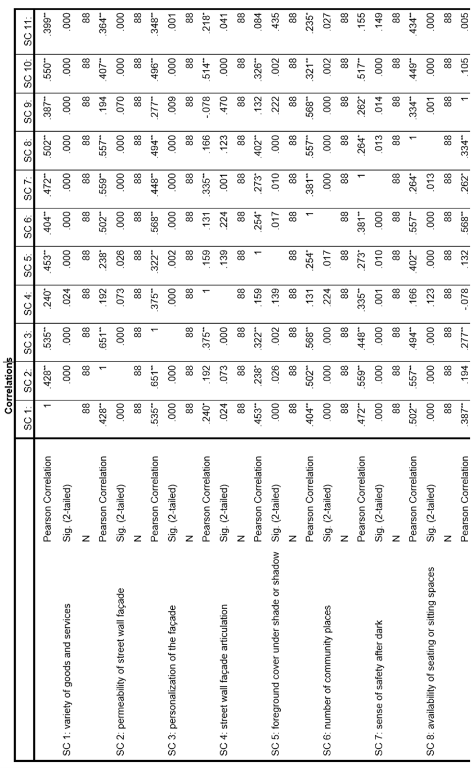
some contradictions seen during comparison of correlation and multi-variate analysis as some variables were seen significant in correlation except street characteristic 4: street wall façade articulation but didn’t show significance in regression model. For the issue, a correlation matrix (Table 5.30) of all eleven characteristics was checked, which showed a high correlation between variables at some places which suggest that many of the highly correlated characteristics may elucidate the same concept. A factor analysis can regulate the variables that fit to the same concept. A factor analysis was made on all these characteristics using Principal Component Analysis; and Varimax rotation with Kaiser normalization to limit the key factors and concepts that explained the liveliness on the neighbourhood commercial street.
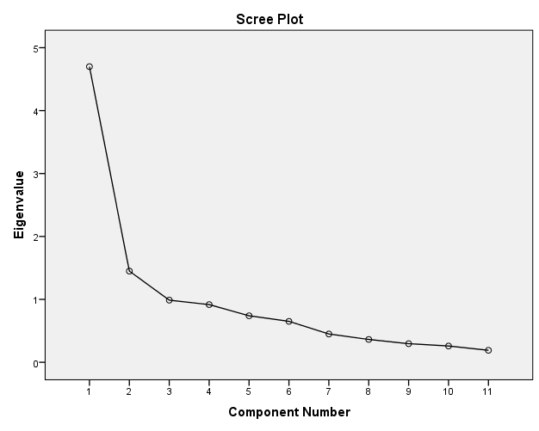
Figure 5.25 Scree plot showing the Eigenvalues of the components
In factor analysis of all eleven street characteristics, KMO measure of sampling adequacy recorded at .783 (≥.70) and Barlett’s Test of Sphericity being significant at p = 0.000, showed that factor analysis was an appropriate method for the available data. The Kaiser criterion recommends using only those components that have Eigenvalues of more than one. However, a Scree plot is sometimes more appropriate in determining the number of factors to be retained (Figure 5.25). To get an optimum number of factors, and include the maximum variance and, keeping the scenario of study area condition, responses from focus group survey and interviews; components/ factors were extracted using fix number method. With this, five factors were selected, which explain 79.92% (Table 5.31) of cumulative variance. (Table 5.32 Factor analysis showing the weightings of each characteristics shows the details of the factor analysis with weightings of each characteristic.
Table 5.31 Percentage variance of five factors
Total Variance Explained
Com-  ponent | Initial Eigenvalues |  |  | Extraction Sums of Squared Loadings |  |  | Rotation Sums of Squared Loadings
 | Total | % of Variance | Cumulative % | Total | % of Variance | Cumulative % | Total | % of Variance | Cumulative %
1 | 4.699 | 42.720 | 42.720 | 4.699 | 42.720 | 42.720 | 2.204 | 20.037 | 20.037
2 | 1.449 | 13.175 | 55.895 | 1.449 | 13.175 | 55.895 | 1.797 | 16.333 | 36.370
3 | .988 | 8.978 | 64.873 | .988 | 8.978 | 64.873 | 1.737 | 15.787 | 52.157
4 | .917 | 8.334 | 73.208 | .917 | 8.334 | 73.208 | 1.626 | 14.782 | 66.939
5 | .739 | 6.721 | 79.929 | .739 | 6.721 | 79.929 | 1.429 | 12.989 | 79.929
6 | .651 | 5.914 | 85.843
7 | .450 | 4.088 | 89.931
8 | .363 | 3.299 | 93.231
9 | .296 | 2.688 | 95.918
10 | .259 | 2.352 | 98.270
11 | .190 | 1.730 | 100.000
Extraction Method: Principal Component Analysis.
Table 5.32 Factor analysis showing the weightings of each characteristics
Rotated Component Matrixª
 | Component
 | 1 | 2 | 3 | 4 | 5
street characteristic 2: permeability of street wall façade | .905
street characteristic 3: personalization of the façade | .668
street characteristic 7: sense of safety after dark | .570
street characteristic 4: street wall façade articulation |  | .854
street characteristic 10: cleanness status of the area |  | .677
street characteristic 9: availability of other street furniture and physical artefacts |  |  | .951
street characteristic 6: number of community places |  |  | .656
street characteristic 11: pedestrian centred strategies and condition |  |  |  | .900
street characteristic 8: availability of seating or sitting spaces |  |  |  | .544
street characteristic 5: foreground cover under shade or shadow |  |  |  |  | .949
street characteristic 1: variety of goods and services |  |  |  |  | .487
Extraction Method: Principal Component Analysis.
Rotation Method: Varimax with Kaiser Normalization.
a. Rotation converged in 6 iterations.
Further, a multivariate regression analysis (Table 5.33) of five component/ factors extracted from PCA showed that together they explain 67% of the variation (adjusted R2=0.670, F=36.28, Sign.of F=0.000) in the liveliness across all 88 block segments of study area over neighbourhood commercial street.
Table 5.33 Model fit statics of the five factors
Model Summary^{b}
Model | R | R Square | Adjusted R Square | Std. Error of the Estimate | Change Statistics |  |  |  |  | Durbin-Watson
 |  |  |  |  | R Square Change | F Change | df1 | df2 | Sig. F Change
1 | .830ª | .689 | .670 | 1.611 | .689 | 36.283 | 5 | 82 | .000 | 1.327
a. Predictors: (Constant), Factor5, Factor2, Factor4, Factor3, Factor1
b. Dependent Variable: core characteristic of preferred third place (liveliness)
All these five factors which are the cumulative construct of the previously identified 11 street characteristics, can be understood as the aspect of street which acts as magnetic part of setting and contributes somehow to attract people for stationary, lingering, and social activities and make it as preferred third place of neighbourhood commercial street.
Amongst these five factors; factor 1 is the combination of ‘permeability of street wall façade’, ‘personalization of the façade’, ‘sense of safety after dark’; all these characteristics are basically generated by the type of business take place at particular block or block segment means derived from land use quality of the block; and explain 42.72% of variance. Depending on the usage and purpose of the business, degree of permeability and personalization by means of decoration, signs, plants, and so on; decides and executed. Another variable in this factor was sense of safety, which again somehow derived and controlled by business type, as it was seen that people felt safer where shops, stalls, or vendors open till late and proximity was lively.
Factor 2 is the combination of ‘street wall façade articulation’, ‘cleanliness status of the area’; and this explain 13.18% of variance. Both are the physical aspect of the street as the street wall façade articulation is a characteristic that is resolute by the architecture, while cleanliness and trash, its placement, categorization part is the aspect maintained by the maintenance department of urban local body.
Factor 3 is the amalgamation of ‘availability of other street furniture and physical artefacts’ and, ‘number of community places’; and this explain 8.98% of variance. Since in study area of research, no or very few commercial or non-commercial seats, so in the absence of seating or when they were not sitting by choice, people supported out most of their sustained or social activities near building walls, show-windows, steps, vehicles parked near the sidewalk, and other physical artefacts on or near the sidewalk. These included planters, bollards, advertising signs on the floor, light poles, signposts, parking meters, tree trunks, railings, fire hydrants, electrical panel boxes, and so on. The users sat, leaned, or just stood next to these objects. A major role executed by these street furniture and physical artefacts are for socialization. Community places were already seen as best lingering points of the people where they meet with their neighbours, friends, known, and unknown ones, and support the social activities which is the core characteristic of preferred third place.
‘Pedestrian centred strategies and condition’, and ‘availability of seating or sitting spaces’ constitutes factor 4, and this explains 8.33% of variance. Both the variables are the aspect of physical comfort and convenience as this was revealed in context derivation analysis that the area, block or block segment were live which was meant for pedestrian only, people used to celebrate parties, playing nukkad-natak, or some time reading and listening earphones there. Provision of commercial or non-commercial seats are under the purview of business owner and urban local bodies respectively which comes under the street improvement part. Though, factor 4 and factor 2, both are the aspects of physical comfort and convenience but their correlation with the core characteristic of the preferred third place is different, and they formed separate factor.
Factor 5 is the combination of ‘foreground cover under shade or shadow’, and ‘variety of goods and services; and this explain 6.72% of variance. The variable ‘foreground cover under shade or shadow’ is the aspect of environmental comfort which included shades which may be a result of trees provided by a public authority but also includes awnings, canopies, retractable umbrellas, and so on, provided by the business owners.

Conclusion
Overall, this part of the research identified the relation between the all identified street characteristics and it showed that no characteristic could fully impact alone over the preferred third place designation. Start with comparing the correlation coefficient with the multi-variate analysis model of all 11 street characteristics with liveliness index at block segment level, it was found that 4 street characteristics were matching and indicating the same point while, other street characteristics were not in a unanimous indication. Correlation between these 11 street characteristics reveals that some street characteristics may elucidate the same concept. To fix it, factor analysis was carried out with PCA method which cumulate few elucidated characteristics in separate bigger construct. Five constructs/ factors were identified. Factor 1 was in the combination of ‘permeability of street wall façade’, ‘personalization of the façade’, ‘sense of safety after dark’; Factor 2 is the combination of ‘street wall façade articulation’, ‘cleanliness status of the area’; Factor 3 is the amalgamation of ‘availability of other street furniture and physical artefacts’ and, ‘number of community places’; Factor 4 is the combination of ‘Pedestrian centred strategies and condition’, and ‘availability of seating or sitting spaces’ while factor 5 is the combination of ‘foreground cover under shade or shadow’, and ‘variety of goods and services. With the above algorithm it could be summarized as the factor 1 could be seen as the outcome derived from the land use quality of the street, while factor 2 seems as it came out to represent the physical aspect of the street. Along with factor 2; factor 4 and 5 are also representing the same origination but with different attentiveness, so factor 2,4, and 5 could be considered collectively from physical quality of the street. Remaining factor 3, which expresses in itself as belong to socialization quality. So, in conclusion it is emerged as, with ‘Socialization quality’, ‘Land use quality & management’ and, ‘physical quality’ of the street; a quality neighbourhood public space could be achieved which could be conducive to stationary, lingering and social activities.

Chapter 06 Conclusions
This research sustained on a systematic scientific exploration to see the built environment setting for preferred third place in urban realm. The complete focus of the research was on to see the algorithm and extent of third place and its corresponding built environment attributes. Through available literatures and formative research, the concept of third place was identified and derived a dimensional scale for its measurement. Next, it explored the potential of spaces over the street which generates the comparative index for the core characteristics of preferred third place based on derived dimensions and also their attributes which were significantly associated with preferred third place. Further, it has evaluated the interrelationship between the identified attributes and use. The final analysis focussed on investigating the relationship of attributes of the built environment setting and the use of spaces within dimensions of preferred third place.
The major findings of the entire research are discussed in the following sections.

Discussion of main findings

Concept of third place
The research showed that the preferred third place designation over neighbourhood commercial street of Lucknow can be derived from three distinct dimensions: environmental and physical comfort, socialization and, land use characteristics & management. Apart from the dimension ‘environmental and physical comfort’ and, ‘land use characteristics & management’; the dimension socialization includes the sense of belongingness, personal attachments and, sense of safety which is a universally desired milieu. Since all these three milieus were representing the insight of social quality so they came up into one single bigger construct as socialization. Here, the ‘opening of shops till late night’ or ‘on street parking is more convenient rather off street at basement’ were also found significant but they did not come out as an independent dimension. The coefficient loadings of selected items based on their mean scores indicated socialization as the primary dimension which was also the primary impression of the concept given by Ray Oldenburg and seconded by Jane Jacobs, Jan Ghel, Christian Mikunda, M. Klang, S. Olsan and many other recent researchers as shown in literature findings. The dimension land use characteristics & management came out as second most significant dimension, while the difference with the third independent dimension environmental and physical comfort was very less.

Attributes of the built environment and use of spaces associated with preferred third place
Urban neighbourhoods and other inhabited places are often known to have their own cultures and norms. Certain behaviour patterns in public spaces and the particular use of neighbourhood commercial street may be specific to the residents of the neighbourhood of the study area or of Lucknow. This study is not intended to suggest that the specific patterns of the behavioural environment, the elements of the physical setting and businesses that have special meanings for the community found on these three neighbourhood commercial streets are representative of all possible behavioural and physical patterns. It is likely that neighbourhood commercial streets or similar settings in other cultural contexts may have a different array of such patterns.
Nonetheless, this study elaborates findings of the identified street characteristics over the neighbourhood commercial street of Lucknow. Characteristic ‘variety of good and services’ play in a particular way over study area to designate the block or block segment as third place. Since most of the user, who were interviewed in structured or unstructured form, live or work nearby, and who therefore come back to visit the street and stores had indicated their significance to the verities in goods and services offered. In contrast some people were prefer to the stores where they aware about the goods, services, owner and their worker. This dealt with long-term familiarity and stability. However, in the short-term the liveliest settings were the ones that made frequent changes. Through frequent changes a curiosity amongst the user maintained and they kept their interest to visit the street or store. Though, personalization which is the other allied street characteristic created change in an otherwise familiar setting that provided stimulation and interest and created a reason to stop and window-shop also. Personalization of the storefront made each one appears and feel different, and that created variety on the street. This variety created interest and engaged people in various activities such as reading signs, window-shopping, touching and smelling objects, browsing through goods, trying things out and so on. All of these activities lead to more people spending more time on the street and their lengthy stay designate the street as preferred third place.
Another street characteristic which was found significant refers the permeability of the street wall façade. The meaning of permeability is to, up to what extent one can visually penetrate the insides. At study area most of the people were scored for their engagements in dynamic activities, or the people who showed their short stay duration over the street were seen as those who simply passing through on their way to another destination, such as work but, were generally curious about what went on in the buildings and spaces along their path. Another group of people who were passing through the street or path and looking towards the goods in show-windows, looking at signs, or watching activities going on inside the stores and discussing with their companion about the trends, often encouraged their stay duration over the street and contributed well in scoring for preferred third place characteristic.
The characteristic ‘façade articulation’ didn’t show much significance in third place designation probably it was overlooked or perceived in personalization by the users of the street in study area. Façade articulation is a kind of interface, which is the first impression for any store or street. Variety in interfaces i.e. façade articulations may encourage the users to visit and lingering in proximity of store or block segment.
shade or shadow came out an important observation over the study area associated with a climate like Lucknow where, cold, sun and rain all happen. Tough, because of too much population, increased level of air and sound pollution and other allied services of not up to the mark, the characteristic didn’t show the much significance towards the third-place designation.
All three neighbourhood commercial streets had businesses that the residents and workers in the area identified as community places. These businesses had recognized themselves as terminuses over time. People reported and were seen engaged in a variety of activities at these businesses. They treated these as places to spend time at to meet neighbours, friends and strangers, to chat, read, work, play games, listen to music, and so on. Users noted that these places meant more than just the act of conducting business and the business owners encouraged this notion by making the environment and policies conducive to letting people stay as long as they desired. These businesses supported a higher level of activity for longer durations compared to other businesses. In cases where the physical characteristics of the street, such as the ones identified in this study, were present these community places became anchors for liveliness. Most of community places identified by people were small dhaba, nukkad cafes, coffee shops, cigarette kiosk, paani batasa wala mehandi wala etc.
The other identified street characteristic was sense of safety, which is a global phenomenon, was found not that much associated with third place designation. Since all three studied neighbourhood commercial streets were the main market and also most of the time these were live in general, so the safety was not the major concern as per the perception of the users over the area.
Seating on the street in the form of benches, chairs or other surfaces provided by a public agency or a private business, located near activity-supporting businesses, had a strong interrelationship with liveliness for preferred third place designation. Since the provision of seats in any form either commercial or non-commercial was not good over the area, people prefer to sit on steps, ledges, tree guards, tree trunks, signages, or on some other physical artefacts. Most of the time in absence of seating opportunity, people prefer to lean over the bikes parked in the proximity. Other allied street characteristic is street furniture and physical artefacts which has been seen significant to liveliness for preferred third place, was also not in significant numbers. Columns of covered veranda were seen as the point where people lean with and chat or listening to music or calling someone. Other most favourite point was near vehicle parked in proximity as very few artefacts were available in all three-study area. Probably, absence of artefacts and proper street furniture was the cause of reduction in kids’ involvement in playing or exploration.
Swachhata (cleanness) has been taken as mission by government of India for the period 2014 to 2019 that aims to clean up the streets, roads and infrastructure of India's cities, towns, and rural areas. In this research (Table 5.24, Figure 5.23) it has been revealed that people prefer to choose the block or block segment and get themselves engaged in stationary or social activities where they find clean setting.
Pedestrianization is always a mesmerizing part for any area deemed to be preferred third place. In this research the finding reveals that it had a good significance to the liveliness of the area for preferred third place designation. Though the all the three-neighbourhood commercial street were not completely pedestrianized but vehicle movements and speed were controlled. The most common suggestion for all three streets was to retain the existing variety and diversity of uses and stores as well as the physical and visual characteristics that made the street more pedestrian-friendlier.

Three Aspects of Neighbourhood Public Space
Study reveals of this research that three aspects which were appeared as ‘socialization quality’, ‘land use quality and management’ and, ‘physical quality’ are critical in the understanding of neighbourhood commercial street. Further, the observations over street and studies in analysis used in this study, to understand the public environment as a combination of patterns of behaviour and patterns of the physical environment, has demonstrated merit and should be useful for understanding, design, and management across varied environments and space types in different cultures. In progression, the findings show that people tend to choose settings that are meaningful to them as places of the community and that offer comfort and pleasure through various amenities and micro-scale physical features: elements that are extremely significant to the users of the environment.
In context of socialization qualities which includes ‘availability of other street furniture and physical artefacts’ and, ‘number of community places’; study suggest that there is a grading in the businesses that sustenance this quality of liveliness, variety, diversity, and social contact on neighbourhood commercial streets. In spirit, certain businesses are able to generate and anchor this quality; others act as supports; and yet others contribute slightly or sometimes even diminish from it. People with diverse outlooks and backgrounds expressed an attachment to certain businesses that had evolved into community places: where they were able to see and meet friends, neighbours, or strangers, spend their leisure time and engage in various activities that reinforced their sense of community. When complimented with other physical characteristics, these businesses that were the community places of the neighbourhood were the anchors for this quality of liveliness on the street.
Another aspect is land use quality and management which includes permeability of street wall façade, personalization of the façade, sense of safety after dark. There is clear evidence from the observational data, surveys, and interviews that users of different backgrounds and outlooks preferred small independently owned businesses. Smaller independently owned businesses were key to the liveliness on the street not only because people preferred them for their quality of goods and services but also because they incorporated other land use characteristics those were important to support liveliness. Physically, smaller businesses consumed much less street frontage, permitting more variety through increased numbers of businesses per unit length of the street. Smaller independently owned businesses had more personalized street-front with shop window and entrance decorations, plants, changing signs, and so on. Since with small frontage of small businesses with high degree of permeability and rich personalization creates more liveliness, safety concerns encountered automatically.
The another most preferred aspect is physical quality consisting 6 street characteristics namely ‘street wall façade articulation’, ‘cleanliness status of the area’, ‘Pedestrian centred strategies and condition’, ‘availability of seating or sitting spaces’, ‘foreground cover under shade or shadow’, and ‘variety of goods and services. The relationship between ‘foreground cover under shade or shadow’, ‘street wall façade articulation’ and liveliness were the most evident. Among other physical characteristics ‘pedestrian centred strategies and condition’, as a clear pedestrian domain on the street, was most important as it was required to accommodate most of the other physical characteristics, such as seating, trees for shade, cleanness status of the area, and other furniture.
It was not the intent of this study to quantify an optimal numbers and percentage but to identify the significant characteristics which cannot be overlooked if someone wants an area which can hold people to stationary, lingering and social activities and make the area lively. It is also important to understand that through the liveliness or in other words with holding maximum number of people at any space will definitely generate some good economy, support the younger or older people in their mental and physical fitness, support to be culturally connected which is the major issue seen in the city of Lucknow at present, beside this the most desired and needed part is to make the area fir for live in.
However, in Lucknow or even in whole country, no such organisation or profession exist in the social sciences, design, planning, management, or marketing fields that caters to understanding and providing for the needs of a cultural, behavioural, and physical environment. Should this be a realm of the urban designer, architect, community planner, economic planner, or the Main Street manager? Presently, the principal paradigm in architecture and urban design lacks an assignation with the social sciences and scientific consistency. For now, urban designers, social scientists, urban planners, and other physical development professionals need to incorporate empirically studied characteristics that combine meaning, use, management, and physical characteristics, as this study revealed it is the people’s choice of everyday use of neighbourhood commercial streets. Further, development regulations may be seen to incorporate the related strategies and support in integrating street, its activities and its role in societal development, and make the neighbourhood commercial streets most preferred in every means rather just a destination for shopping and channel for movement.

Bibliography
Abu-Ghazzeh, T. M. (1990). Housinglayout, Social Interaction, and the Place. Journal of Environmental Psychology, 41-73.
Aggarwal, M. (2001). Outdoor Play Areas for Children in High-Density Housing in Montreal, Master of Architecture Thesis. Montreal: Faculty of Graduate Studies and Research, School of Architecture, McGill University.
Akhtar, S. M. (1998). From Lucknow to Lovable Lucknow. Lucknow: Lucknow first.
Alexander, C. (1977). A pattern language : towns, buildings, construction. New York: Oxford University Press.
Al-Hagla, K. (2008). Towards a sustainable neighborhood: The role of open spaces. International, 162-177.
Altman, I. (1975). The Environment and Social Behavior: Privacy, Personal Space, Territory, Crowding. Monterrey, CA: Brooks/Cole.
Amick, D. J., & Kviz,, F. J. (1975). Social alienation in public housing: The effects of density and building. Ekistics, 118-120.
Appleyard, D., Gerson, M. S., & Lintell, M. (1981). Livable Streets. California: University of California Press.
Audirac, I., & Shermyen, A. (1994). An evaluation of neotraditional design's social prescription: postmodern placebo or remedy for suburban malaise? Journal of Planning Education , 161-173.
Bacon, E. (1967). Design of Cities. London: Thames & Hudson.
Bandyopadhyay, A. (1998). Formulation of urban development norms & provision of physical infrastructure: an integrated approach for a better living environment. Proceedings of 47th TCP congress. New Delhi: ITPI, New Delhi.
Banerjee, T. (2001). The Future of Public Space: Beyond Invented Streets and Reinvented Places. Journal of the American Planning Association, 9-24.
Barker, R. (1968). Ecological Psychology. California: Stanford University Press.
Bartuska, T. J. (2007). The Built Environment: Definition and Scope. In R. McClure, W. Rule, & T. J. Bartuska, , The built environment : a collaborative inquiry into design and planning (pp. 3-14). John Wiley & Sons.
Bechtel, R. (1977). Enclosing Behavior. Stroudsburg, PA: Hutchinson and Ross.
Bechtel, R. (1997). Environment and Behavior: An Introduction. Thousand Oaks, CA: Sage Publications.
Bechtel, R. B., & Churchman, A. (2002). Handbook of Environmental Psychology. New York: John Wiley & Sons, Inc.
Bechtel, R. B., & Zeisel, J. (1987). Observation: The World Under a Glass. In R. B. Bechtel, R. W. Marans, & W. M. Michelson, Methods in Environmental and Behavioral Research. New York: Van Nostrand Reinhold Comp.
Bentley, I., Alcock, A., Murrain, P., McGlynn, S., & Smith, G. (1985). Responsive Environments: A manual for Designers. London: Architectural Press.
Berger-Schmitt, R. (2000). Social Cohesion as an Aspect of the Quality of Societies: Concept and Measurement. Mannheim: EuReporting Working Paper.
Bernard, P. (1999). Social cohesion: A critique. Montréal: Canadian Policy Research Networks.
Bhaduri, S., & Daniel, L. S. (2013). Urban Density and Spatial Quality of Urban Spaces. International Journal of Innovative Research and Studies.
Blake, S. P. (1991). Shahjahanabad: The Sovereign City in Mughal India. Cambridge: Cambridge University Press.
Bloch, P., Ridgway, N., & Dawson, S. (1994). The shopping mall as a consumer habitat. Journal of Retailing, 23-42.
Bloch, P., Ridgway, N., & Sherrel, D. (1989). Extending the concept of shopping: An investigation in browsing activity. Journal of the Academy of Marketing Science, 13-21.
Bottoni, G. (2016). A Multilevel Measurement Model of Social Cohesion. Social Indicators Research, doi:10.1007/s11205-016-1470-7 .
Boyer, M. (1994). The city of collective memory: Its historical imagery and architectural entertainments. Cambridge: MIT Press.
Brower, S. (1996). Good Neighborhoods. Westport, CT: Praeger Publishers.
Brown, B., & Perkins, D. (1992). Disruptions in Place Attachment. In I. Altman, & L. M. Setha, Human Behavior and Environment: Advances in Theory and Research (pp. 279-301). New York: Plenum Press.
Brown, B., Perkins, D., & Brown, G. (2003). Place attachment in a revitalizing neighborhood: Individual and block. Journal of Environmental Psychology, 259-271.
Brown, G., Brown, B., & Perkins, D. (2004). New housing as neighborhood revitalization: Place attachment and confidence among residents. Environment and Behavior, 749-775.
Bruhn, J. (2009). The Group Effect: Social Cohesion and Health Outcomes. Springer.
Buckner, J. (1988). The Development of an Instrument to Measure Neighbourhood Cohesion. American Journal of Community Psychology, 771-791.
Burke, K. (1945). A Grammar of Motives. New York: Prentice-Hall.
Butterworth, I. (2000). The Relationship Between the Built Environment and Wellbeing: a Literature Review. Melbourne: Victorian Health Promotion Foundation.
Calthorpe, P. (1993). The Next American Metropolis. Ecology, Community and the American Dream. New York: Princeton Architectural Press.
Canter, D. (1991). Understanding, assessing, and acting in places: Is an integrative framework possible? . In G. Evans, Environment, cognition, and action: An integrative approach. New York: Oxford University Press.
Carmona, M., Heath, T., Oc, T., & Tiesdell, S. (2010). Public Places, Urban Spaces: The Dimensions of Urban Design. Elsevier Science.
Carr, S., Francis, M., Rivlin, L., & Stone, A. (1992). Public Space. Cambridge: Cambridge University Press.
Cervero, R. (1996). Mixed land-uses and commuting: Evidence from the American Housing Survey. Transportation Research , 361-377.
Cervero, R., & Kockelman, K. (1997). Travel demand and the 3Ds: Density, diversity, and design. Transportation Research, 199-219.
Chan, J. (n.d.).
Chan, J., To, h.-P., & Chan, E. (2006). Reconsidering Social Cohesion: Developing a Definition and Analytical Framework for Empirical Research. Social Indicators Research, 273-302.
Chani, P., & Najamuddin. (2003). Natural Facades – Harmonized Urban Environment. Indian Journal of Architectural Design Perspective, 34-36.
Chavis, D., Lee, K., & Acosta, J. (2008). The Sense of Community (SCI) Revised: The Reliability And Validity Of The SCI-2. 2nd International Community Psychology Conference. Portugal: UoM.
Chavis, D., & Wandersman, A. (1990). Sense of Community in the Urban Environment: A Catalyst for Participation and Community Development. American Journal of Community Psychology, 55-81.
Chekki, D. A., Lofland, L. H., & Cahill, S. E. (1994). Community of the Streets. Emerald Group Publishing Limited.
Chen, D. (2006). Shared Outdoor Spaces and Community Life: Assessing the Relationship Between Design and Social Interaction. Master of Landscape Architecture Thesis: Faculty of Graduate Studies, University of Guelph.
Chermayeff, S., & Alexander , T. (1971). Shape of community: realization of human potential. Harmondsworth: Penguin.
Chermayeff, S., & Alexander, C. (1966). Community and privacy: toward a new architecture of humanism. Harmondsworth: Penguin.
Child, D. (2006). The Essentials of Factor Analysis. London: A&C Black.
Chipuer, H., & Pretty, G. H. (1999). A review of the sense of community index: Current uses, factor structure, reliability, and further development. Journal of Community Psychology, 643-658.
Cilliers, E. J., & Timmermans, W. (2014). The Importance of Creative Participatory Planning in the Public Place-Making Process. Environment and Planning B: Planning and Design, 413-429.
Clay, G. (1991). The Street as Teacher. In A. V. Moudon, Public Streets for Public Use. New York: Columbia University Press.
Cohen, H., Moss, S., & Zube, E. (1979). Pedestrians and the wind in the urban environment. In A. Seidel, & S. Danford , Environmental Design: Research , Theory and Application (EDRA 10) (pp. 71-82). Washington, DC: EDRA.
Conroy, K. M., Elliott, D., & Burrell, A. R. (2013). Developing content for a process-ofcare checklist for use in intensive care units: a dual-method approach to establishing construct validity. BMC Health Services Research, 380.
Coupland, A. (1997). Reclaiming the City: Mixed use development. London: E & FN Spon.
Cousseran, A. (2006). Post Modern Movement: The ‘Inscribed’ City. In M. Moor, & J. Rowland, Urban Design Futures. London: Routledge.
Craik, K. (1970). Environmental Psychology. In K. Craik, B. Kleinmuntz, R. Rosnow, B. Rosenthal, J. Cheyne, & J. Walters, New Directions in Psychology (pp. 1-122). New York: Rinehart and Winston.
Crane, R. (2000). The influence of urban form on travel: An interpretative review. Journal of Planning Education and Research, 3-23.
Creswell, J. (2014). Research Design: Qualitative, Quantitative, and Mixed Methods Approaches. Thousand Oaks, CA: SAGE Publications.
Cullen, G. (2012). Concise Townscape. London: Routledge.
Dalkey, N., & Helmer, O. (1963). An Experimental Application of the Delphi Method to the Use of Experts. Management Science, 458--467.
Dempsey, N. (2009). Are good-quality environments socially cohesive?: Measuring quality and cohesion in urban neighbourhoods. Town Planning Review, 315-345.
Drew, C. J. (1971). Research on the Psychological-Behavioral Effects of the Physical Environmnet. Review of educational research, 447-465.
DUAC. (2017). City level projects: Movements Corridors- Vision for Delhi (South Zone). New Delhi: Delhi Urban Art Commission.
Duany, A., Plater-Zyberk, E., & Speck, J. (2000). Suburban Nation: The Rise of Sprawl and the Decline of the American Dream. New York: North Point Press.
Engwicht, D. (1999). Street Reclaiming: Creating Liveable Streets and Vibrant. Sydney: Pluto Press.
Eubank-Ahrens, B. (1991). A closer look at the users of Woonerven. In A. V. Moudon, Public streets for public use. New York: Columbia University Press.
Eubank-Ahrens, B. (1991). The impact of woonerven on children’s behavior. Children’s Environments Quarterly, 1(4), pp. 39-45.
Ewing, R., Clemente, O., Handy, S., Brownson, R., & Winston, E. (2006). Identifying and Measuring Urban Identifying and Measuring Urban Design Qualities Related to Design Qualities Related to Walkability. Journal of Physical Activity & Health, 223-240.
Falk, P. (1997). The scopic regimes of shopping. In P. Falk, & C. Campbell, The Shopping Experience (pp. 177-185). London: Sage Publications.
Field, A., & Miles, J. (2010). Discovering Statistics using SPSS. London: SAGE.
Fornell, C., & Larcker, D. F. (1981). Evaluating structural equation models with unobservable variables and measurement error. Journal of marketing research, 39-50.
Franck, K. A., & Stevens, Q. (2007). Loose space : possibility and diversity in urban life. London: Routledge.
French, J. S. (1978). Urban Space: A Brief History of the City Square. Iowa: Kendall/Hunt Pub. Co.
Gehl, J. (1987). Life Between Buildings: Using Public Space. New York: Van Nostrand-Reinhold.
Gehl, J. (2010). Cities for people. Washington, DC: Island Press.
Gehl, J., & Gemzøe, L. (2004). Public spaces, public life. Denmark: Danish Architectural Press.
Ghose, B. (1968, jan. 1). Jaiselmer: Urban Form and Pattern of Medieval Indian Town. Urna and Rural Thought Vol. X1, p. 1968.
Giannarou, L., & Zervas , E. (2014). Using Delphi technique to build consensus in practice, Int. Journal of Business Science and Applied Management. Int. Journal of Business Science and Applied Management, 65-82.
Gibson, J. J. (1979). The Ecological Approach to Visual Perception. Boston: Houghton Mifflin.
Gifford, R. (2007). Environmental Psychology: Principles and Practice. New York: Optimal Books.
Glaeser, E., & Gottlieb, J. (2008). The Economics of Place-Making Policies. NBER Working Paper No. 14373 . Cambridge: MA: NBER.
Glynn, T. J. (1981). Psychological Sense of Community: Measurement and Application, Human Relations. Human Relations, SAGE.
Granovetter, M. (1973). The Strength of Weak Ties. American Journal of Sociology , 1360-1380.
Greenwald, M., & Boarnet, M. (2000). Built environment as a determinant of walking behavior: Analyzing non work pedestrian travel in Portland. Transportation Research Record, 33-42.
Hair, J. F., Black, W. C., Babin, B. J., & Anderson, R. E. (2014). Multivariate data analysis. Harlow: Pearson Education Limited.
Hass-Klau, C. (1999). Streets as Living Space: Helping Public Places Play Their Proper Role : Good Practice Guidance with Examples from a Town Centre Study of European Pedestrian Behaviour. London: Landor.
Hayden, D. (1995). The Power of Place. Cambridge: MIT Press.
Heft, H. (1997). The Relevance of Gibson's Ecological Approach to Perception for Environment-Behavior Studies. In G. Moore, & R. Marans , Advances in Environment, Behavior, and Design, Volume 4: Toward the Integration of Theory, Methods, Research, and Utilization. New York: Plenum Press.
Hester, R. (1993). Sacred structures and everyday life: A return to Manteo, North Carolina. In D. Seamon, Dwelling seeing and designing: Toward a phenomenological ecology (pp. 217-298). New York: State University of New York Press.
Hillier, B. (1998). Space is the Machine: A Configurational Theory of Architecture. Cambridge: Cambridge University Press.
Hippocrates. (2007). On Airs, Waters and Places. Egypt: Library of Alexandria.
Hiss, T. (1990). The Experience of Place. Ney York: Knopf.
Hochschild, j. T. (2011). Neighbors by Design: Determinants and Effects of Residential Social Cohesion. PhD Thesis: University of Connecticut.
Hoogland, C. (2000). Semi-private Zones as a Facilitator of Social Cohesion. Nijmegen: Nijmegen University.
Hope, T. (1988). Area, crime and incivility: A profile from the British Crime Survey. In T. Hope, & M. Shaw , Communities and crime reduction (pp. 30-47). london: HMSO.
Huang, S.-C. L. (2006). A study of outdoor interactional spaces in high-rise housing. Landscape and Urban Planning, 193-204.
Hull, R., & Harvey, A. (1989). Explaining the emotion people experience in suburban parks. Environment and Behavior, 323-345.
Jacobs, A. B. (1993). Great Streets. Cambridge: Mit Press.
Jacobs, J. (1961). The Death and Life of Great American Cities. New York: Vintage Books.
Jansen-Verbeke, M. (1987). Women, shopping and leisure. Leisure Studies, 71-86.
Jenson, J. (1998). Mapping Social Cohession: The state of Canadian Research. montreal: Canadian Policy Research Networks Inc.
Joardar, D. S., & Neill, J. (1978). The subtle differences in configuration of small public spaces. Landscape Architecture, 487-491.
Joardar, S. D. (1977). Emotional and behavioral responses of people to urban plazas : a case study of downtown Vancouver. Vancouver: University of British Columbia Library.
Johnston, C. (1992). What is Social Value? Canberra: Australian Heritage commission.
Jones, P., Boujenko, N., & Marshall, S. (2007). ‘Link’ And ‘Place’: A New Approach to Street Planning and Design. London: Landor Press.
Jonge, D. D. (1968). Applied Hodology. Landscape, 10-11.
Kaiser, H. F. (1960). The Application of Electronic Computers to Factor Analysis. Educational and Psychological Measurement, 141–151.
Kaiser, H. F. (1974). An index of factorial simplicity. Psychometrika, 31-36.
Kaiser, H. F., & Rice, J. (1974). Little Jiffy, Mark Iv. Educational and Psychological Measurement, 111-117.
Kaplan, R., & Kaplan, S. (1989). The Experience of Nature – A Psychological Perspective. New York: Cambridge University Press.
Kasturi, T., Sun, X., & Wilmot, C. (1998). Household travel, household characteristics, and land use: An empirical study from the 1994 Portland activity-based travel survey. Transportation Research Record, 10-17.
Keane, C. (1991). Socioenvironmental Determinants of Community Formation. Environment and Behavior, 27-46.
Kitamura, R., Laidet, L., & Mokhtarian, P. (1997). A micro-analysis of land use and travel in five neighborhoods in the San Francisco Bay Area. Transportation, 125-158.
Kittell-Limerick, P. (2005). Perceived barriers to completion of the academic doctorate: A Delphi study. PhD report-Commerce: Texas A&M University.
Klang, M., & Olson, S. (1999). Virtual Communities. Proceedings of the 22nd information systems conference (pp. 249-259). Pennsylvania: Penn State University.
Krier, R. (1991). Urban Space. Academy Editions.
Kunstler, J. H. (1994). The Geography of Nowhere: the Rise and Decline of America's Man-Made Landscape. New York: Simon & Schuster.
Kuo, F. E., Sullivan, W. C., Coley, R. L., & Brunson, L. (1998). Fertile Ground for Community: Inner-City Neighborhood Common Spaces. American Journal of Community Psychology, 823–851.
Kweon, B., Sullivan, W., & Wiley, A. (1998). Green Common Spaces and the Social Integration of Inner-City Older Adults. Environment and Behavior, 832-858.
Lang, J. (1987). Creating Architectural Theory: The role of the behavioral sciences in environmental design. New York: Van Nostrand Reinhold Co.
Langdon, P. (1997). A Better Place to Live: Reshaping the American Suburb. Massachusetts: Univ of Massachusetts Press.
Lennard, S. H. (2018, October 09). The Public Realm and the Good City. Retrieved from Making Cities Livable: www.livablecities.org
Lennard, S. H., & Lennard, H. (1995). Livable cities observed. California : Gondolier Press.
Liebermann, E. (1984). People’s needs and preferences as the basis of San Francisco’s downtown open space plan. 8th conference of the International Association for the Study of People and Their Physical Surroundings. Berlin.
Liebermann, E. (1984). People’s needs and preferences as the basis of San Francisco’s downtown open space plan. 8th conference of the International Association for the Study of People and Their Physical Surroundings. Berlin.
Linday, N. (1978). It all comes down to a comfortable place to sit and watch. Landscape Architecture, 492-497.
Llewelyn-Davies. (2000). Urban Design Compendium. London: English Partnerships/Housing Corporation.
Lofland, L. H., & Lofland, P. L. (1998). The Public Realm: Exploring the City's Quintessential Social Territory. Transaction Pub.
Long, D., & Perkins, D. (2003). Confirmatory Factor Analysis of the Sense of Community Index and Development of a Brief SCI. Journal of Commmunity Psychology, 279-296.
Loukaitou-Sideris, A., & Banerjee, T. (1993). The Negotiated Plaza: Design and Development of Corporate Open Space in Downtown Los Angeles and San Francisco. Journal of Planning Education and Research, 1-12.
Low, S. (2000). On the Plaza: The politics of public space and culture. Austin: University of Texas Press.
Luhr, G. A. (2016). The Effects of Frequency of Social Interaction, Social Cohesion, Age, and the Built Environment on Walking . Portland: Portland State University.
Lynch, K. (1960). The Image of the City. Cambridge: MIT Press.
Lynch, K. (1984). Good City Form. Cambridge: MIT Press.
Madanipour, A. (1996). Design of Urban Space. New York: Wiley.
Mak, W., Cheung, R., & Law, L. (2009). Sense of Community in Hong Kong: Relations with Community-Level Characteristics and Residents’ Well-Being. Americal Journal of Community Psychology, 80-92.
Marcus, C. C., & Francis, C. (1997). People Places: Design Guidlines for Urban Open Space. New York: John Wiley & Sons.
Marsden, P., & Campbell, K. (1984). Measuring Tie Strength. Social Forces, 482-501.
Maslow, A. H. (1954). The Instinctoid Nature of Basic Needs. Personality, 326-347.
McCluskey, J. (1992). Road Form and Townscape. Oxford: Butterworth-Heinemann.
McMillan, D., & Chavis, D. (1986). Sense of Community: A Definition and Theory. Journal of Community Psychology, 6-23.
Mehta, V. (2006). Lively Streets: Exploring the Relationship between Built Environment and Social Behavior. MD: DRUM.
Mehta, V. (2007). Lively Streets: Determining Environmental Characteristics to Support Social Behaviour. Journal of Planning Education and Research, 165-187.
Mehta, V., & Bosson, J. K. (2010). Third Places and the Social Life of Streets. Environment and Behavior, 779-805.
Meshkat, B., Cowman, S., Gethin, G., Ryan, K., Wiley, M., Brick, A., . . . Mulligan, E. (2014). Using an e-Delphi technique in achieving consensus across disciplines for developing best practice in day surgery in Ireland. Journal of Hospital Administration, 1-8.
Messenger, T., & Ewing, R. (1996). Transit-oriented development in the Sunbelt. Transportation Research Record, 145-152.
Michelson, W. (1975). Behavioral Research Methods in Environmental Design. PA: Dowden: Hutchinson and Ross.
Mihaylov, N., & Perkins, D. (2014). Community Place Attachment and its Role in Social Capital Development in Response to Environmental Disruption. In L. Manzo, & P. Devine-Wright , Place Attachment: Advances in Theory, Methods and Research (pp. 61-74). London and New York: Routledge.
Mikunda, C. (2004). Brand Lands, Hot Spots & Cool Spaces: Welcome to the Third Place and the Total Marketing Experience. London: Kogan Page .
Miles, D. C., Cook, R. S., & Roberts, C. B. (1978). Plazas for People. Virginia: Project for Public Spaces.
Miles, M. B., & Huberman, A. M. (1994). Qualitative Data Analysis: A Methods Sourcebook. Thousand Oaks, California: SAGE Publications.
Mital, R. (2002). Evaluation of Residential Streets as Places for People. New Delhi.
Montgomery, J. (1998). Making a city: Urbanity, vitality and urban design. Journal of Urban Design, 93-116.
Moore, G. T. (1979). Knowing about Environmental Knowing: The Current State of Theory and Research on Environmental Cognition. Environment and Behavior, 33–70.
Moore, R. C. (1991). Streets as Playgrounds. In A. V. Moudon, Public Streets for Public Use (pp. 45-62). New York: Columbia Univ. Press.
Moudon, A. V. (1991). Public Streets for Public Use. New York: Columbia University Press.
Moughtin, C. (2016). Urban Design: Street and Square. Abingdon, United Kingdom: Routledge.
Nasar, J. L., & Julian, D. (1995). The Psychological Sense of Community in the Neighborhood. Journal of the American Planning Association, 178-184.
National Commission on Urbanisation, I. (1988). India. National Commission on Urbanisation. New Delhi: Government of India Press.
Nellthorp, J., Chintakayala, P., & Wardman, M. (2011). Valuation of Townscape Improvements Using a Two-Level Stated Preference and Priority Ranking Approach. International Choice Modelling Conference. Leeds: Institute of Transport Studies, University of Leeds.
New York City Department of Transportation. (2008). World Class Streets: Remaking New York City’s Public Realm. New York: NYC DOT.
Newman, O. (1972). Defensible Space: People and Design in the Violent City. New York: Macmillan.
Norberg-Schuiz, C. (1971). Existence, Space and Architecture. New York: Praeger Publisher.
Nunnally, J. (1978). Psychometric theory. New York: McGraw-Hill.
O’Connor, B. P. (n.d.).
O'Connor, B. P. (2000). SPSS and SAS programs for determining the number of components using parallel analysis and Velicer’s MAP test. Behavior Research Methods, Instruments, & Computers, 396-402.
Oldenburg, R. (1998). The Great Good Place: Cafés, Coffee Shops, Bookstores, Bars, Hair Salons, and Other Hangouts at the Heart of a Community. New York: Marlowe.
Oldenburg, R. (2001). Celebrating the Third Place: Inspiring Stories About the Great Good Places at the Heart of Our Communities. Boston: Da Capo Press.
O'Rourke, N., Hatcher, L., & Stepanski, E. (2005). A Step-by-Step Approach to Using SAS for Univariate & Multivariate Statistics. Cary, NC: SAS Institute.
Pendola, R., & Gen, S. (2008). Does “Main Street” Promote Sense of Community? A Comparison of San Francisco Neighborhoods. Environment & Behavior, 545-574.
Perin, C. (1970). With Man in Mind. Cambridge, MA: MIT Press.
Perkins, D., Florin, P., Rich, R., Wandersman, A., & Chavis, D. (1990). Participation and the Social and Physical Environment of Residential Blocks: Crime and Community Context. American Journal of Community Psychology, 83-115.
Perkins, D., Wandersman, A., Rich, R., & Taylor, R. (1993). The physical environment of street crime: Defensible space, territoriality and incivilities. Journal of Environmental Psychology, 29-49.
Pushkarev, B., & Zupan, J. (1975). Urban Space for Pedestrians. Cambridge, MA: MIT Press.
Putnam, R., Light, I., Briggs, X., Rohe, W., Vidal, A., Hutchinson, J., . . . Woolcock, M. (2004). Using Social Capital to Help Integrate Planning Theory, Research, and Practice: Preface. Journal of the American Planning Association, 142-192.
Rabiee, F. (2004). Focus-group interview and data analysis. The Proceedings of the Nutrition Society, 655-660.
Rao, P., & Puntambekar, K. (2012). Measurement of Sustainability In Terms of Human Population and Their Respective Environments Across Time and Space. CASA 2012 .
Rapoport, A. (1969). House form and culture. Prentice-Hall.
Rapoport, A. (2013). History and Precedent in Environmental Design. Berlin: Springer Science & Business Media.
Raskin, M. (1994). The Delphi Study in Field Instruction Revisited: Expert Consensus on Issues and Research Priorities. Journal of Social Work Education, 75-89.
Raubenheimer, J. (2004). An item selection procedure to maximise scale reliability and validity. Journal of Industrial Psychology, 59-64.
Rayens, M. K., & Hahn, E. (2000). Building Consensus Using the Policy Delphi Method. Policy, Politics, & Nursing Practice, 308-315.
Relph, E. (1976). Place and Placelessness. London: Pion.
Rybczynski, W. (1993). The New Downtowns. Atlantic Monthly, 98-106.
Safiullah, & Sharma , A. (2017). Built Environment Psychology A Complex Affair of Buildings and User. International Journal of Engineering and Technology, 503-509.
Safiullah, & Sharma, A. (2017). Setting of Urban Spaces: Human perception from Mediaeval to Modern. Journal of Advance Research in Dynamical and Control Systems, 1683-1694.
Salama, A. M., Remali, A. M., & Maclean, L. (2017). Deciphering Urban Life: A Multi-Layered Investigation of St. Enoch Square, Glasgow City Centre. International Journal of Architectural Research: ArchNet-IJAR, 137-156.
Sarason, S. (1974). The psychological sense of community: Prospects for a community psychology. Oxford: Jossey-Bass.
Scannell, L., & Gifford, R. (2010). Defining place attachment: A tripartite organizing framework. Journal of Environmental Psychology, 1-10.
Schiefer, D., & Noll, J. (2017). The Essentials of Social Cohesion: A Literature Review. Social Indicators Research, 579-603.
Schneekloth, L. H., & Shibley, R. (1995). Placemaking: The Art and Practice of Building Communities. New York: Wiley.
Sheldon, R., Heywood, C., Buchanan, P., Ubaka, D., & Horrell, C. (2007). Valuing Urban Realm – Business Cases for Open. Proceedings of The European Transport Conference. Leiden: Transportation Reseach Board (TRB).
Skjaeveland, O., Gilding, T., & Maeland, J. (1996). A Multidimensional Measure of Neighboring. American Journal of Community Psychology, 413-435.
Skjœveland, O. (2001). Effects of Street Parks on Social Interactions Among Neighbors: A Place Perspective. Journal of Architectural and Planning Research, 131-147.
Skogan, W., & Maxfield, M. (1981). Coping with Crime: Individual and neighborhood reactions. Beverly Hills, CA: Sage Publications.
Southworth, M., & Ben-Joseph, E. (1997). Streets and the Shaping of Towns and Cities. New York: McGraw-Hill.
Steele, F. I. (1973). Physical settings and organization development. California: Addison-Wesley Longman, Incorporated.
Stokols, D., & Altman, I. (1987). Handbook of environmental psychology. New York: A Wiley-Interscience publication.
Stone, W., & Hulse, K. (2007). Housing and Social Cohesion: An Empirical Exploration. Australia: Australian Housing and Urban Research Institute.
Studer, R. (1969). The dynamics of behavior-contingent physical systems. In A. Ward, & G. Broadbent , Design Methods in Architecture (pp. 59-70). London: Lund Humphries.
Sullivan, W. C., Kuo, F. E., & Depooter, S. F. (2004). The Fruit of Urban Nature: Vital Neighborhood Spaces. Environment and Behavior, 678-700.
T.Moore, G. (1986). Effects of the spatial definition of behavior settings on children's behavior: A quasi-experimental field study. Journal of Environmental Psychology, 205-231.
T.Moore, G. (1987). Environment and behaviour research in North America. In D. Stokol, & I. Altman, Handbook of Environmental Psychology. New York: John Willey.
Talen, E. (1999). Sense of community and neighbourhood form: An assessment of the social doctrine. Urban Studies, 1361-1379.
Tauber, E. (1972). Why do people shop? Journal of Marketing, 6-59.
Taylor, R., Gottfredson, S., & Brower, S. (1984). Block crime and fear - defensible space, local social ties, and territorial functioning. Journal of Research in Crime and Delinquency, 303-331.
TfL. (2017). Streetscape Guidance. London: Transport for London.
Thapar, R. (1982). Role of City in Indian Culture. Lotus international.
Thomas, M. (1991). The demise of public space. 209-224: cited in 43rd ISOCARP Congress 2007.
Tibbalds, F. (1992). Making People Friendly Towns: Improving the public environment in towns and cities. Harlow, UK: Longman.
Trochim, W. M. (2004). The Research Methods Knowledge Base (2nd ed.). Cincinnati: Atomic Dog Publishing.
Tuan, Y.-F. (1977). Space and place: the perspective of experience. Minneapolis, MN: University of Minnesota Press.
Unger, D., & Wandersman, A. (1985). The Importance of Neighbors: The Social, Cognitive, and Affective Components of Neighboring. American Journal of Community Psychology, 139-169.
van den Akker, J. (1999). Principles and Methods of Development Research. In J. Branch, G. M. Robert, K. Nieveen, P. Nienkeand, & T. Jreed, Design Approaches and Tools in Education and Training (pp. 1-14). Dordrecht: Springer.
Verhagen, A. P. (1998). The Delphi list: a criteria list for quality assessment of randomized clinical trials for conducting systematic reviews developed by Delphi consensus. Journal of clinical epidemiology, 1235-1241.
Verhagen, A., d. V., d. B., K. A., B. M., B. L., & K. P. (1998). The Delphi list: a criteria list for quality assessment of randomized clinical trials for conducting systematic reviews developed by Delphi consensus. J Clin Epidemiol, 1235-41.
Vet, E. D., Brug , J., Nooijer, J. D., Dijkstra, A., & De Vries, N. (2005). Determinants of forward stage transitions: a Delphi study. Health Education Research, 195-205.
von der Gracht, H. A. (2012). Consensus measurement in Delphi studies: Review and implications for future quality assurance. Technological Forecasting and Social Change, 1525-1536.
Whyte, W. H. (1980). The social life of small urban spaces. Washington, D.C: Conservation Foundation.
Whyte, W. H. (1988). City: rediscovering the center. New York: Doubleday.
Wicker, A. (1979). An Introduction to Ecological Psychology. Monterey, CA: Cole Publishing Company.
Woudenberg, F. (1991). An Evaluation of Delphi. Technological Forecasting and Social Change, 131-150.
Yan W., K. Y. (2005). Simulating Human Behaviour in Built Environments. Computer Aided Architectural Design Futures 2005 (pp. 301-310). Vienna: Springer, Dordrecht.
Yan, W., & Forsyth, D. (2005). Learning the Behavior of Users in a Public Space through Video Tracking. 2005 Seventh IEEE Workshops on Applications of Computer Vision (WACV/MOTION'05) - Volume 1. Breckenridge: IEEE.
Yau, Y. (2010). Sense of community and homeowner participation in housing management: A study of Hong Kong. Urbani izziv, 126-135.
Yin, R. K. (2003). Case Study Research: Design and Methods. Thousand Oaks, California: SAGE.
Zacharias, J., Stathopoulos, T., & Wu, H. (2001). Microclimate and downtown open space activity. Environment and Behavior, 296-315.
Zeisel, J. (1984). Inquiry by Design: Tools for Environment-Behaviour Research. Cambridge: CUP Archive.
Zhang, W., & Lawson, G. (2009). Meeting and greeting: Activities in public outdoor spaces outside high-density urban residential communities. Urban Design International, 207–214.
Zucker, P. (1970). Town and Square, from the Agora to the Village Green. Cambridge: M.I.T. Press.

